**PRACTICAL NO:-1**

**EXPERIMENT NO:-1.A**

**TITLE:-INTRODUCTION TO TINKERCAD CIRCUITS AND BREAD-BOARDING.**

**AIM:-TO UNDERSTAND TINKERCAD SOFTWARE AND DESIGN A BREADBOARD CIRCUIT.**

**REQUIRMENTS:-A PC WITH THE INTERNET CONNECTION, TINKERCAD LOGIN .**

**THEORY:-**Tinker-cad **is a free web app for 3D design, electronics, and coding, trusted by over 50 million people around the world. Build STEM confidence by bringing project-based learning to the classroom. A breadboard is a solder-less device for temporary prototype with electronics and test circuit designs. Most electronic components in electronic circuits can be interconnected by inserting their leads or terminals into the holes and then making connections through wires where appropriate.**

**PROCEDURE:-**

1. To get started, visit Tinker-cad's website and create an account or log into an existing one
2. After logging in to Tinker-cad, click on "Circuits" on the left-hand side.
3. Click on the "Create New Circuit" homepage in Tinker-cad.
4. Take 9v battery ,1 resistor with 1kΩ, 1 led, 1small breadboard.
5. Connect negative point of battery to negative point of small breadboard and positive point of battery to positive point of small breadboard. Also connect positive to positive and negative to negative in small breadboard.
6. Now take 1 kΩ Resistor and connect it’s positive point to positive point of small breadboard with wire and take 1 led it’s left point connect to resistor negative point.
7. Led right pin connect with negative point of small breadboard.
8. After all connection done start simulation.
9. Led is on means all connection are properly connected.

**CIRCUIT DIAGRAM:-**

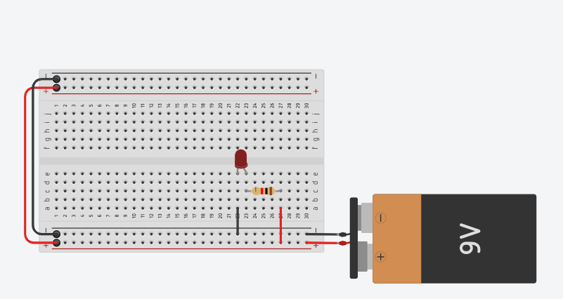

**OUTPUT:-**

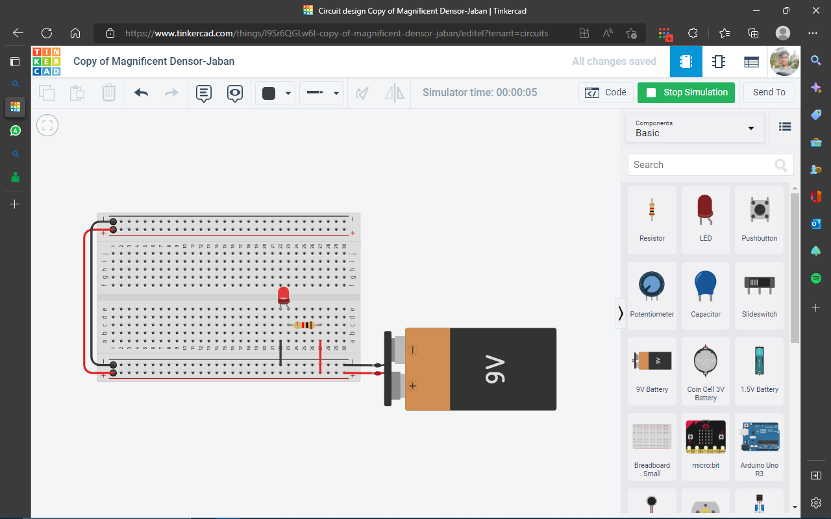

**CONCLUSION:-**Tinker-cad Circuits is the easiest way to get your students started with learning electronics. Using our interactive circuit editor, students can explore, connect, and code virtual projects with a bottomless toolbox of simulated components.

Hence led is on and circuit connection is work fine.

**EXPERIMENT NO:-1.B**

**TITLE:-CIRCUIT DESIGN WITH TINKERCAD.**

**AIM:-VARYING THE RESISTANCE OF A LED CIRCUIT IN TINKERCAD.**

**REQUIRMENTS:-** **A PC WITH THE INTERNET CONNECTION, TINKERCAD LOGIN.**

**THEORY:- The electrical resistance is varied by**sliding a wiper contact along a resistance track**. Sometimes the resistance is adjusted at pre-set value as required at the time of circuit building by adjusting screw attached to it and sometimes resistance can be adjusted as when required by controlling knob connected to it.**

**A photo-resistor (also known as a Photocell, or light-dependent resistor, LDR, or photo-conductive cell) is a passive component that decreases resistance with respect to receiving luminosity (light) on the component's sensitive surface. The [resistance](https://en.wikipedia.org/wiki/Electrical_resistance" \o "Electrical resistance) of a photo-resistor decreases with increase in incident light intensity; in other words, it exhibits [photoconductivity](https://en.wikipedia.org/wiki/Photoconductivity" \o "Photoconductivity). A photo-resistor can be applied in light-sensitive detector circuits and light-activated and dark-activated switching circuits acting as a resistance [semiconductor](https://en.wikipedia.org/wiki/Semiconductor" \o "Semiconductor).**

**PROCEDURE:-**

1. To get started, visit Tinker-cad's website and create an account or log into an existing one
2. After logging in to Tinker-cad, click on "Circuits" on the left-hand side.
3. Click on the "Create New Circuit" homepage in Tinker-cad.
4. Take 9v battery ,1resistor with 1kΩ, 1resistor with 100kΩ, 2 red led, 1 blue led, 1Photoresistor, 250 kΩ Potentiometer, 1small breadboard.
5. Connect negative point of battery to negative point of small breadboard and positive point of battery to positive point of small breadboard. Also connect positive to positive and negative to negative in small breadboard.
6. Now take 1 kΩ Resistor and connect it’s positive point to positive point of small breadboard with wire and take 1red led it’s left point connect to resistor negative point.
7. Led right pin connect with negative point of small breadboard.
8. Connect 250 kΩ Potentiometer in small breadboard left pin connect to positive point of breadboard and middle pin with 100kΩ resistor positive point.
9. Take 1 blue led it’s left point connect to 100kΩ resistor negative point and blue led right pin connect to negative point of breadboard.
10. Take 1Photoresistor it’s left pin connect to positive point of breadboard and right pin connect with new another red led left pin, new red led right pin connect to negative point of breadboard.
11. After all connection done start simulation.
12. All 3 Led is on means all connection are properly connected.

**CIRCUIT DIAGRAM:-**

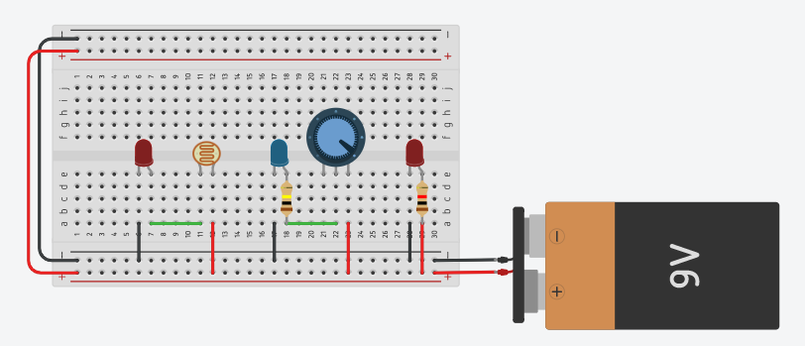

**OUTPUT:-**

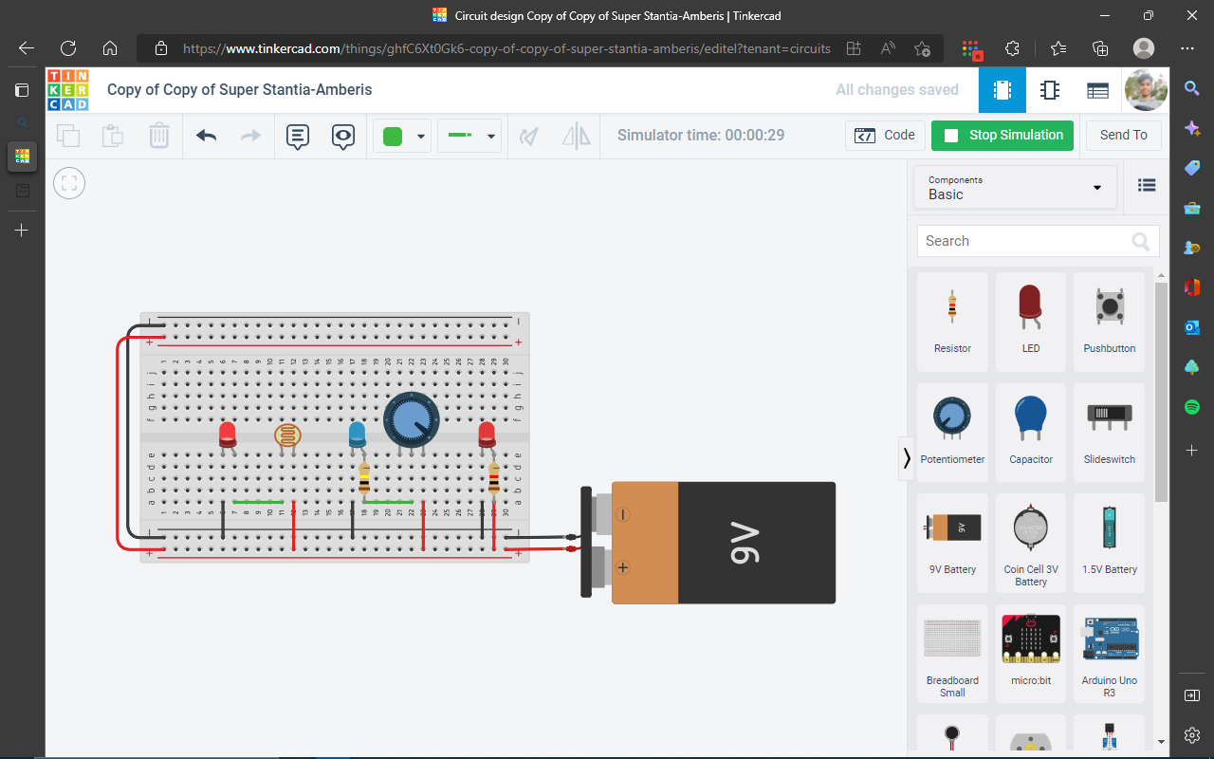

**CONCLUSION:-**

Hence the all 3 led is on means it is verified the resistance of led circuit in tinker-cad

**EXPERIMENT NO:-2**

**TITLE:-INTRODUCTION OF ARDUINO PROGRAMMING PROJECT.**

**AIM:-TO DESIGN AND SIMULATE A ARDUINO-BASED CIRCUIT IN TINKER-CAD.**

**REQUIREMENTS:- A PC WITH THE INTERNET CONNECTION, TINKERCAD LOGIN.**

**THEORY:- Tinker-cad is a free web app for 3D design, electronics, and coding, trusted by over 50 million people around the world. A breadboard is a solder-less device for temporary prototype with electronics and test circuit designs. Most electronic components in electronic circuits can be interconnected by inserting their leads or terminals into the holes and then making connections through wires where appropriate.**

**The ARDUINO UNO R3 is a micro-controller board based on a removable, dual-in-line-package (DIP) ATmega328 AVR micro-controller. It has 20 digital input/output pins (of which 6 can be used as PWM outputs and 6 can be used as analog inputs). Programs can be loaded on to it from the easy-to-use Arduino computer program. The Arduino has an extensive support community, which makes it a very easy way to get started working with embedded electronics. The R3 is the third, and latest, revision of the ARDUINO UNO.**

**SPEAKER WITH RED LED, SLIDE SWITCH CONTROLL BY ARDUINO UNO CODE WITH C,C++.When power is on and we slide the switch then led and speaker on and off automatically both at same time.**

**PROCEDURE:-**

1. To get started, visit Tinker-cad's website and create an account or log into an existing one
2. After logging in to Tinker-cad, click on "Circuits" on the left-hand side.
3. Click on the "Create New Circuit" homepage in Tinker-cad.
4. Take 1 RED LED, 1 slide switch, 1 speaker and one ARDUINO UNO BOARD.
5. Connect speaker positive pin to 13 number pin in **ARDUINO UNO** and speaker negative pin connect to slide-switch left pin.
6. Slide-switch middle pin connect to red led left pin and right pin of slide-switch connect to GND pin which is right side to 13 pin number in **ARDUINO UNO**.
7. Red Led right pin connect in same GND pin in **ARDUINO UNO**.
8. After all connection done then code for what we have to do with this all connection
9. Source code is c,c++ language which is mention below.
10. Now start simulation and slide the switch now our red led and speaker on off automatically which we code in **ARDUINO UNO BOARD**.

**CIRCUIT DIAGRAM:-**

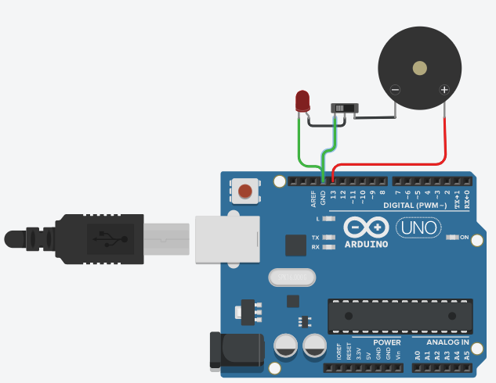

**SOURCE CODE:-**

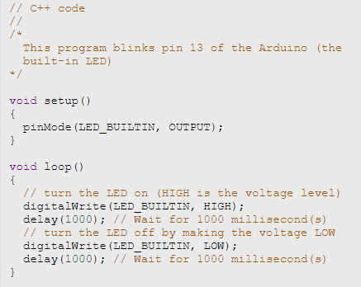

**OUTPUT:-**

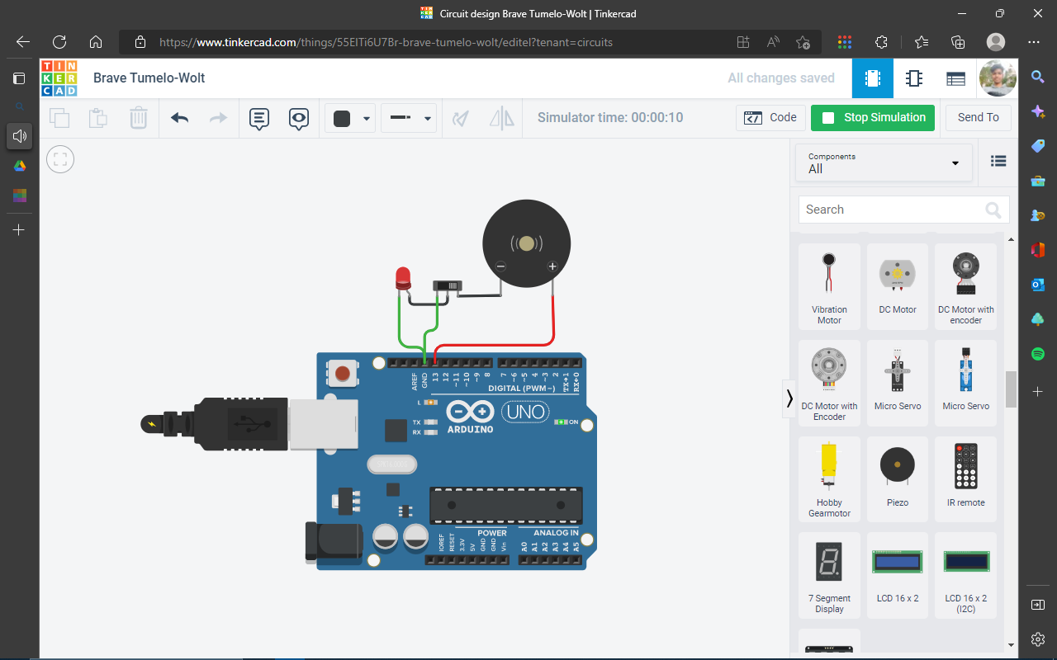

**CONCLUSION:-**

Hence all circuit is work properly and code is also working in ARDUINO UNO board fine.

Red led blink and speaker also work.

Designed AND Simulated A ARDUINO-BASED CIRCUIT IN TINKER-CAD.

**PRACTICAL NO:-3**

**TITLE:-**LED BLINKING USING EDSIM51.

**AIM:-**WRITE A PROGRAM TO BLINK AN LED USING EDSIM51.

**REQUIREMENTS:-**EDSIM51 SIMULATOR ON A PC WITH SPECIFICATION

1. Pc
2. Latest version java install

**THEORY:-**EdSim51, developed by James Rogers, is a simulator unlike the many industry-standard simulators that are widely available - this simulator has the student in mind. Take a look at the screen-shot below: The top left box gives the user **access to all the 8051's registers, data memory and code memory.**

**FLOWCHART:-**

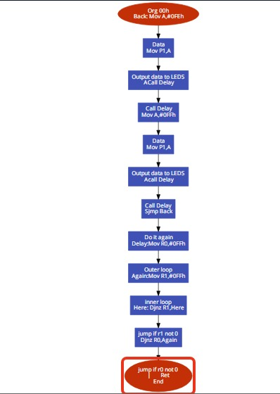

**PROGRAM:-**

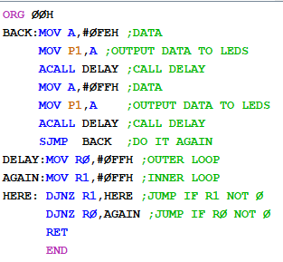

**OUTPUT:-**

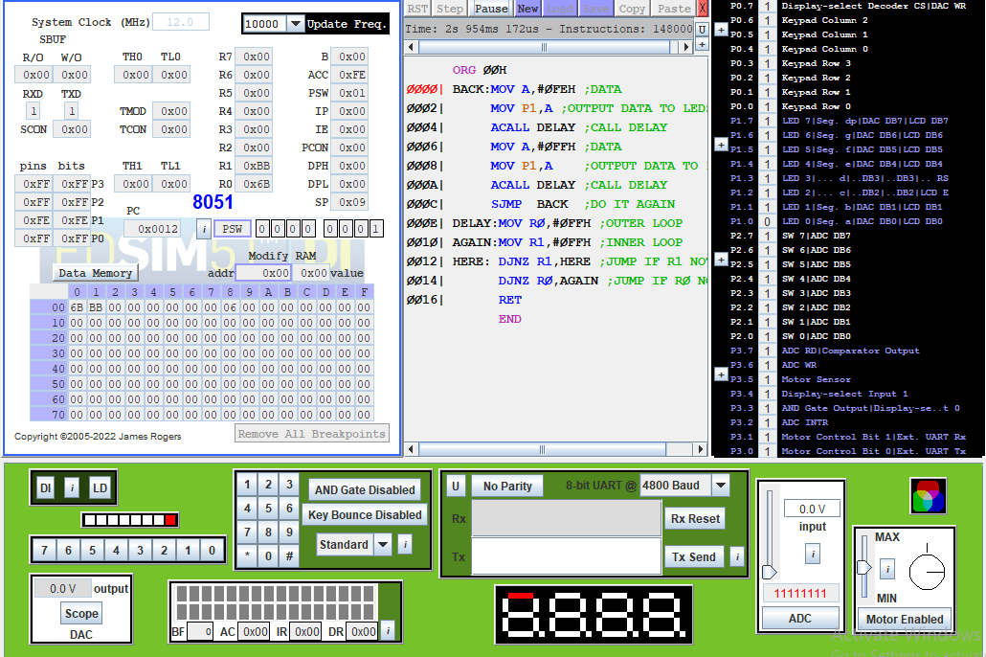

**CONCLUSION:-**HENCE LED IS BLINKING MEANS CODE IS WORK FINE WITHOUT ANY ERROR.

**PRACTICAL NO:-4**

**Aim:-** Write an assembly language program (ALP) to perform arithmetic operations.

**Requirement:-** Keilu5 Software.

**Flowchart:-**

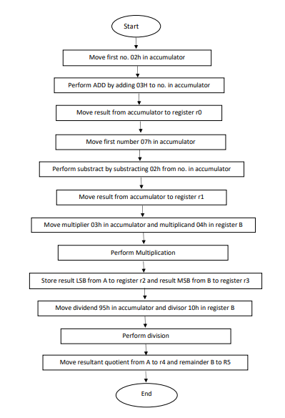

**PROGRAM:-**

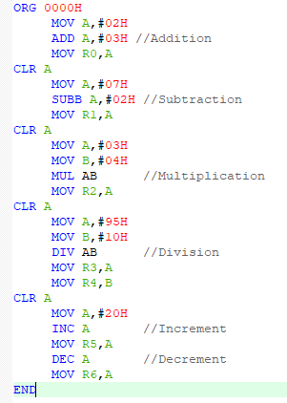

**PROCEDURE:-**

**STEP1:-**OPEN KEIL SOFTWARE AND GO UNDER PROJECT AND SELECT NEW UVERSION PROJECT.

**STEP2:-**NOW NAME WHATEVER YOU WANT AND GIVE IT’S EXTENTION .asm (ASSEMBLY LANGUAGE).

**STEP3:-** UNDER SEARCH COLUMN TYPE 8051 AND SELECT IT AND PRESS ENTER. 8051 IS A MICRO-CONTROLLER. AFTER PRESSED ENTER THEN SELECT NO AND PRESS ENTER.

**STEP4:-** NOW GO UNDER PROJECT SECTION AND CLICK SIGN(+) TO SEE SOURCE GROUP. NOW DOUBLE CLICK ON SOURCE GROUP AND SELECT THAT FILE WHICH WE CREATED WITH EXTENTION .asm (ASSAMBLY LANGUAGE).

**STEP5:-** AFTER SELECT FILE NOW WRITE CODE FOR 8051 MICRO-CONTROLLER IN ASSEMBLY LANGUAGE.

**STEP6:-** NOW WE HAVE TO BUILT IT OR TARGET IT SO GO UNDER PROJECT AND BUILT IT OR SHORT-CUT KEY F7. YOU CAN SEE IN DOWN BUILT OUTPUT WHICH SO IS THERE ANY ERROR, WARNING. IF IT’S SO 0 ERROR AND WARNING THEN IT IS BUILT IT.

**STEP7:-** NOW GO UNDER DEBUG SECTION AND START DEBUG OR YOU CAN ENTER SHORT-CUT KEY CTRL+F5. THEN PRESS ENTER.

**STEP8:-**NOW GOTO MEMORY ADDRESS d:0x00H AND PRESS ENTER.

**STEP9:-** CLICK ON STEP AND CHECK AND RECORD ALL ARTHMETIC OPERATION AND CHANGES IN MEMORY ADDRESS.

**STEP10:-**ALL ARTHMETIC OPERATION IS DONE.

**OUTPUT:-**

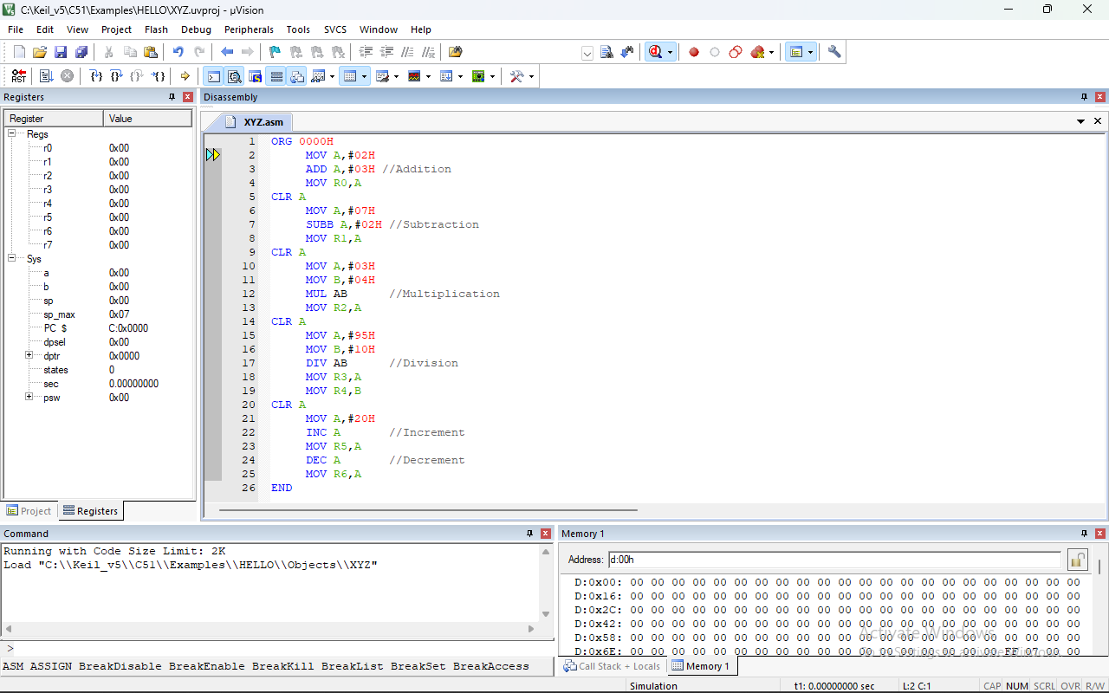

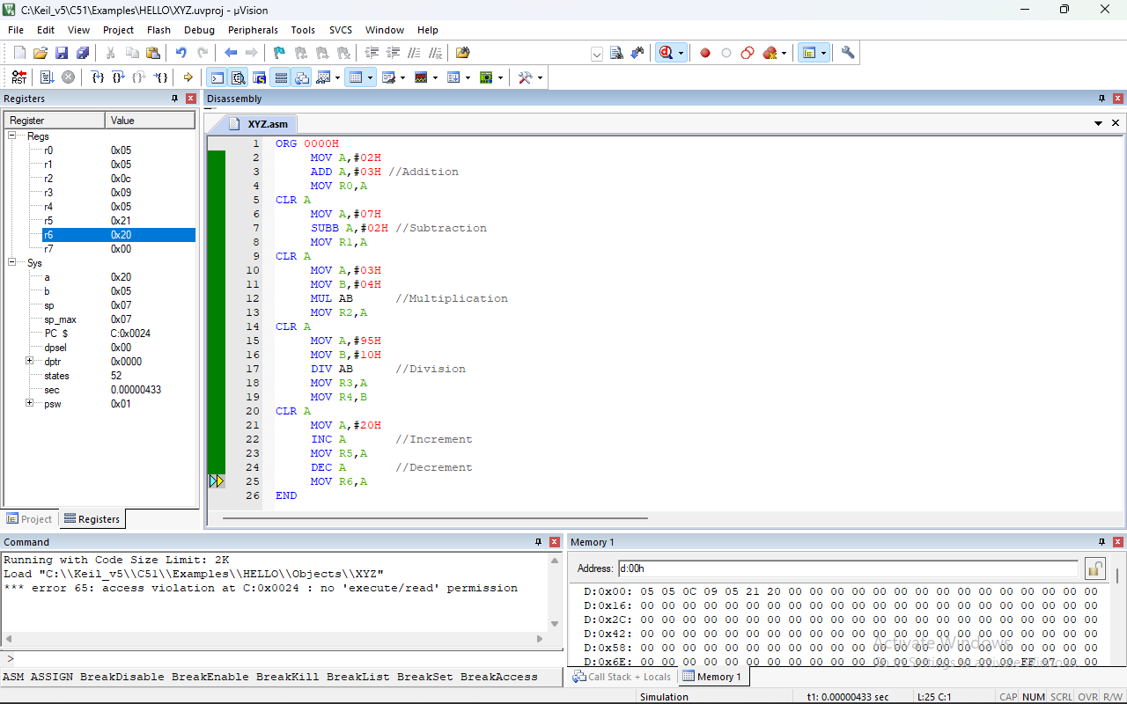

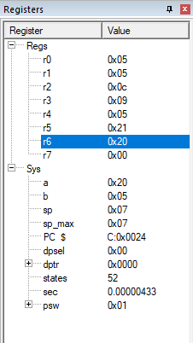 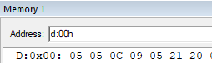

**CONCLUSION:-**

**Hence all Arithmetic Operation ADDITION, SUBSTRACTION, MULTIPLICATION, DIVISION, INCREMENT AND DECREMENT is done.**

**PRACTICAL NO:-5**

**Aim:-** Write an ALP to transfer data from source to destination location of internal/external data memory.

**Requirement:-** Kiel_v5 Software.

**Flowchart:-**

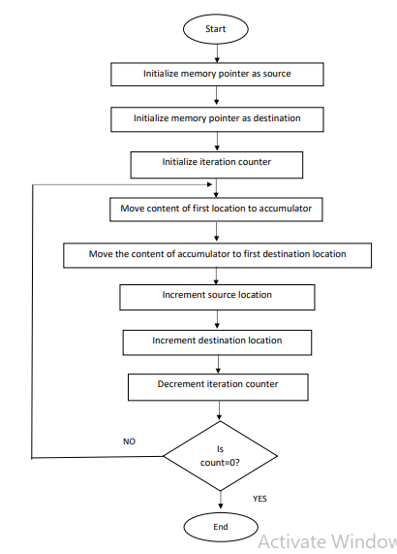

**PROGRAM:-**

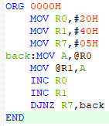

**PROCEDURE:-**

**STEP1:-**OPEN KEIL SOFTWARE AND GO UNDER PROJECT AND SELECT NEW UVERSION PROJECT.

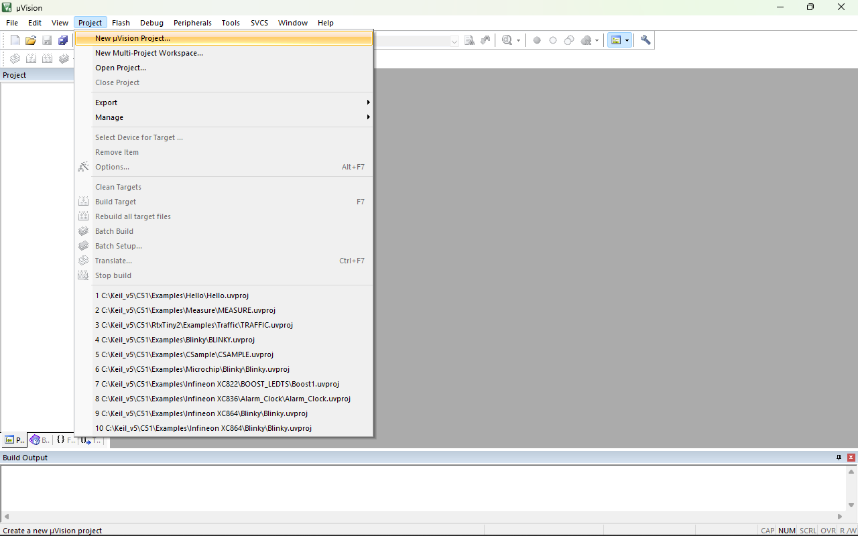

**STEP2:-**NOW NAME WHATEVER YOU WANT AND GIVE IT’S EXTENTION .asm (ASSEMBLY LANGUAGE).

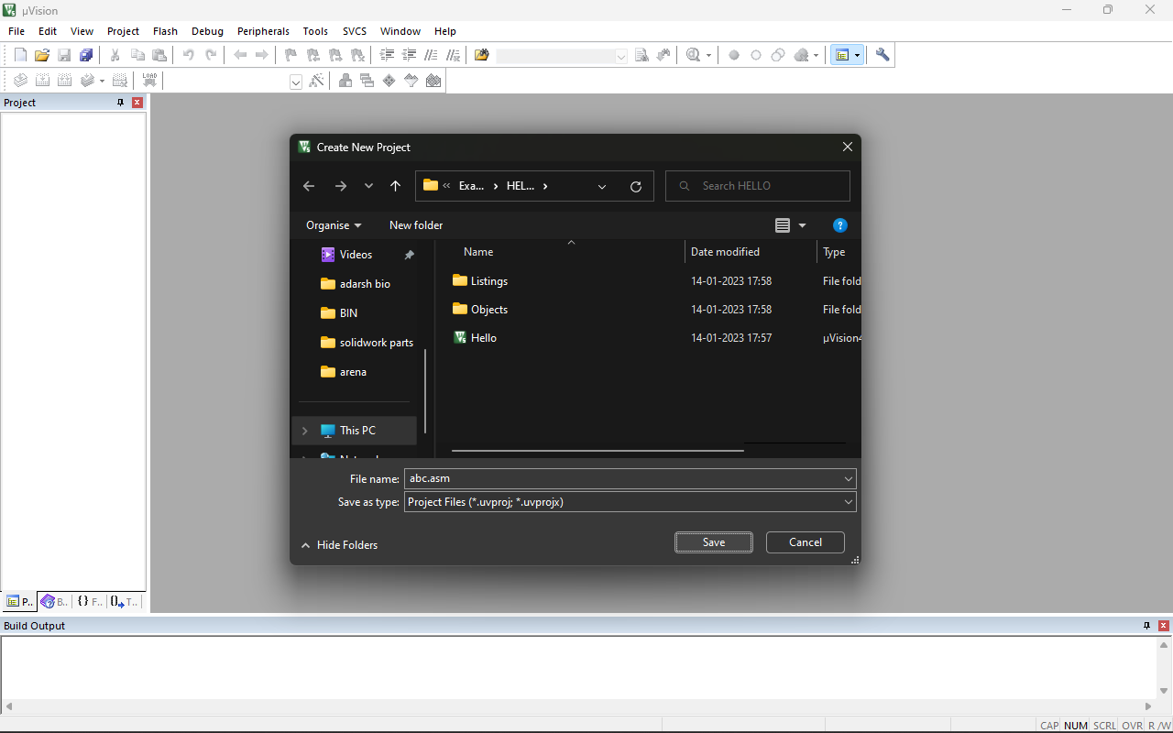

**STEP3:-** UNDER SEARCH COLUMN TYPE 8051 AND SELECT IT AND PRESS ENTER. 8051 IS A MICRO-CONTROLLER. AFTER PRESSED ENTER THEN SELECT NO AND PRESS ENTER.

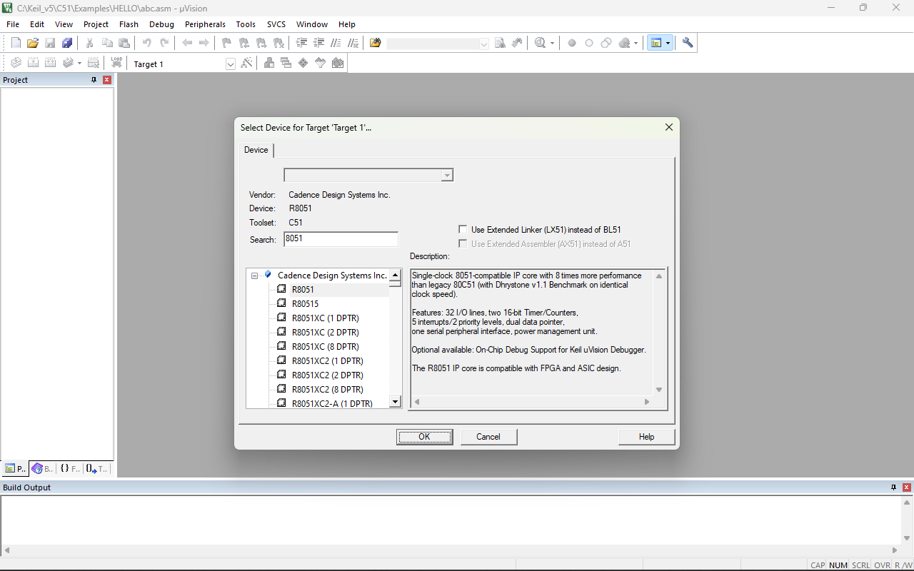

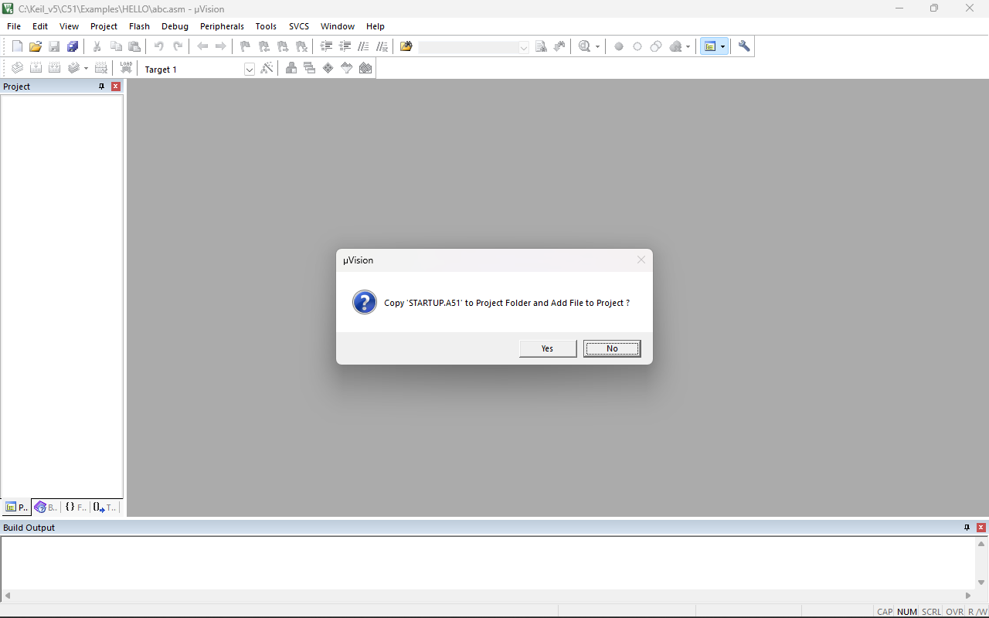

**STEP4:-** NOW GO UNDER PROJECT SECTION AND CLICK SIGN(+) TO SEE SOURCE GROUP. NOW DOUBLE CLICK ON SOURCE GROUP AND SELECT THAT FILE WHICH WE CREATED WITH EXTENTION .asm (ASSAMBLY LANGUAGE).

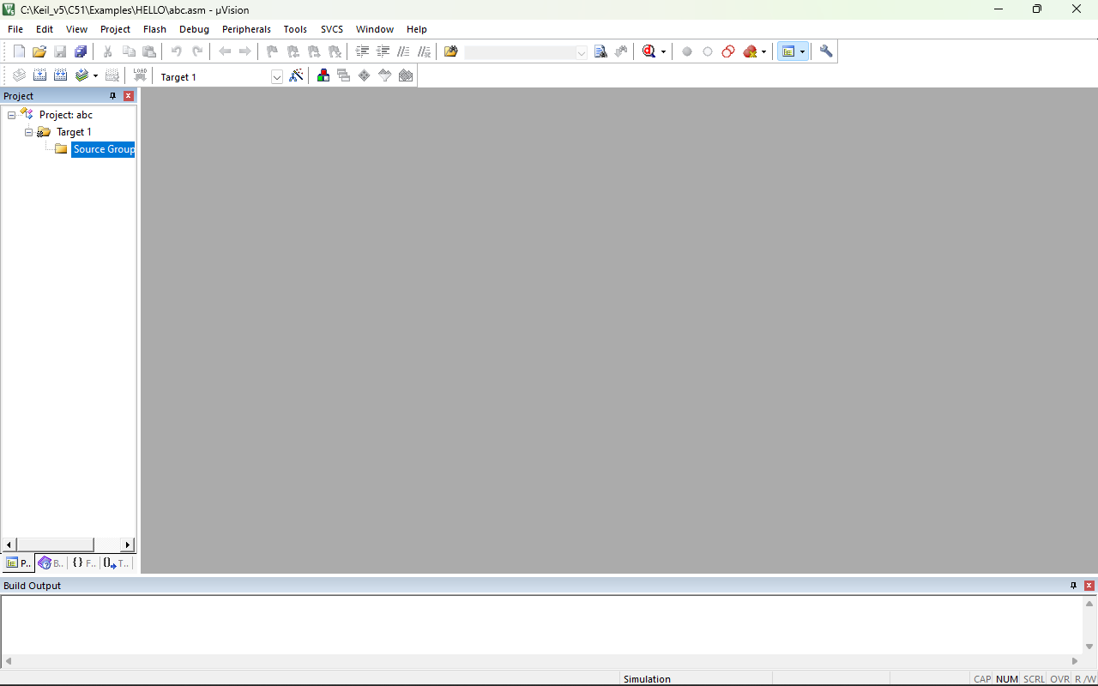

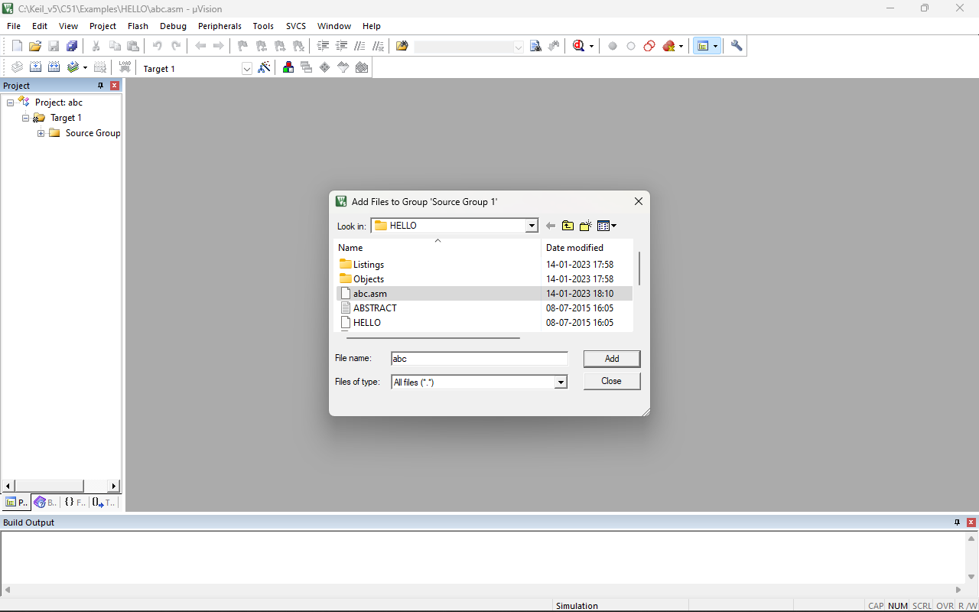

**STEP5:-** AFTER SELECT FILE NOW WRITE CODE FOR 8051 MICRO-CONTROLLER IN ASSEMBLY LANGUAGE.

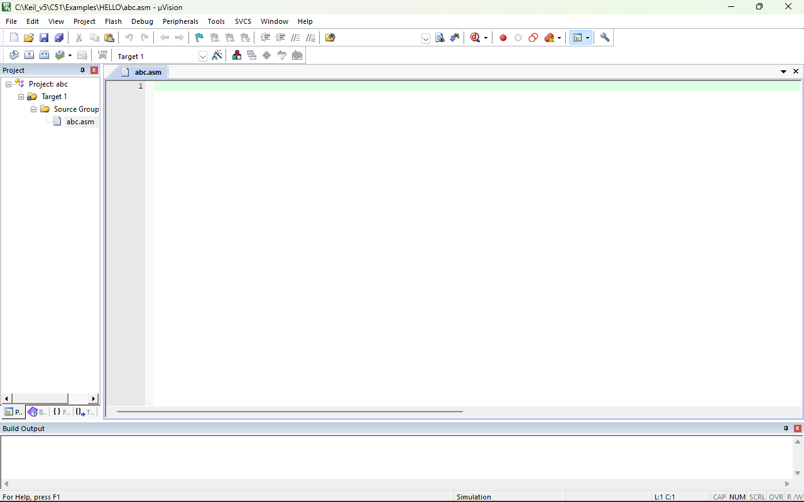

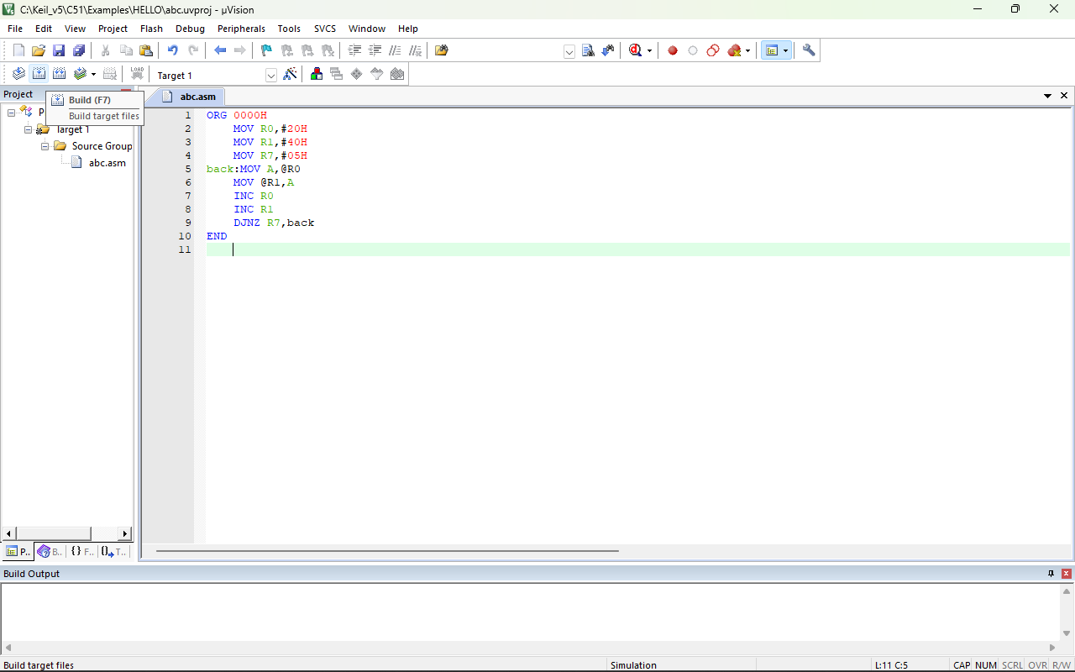

**STEP6:-** NOW WE HAVE TO BUILT IT OR TARGET IT SO GO UNDER PROJECT AND BUILT IT OR SHORT-CUT KEY F7. YOU CAN SEE IN DOWN BUILT OUTPUT WHICH SO IS THERE ANY ERROR, WARNING. IF IT’S SO 0 ERROR AND WARNING THEN IT IS BUILT IT.

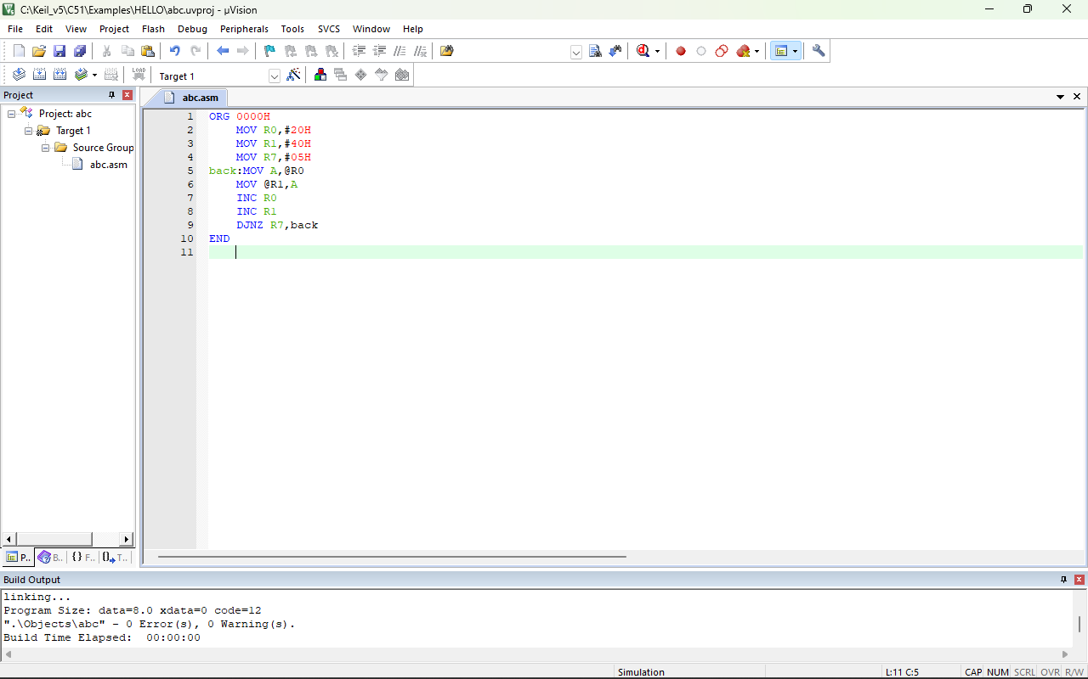

**STEP7:-** NOW GO UNDER DEBUG SECTION AND START DEBUG OR YOU CAN ENTER SHORT-CUT KEY CTRL+F5. THEN PRESS ENTER.

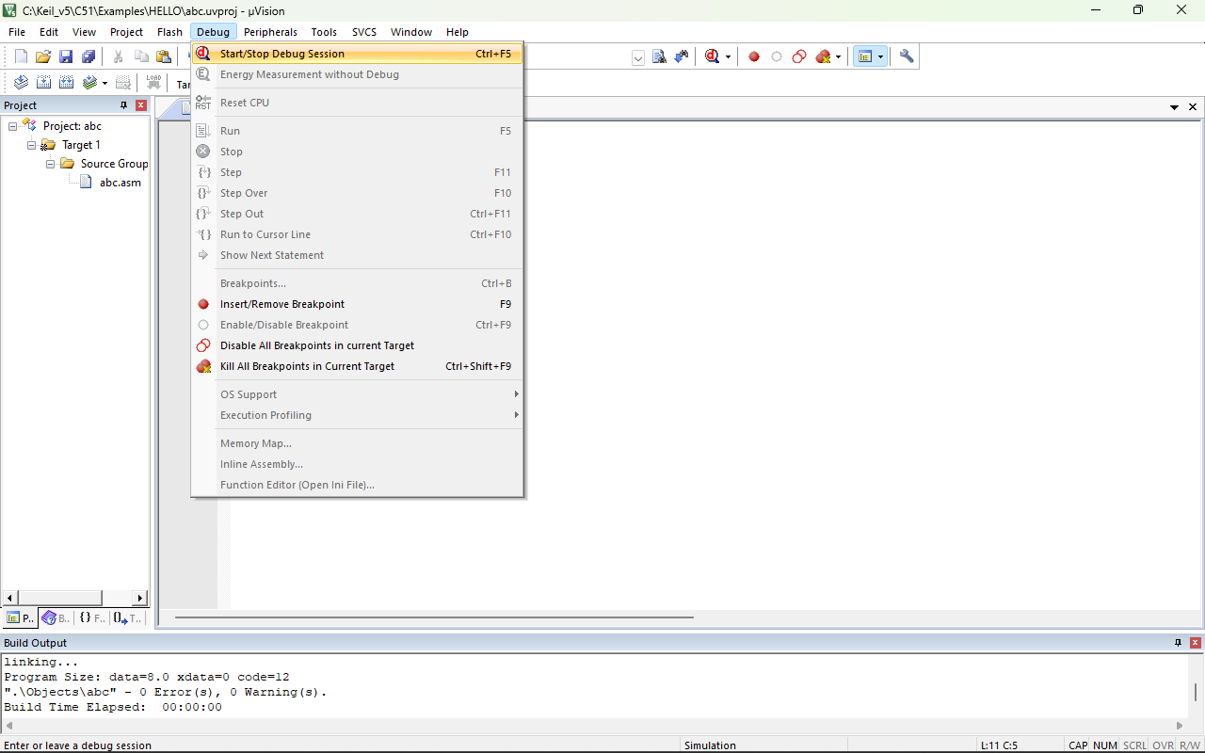

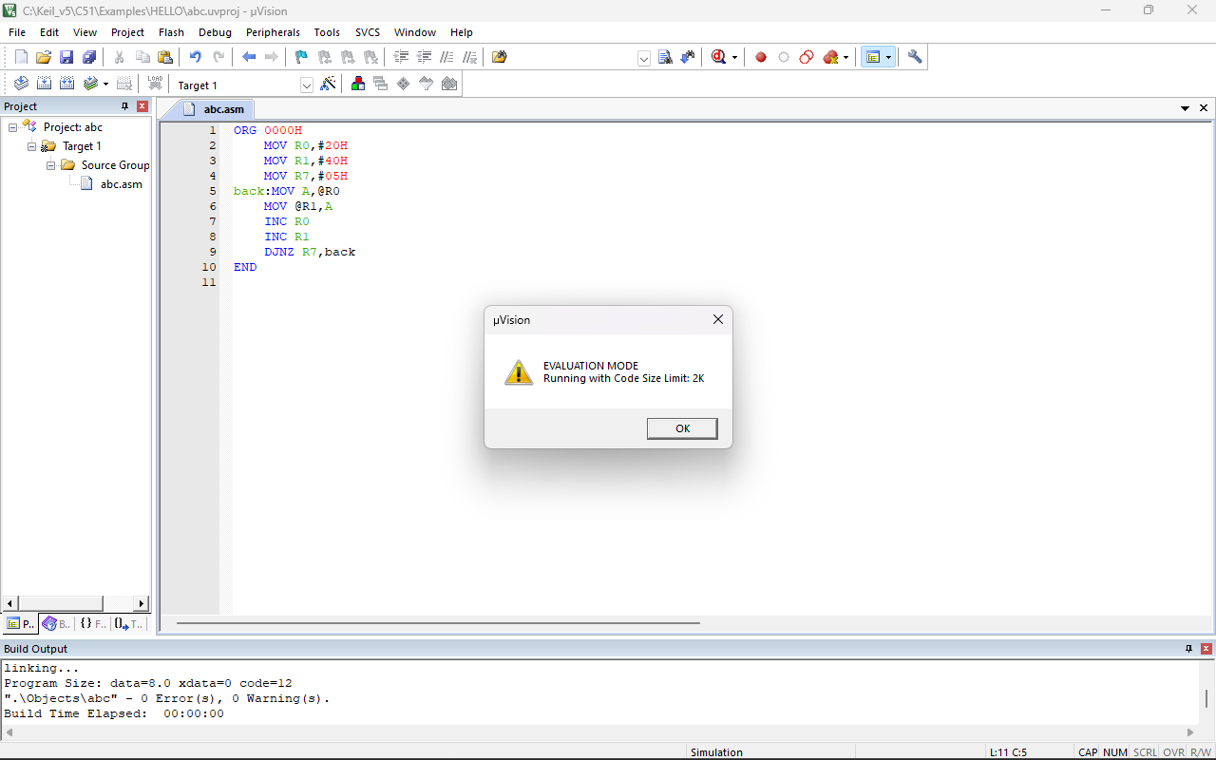

**STEP8:-** NOW CHECK ALL MEMORY ADDRESS.

**STEP9:-** NOW ENTER I:0x020 IN MEMORY ADDRESS WHICH IS R0 RASISTOR 20H. THEN MODIFY MEMORY AT 0x020, ENTER IN FORM 1H,2H AND THEN PRESS ENTER.

**STEP10:-** NOW ENTER I:0x040 IN MEMORY ADDRESS AND THEN CLICK ON STEP AND CHECK AND RECORD ALL CHANGES IN MEMORY ADDRESS IN I:0x020. IT GOES LIKE LOOP IT CHECK R7=0 OR R7 NOT =0, IF IT R7=0 THEN IT GO TO END THE PROGRAM IF IT IS NOT EQUAL TO 0 THEN IT GO TO LABEL BACK.

**STEP11:-**ASSEMBLY LANGUAGE CONVERTED INTO HEX.FILE.

**OUTPUT:-**

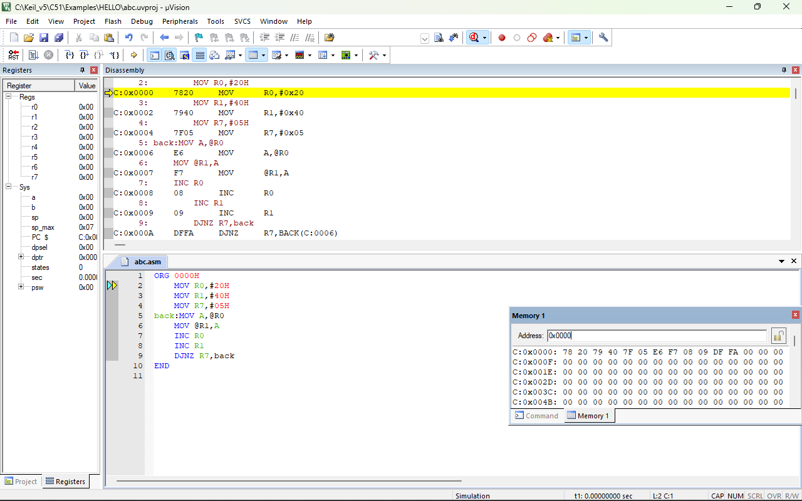

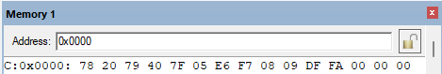

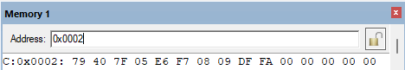

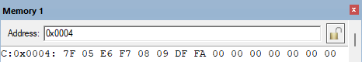

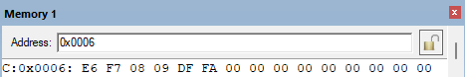

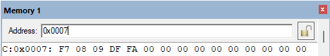

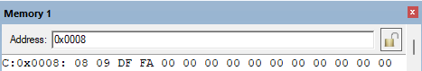

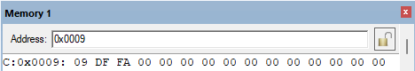

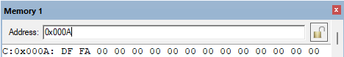

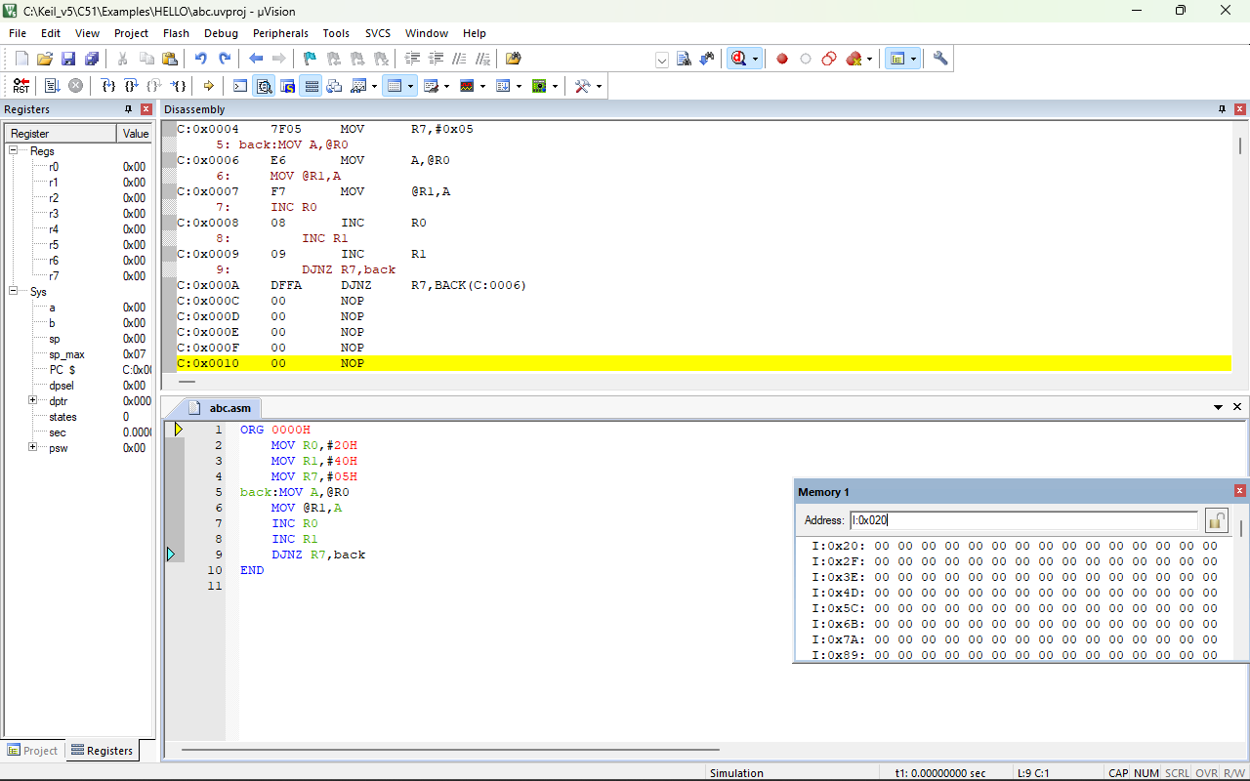

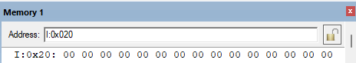

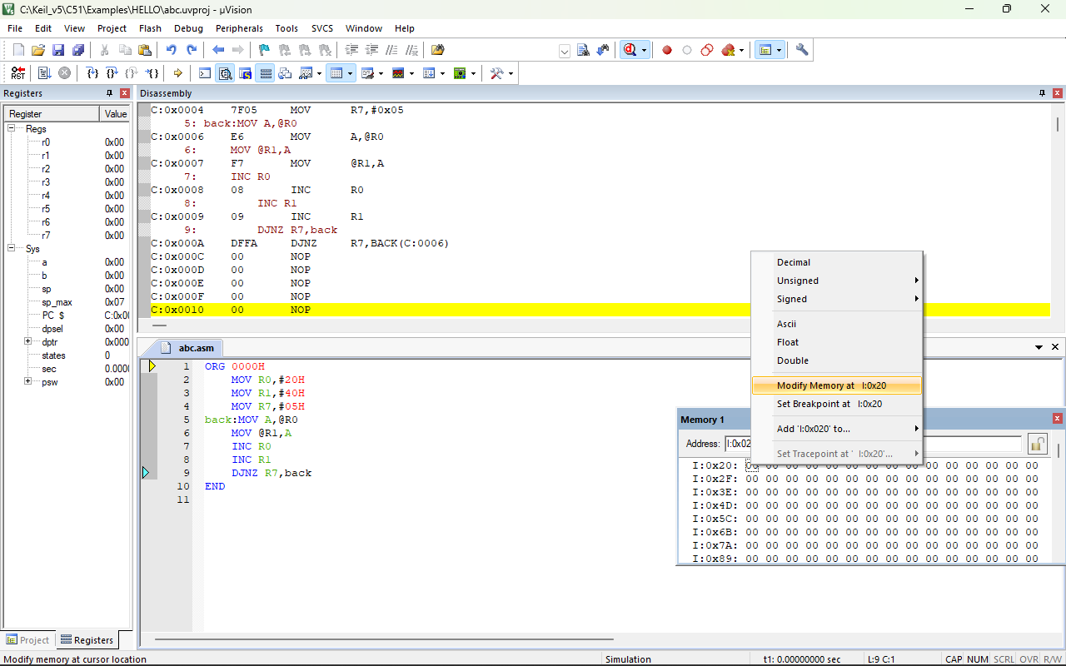

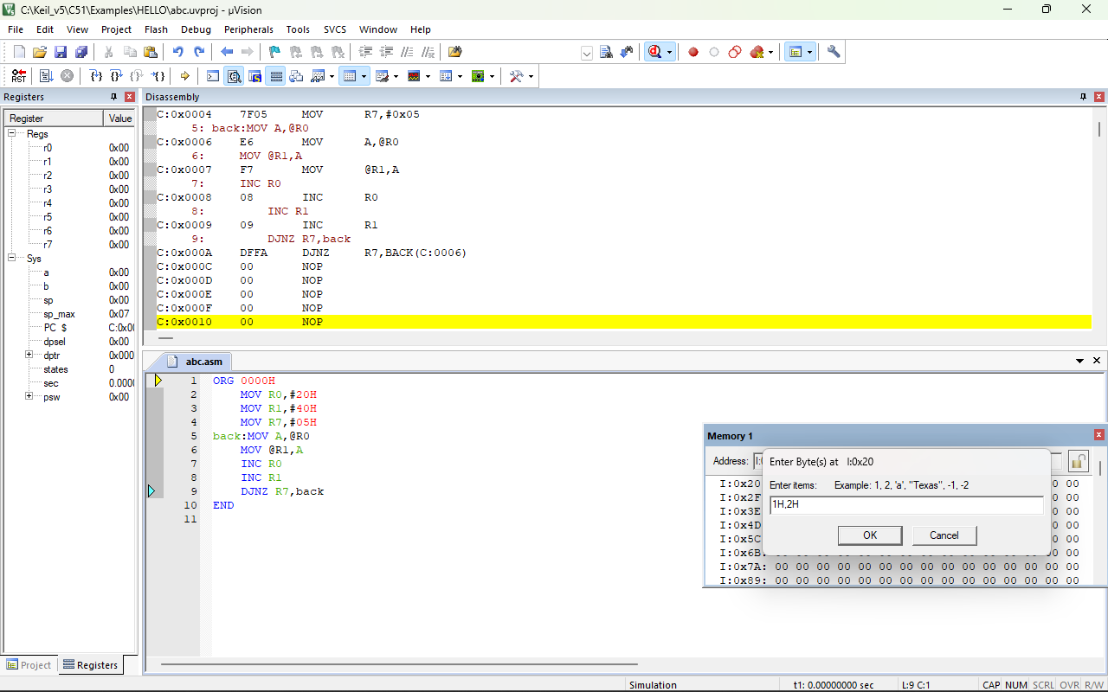

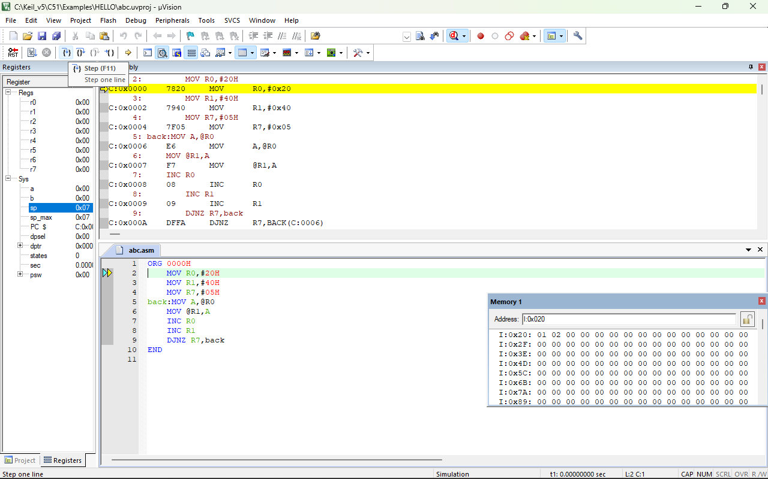

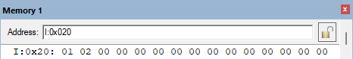

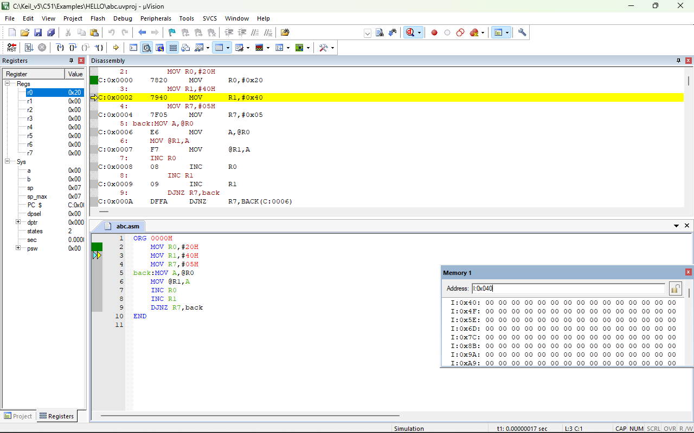

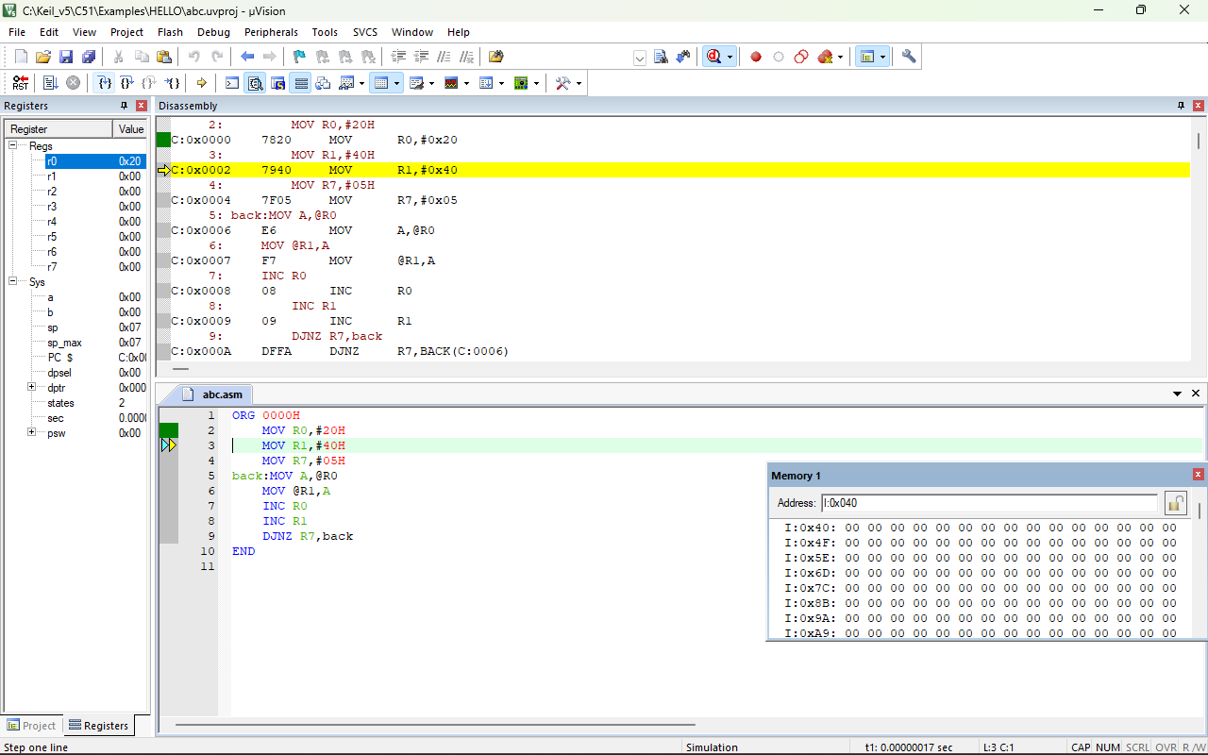

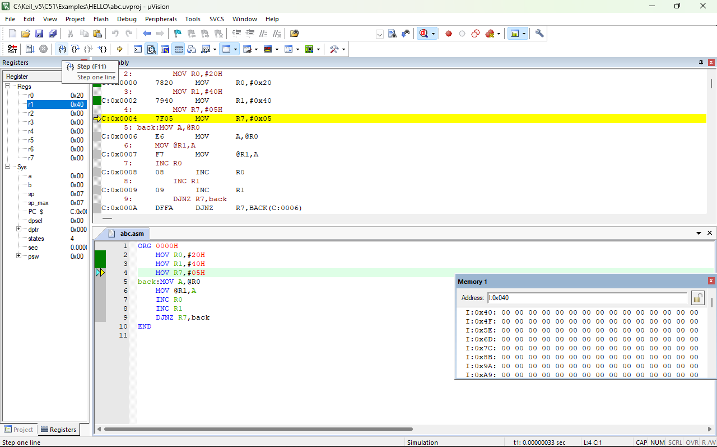

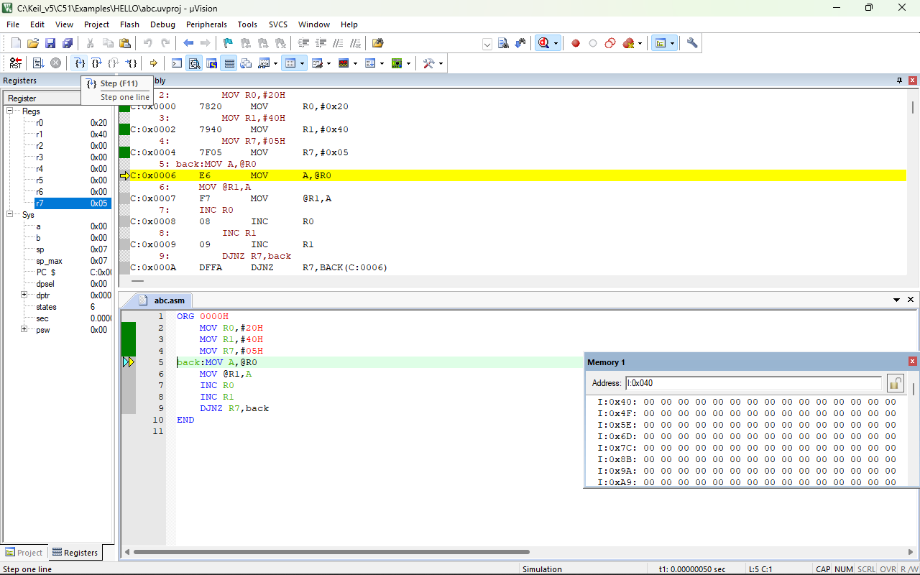

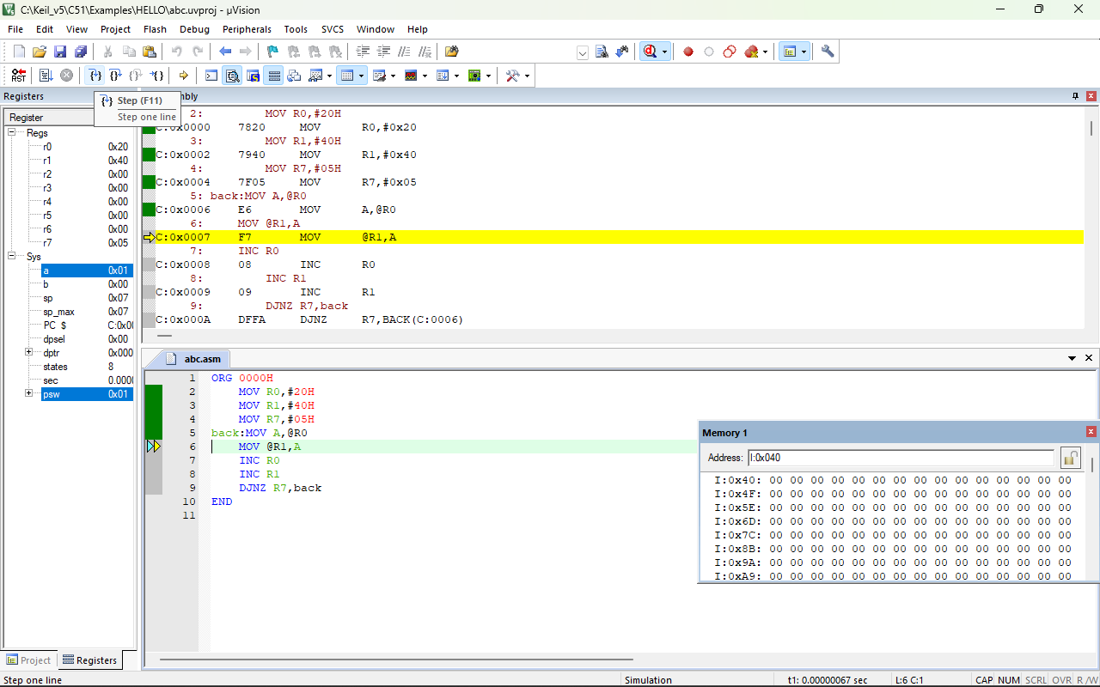

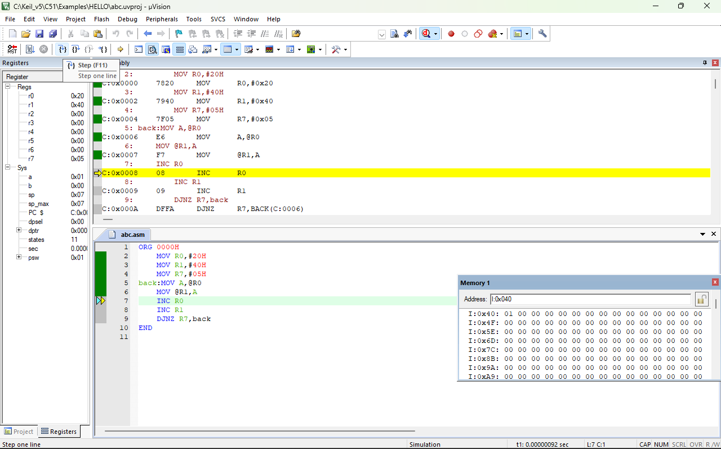

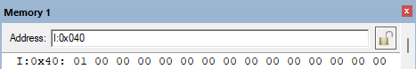

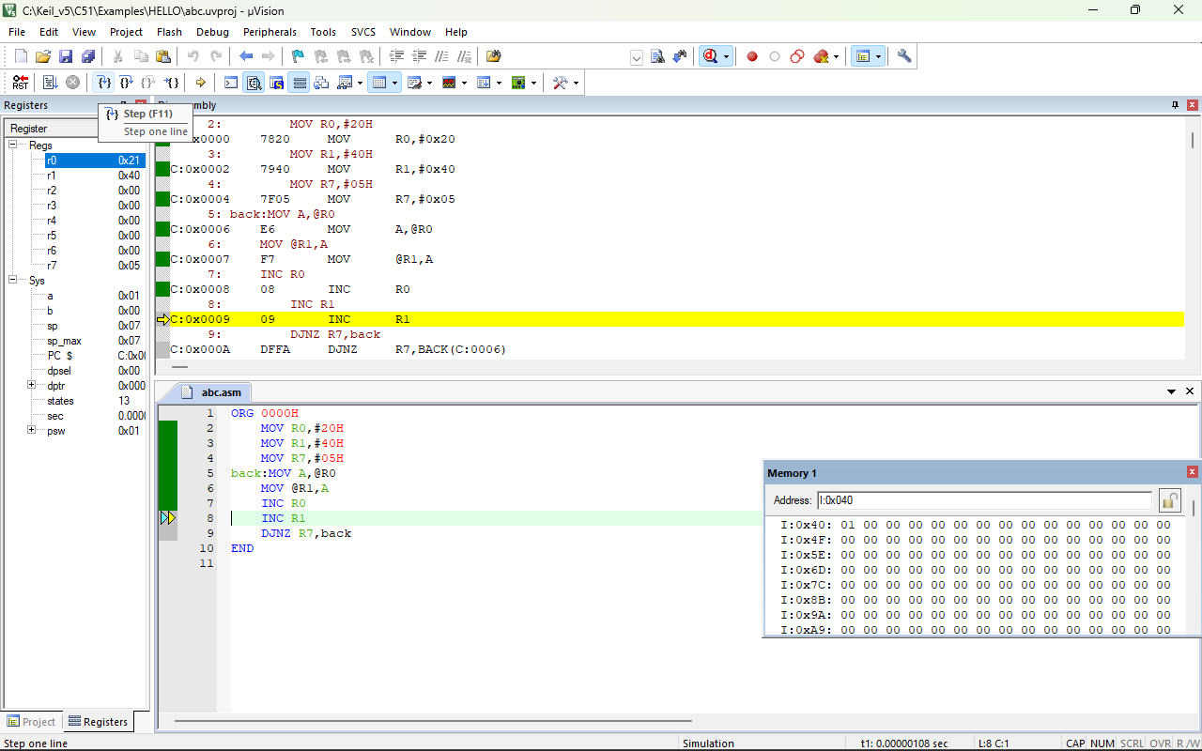

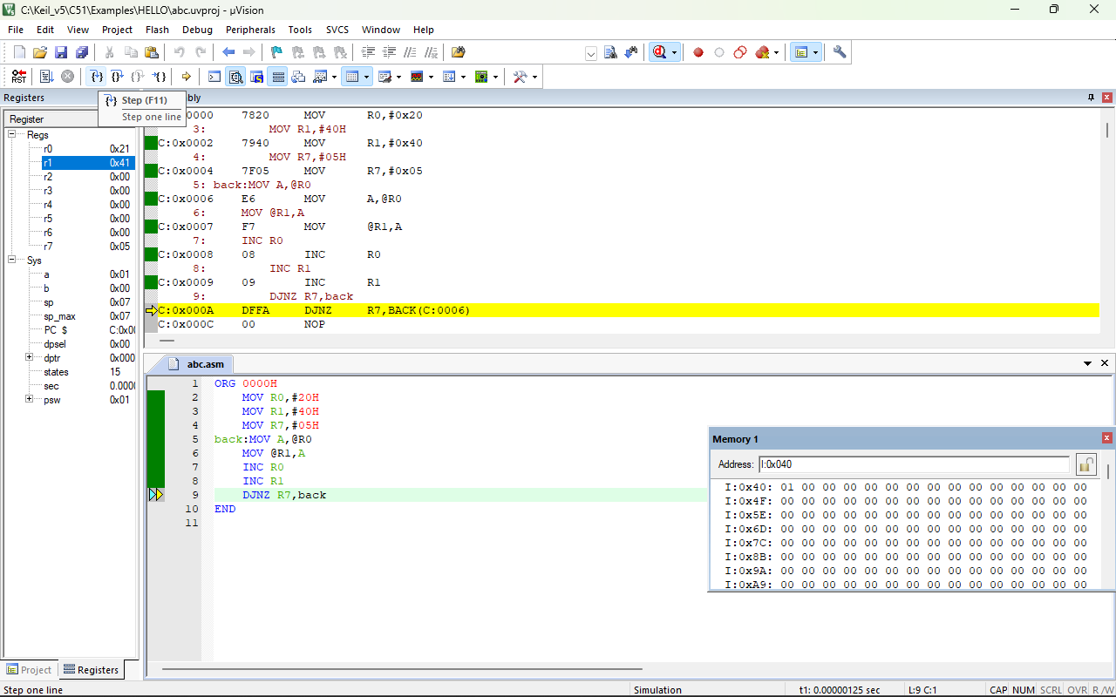

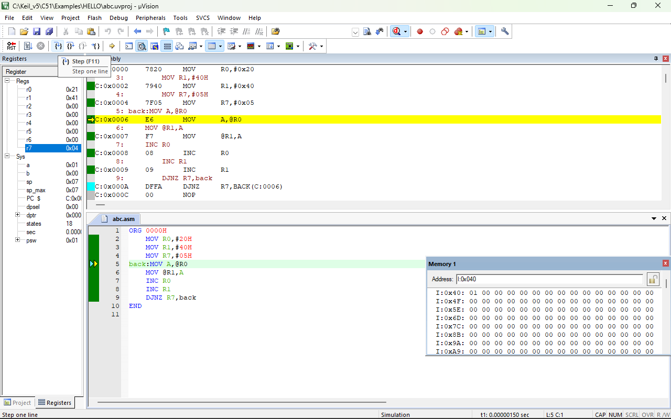

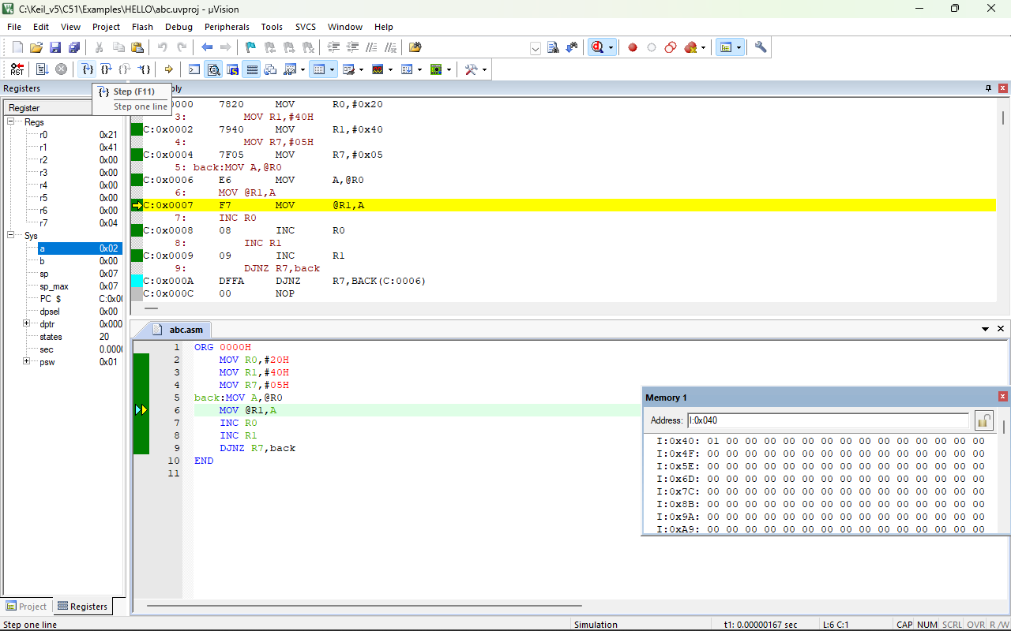

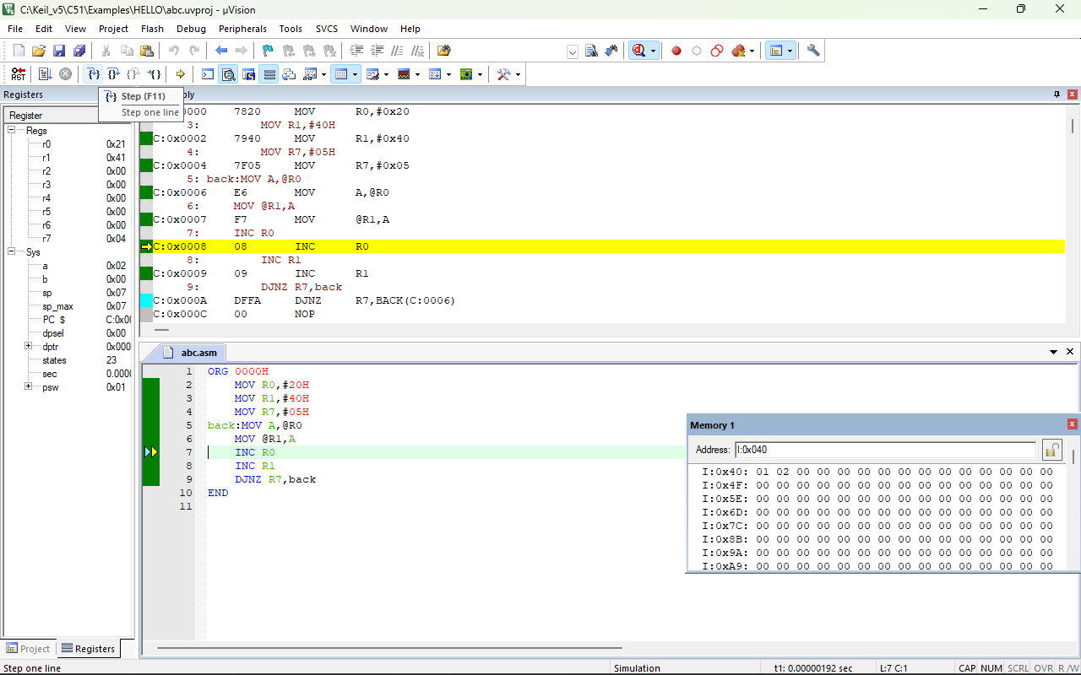

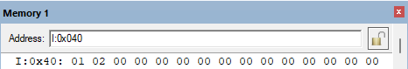

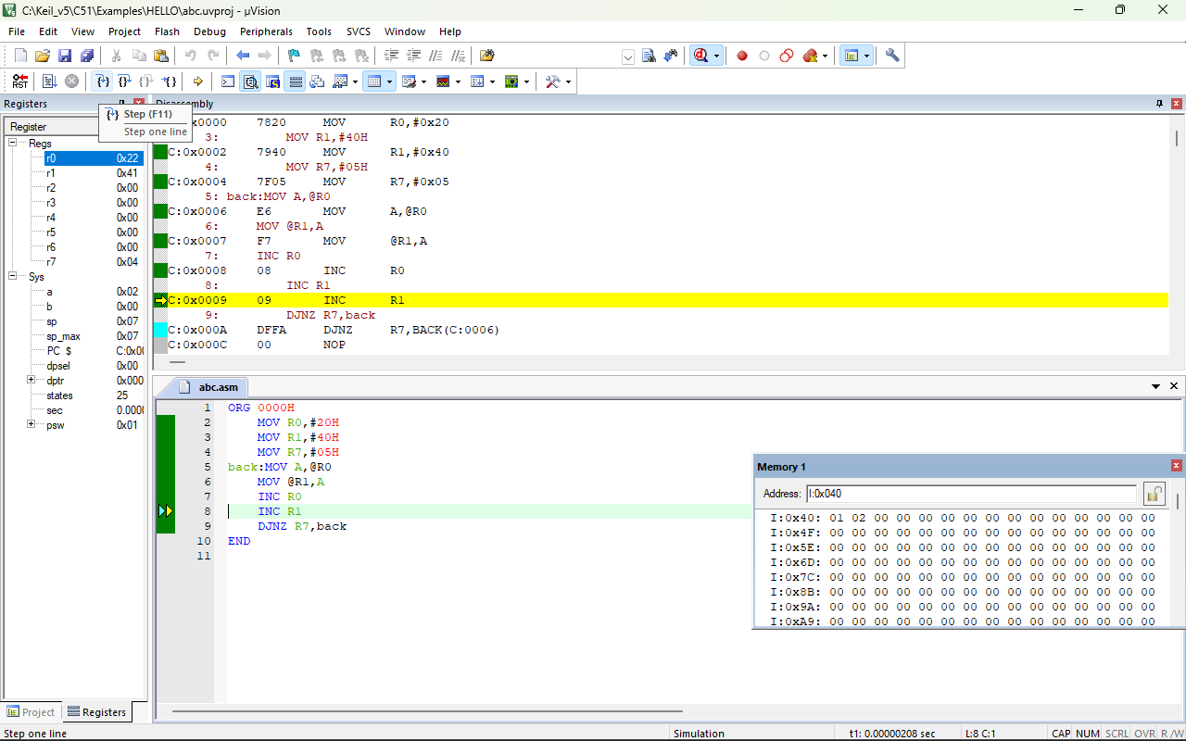

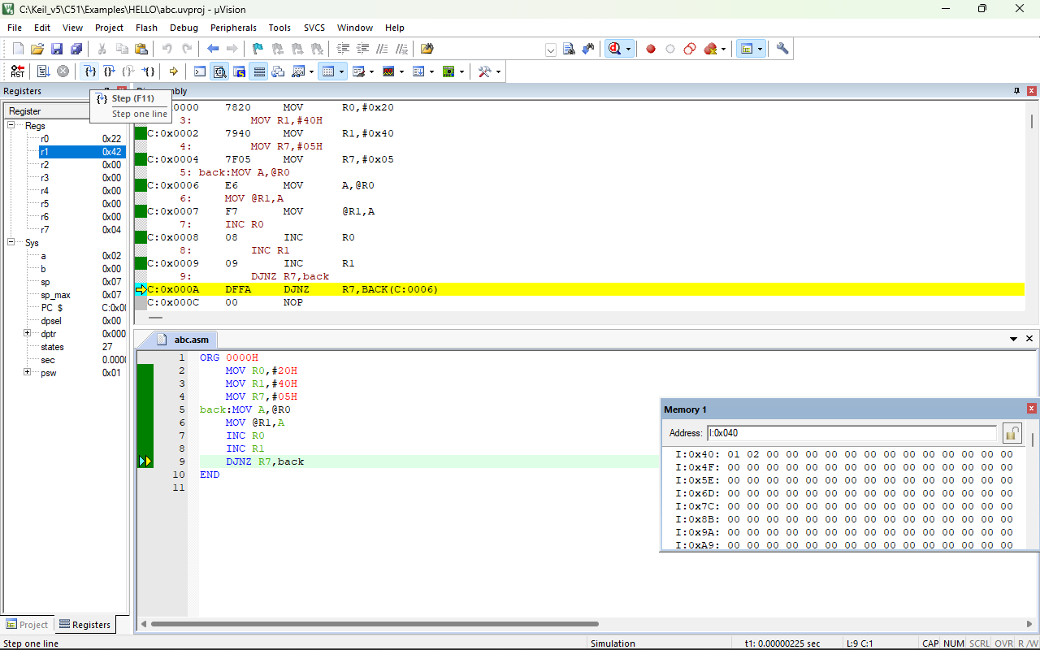

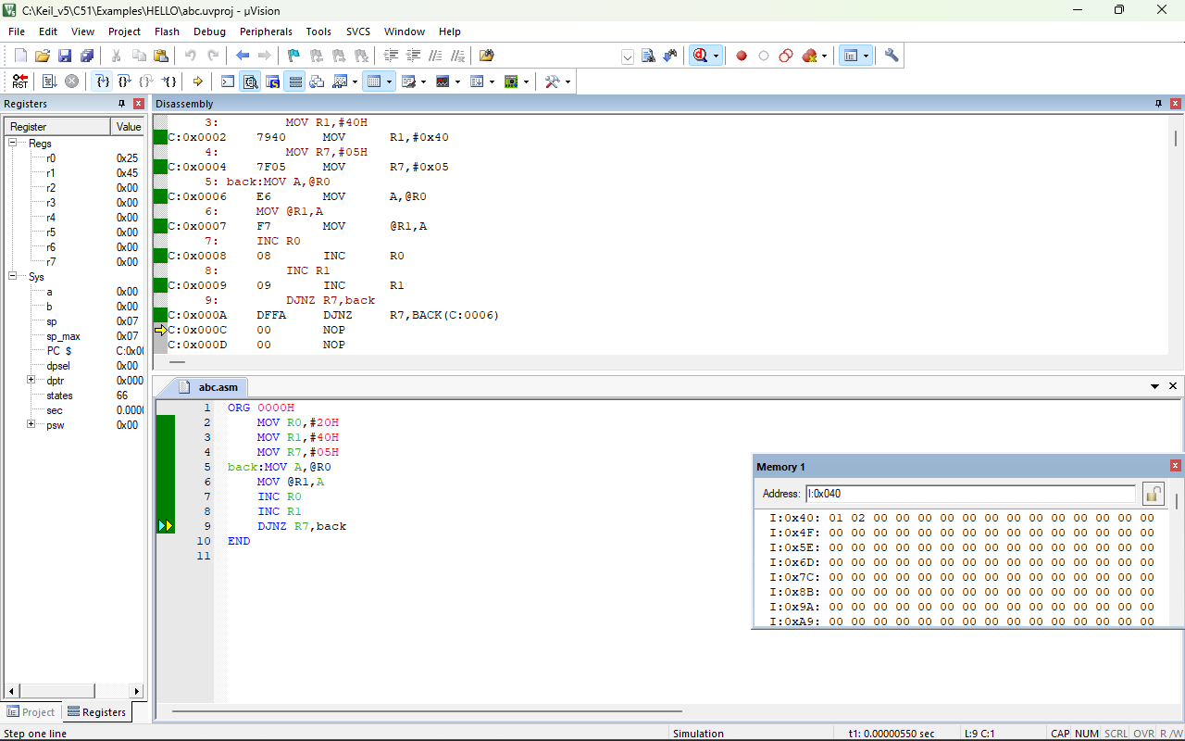

**CONCLUSION:-**

Hence ALP to transfer data from source to destination location of internal/external data memory is done.

**CLASS ACTIVITY:-2**

1. **Draw the pin diagram of the 8051 micro-controller and explain the function/usage of each pin.**

**Answer:-** Let's see the 40 pin Dual In-line Package (DIP) of micro-controller integrated circuit with externally connected power supply and oscillator.

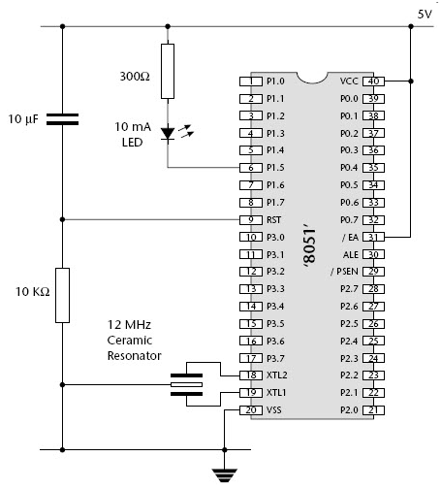

Consider the brief description of pin configuration inside micro-controller is:

****Pins 1-8****: These pins belongs to Port 1 of micro-controller. Port 1 is used as domestically pulled up, quasi bi directional input/output port.

****Pin 9****: It is a RESET pin which is utilized to set the micro-controller 8051 to its primary value. During the beginning of an application the RESET pin is to be set elevated for two machine rotations.

****Pins 10-17****: These pins belong to Port 3 of micro-controller. Port 3 can be used for number of functions such as timer input, interrupts, serial communication indicator for transmitting (TxD) and receiving (RxD). It is also known as domestic pull up port with quasi bi direction port embedded within.

****Pins 18 and 19****: These pins are generally be used for interfacing outer crystal oscillator with given system clock.

****Pin 20****: This pin titled as Vss. It symbolizes ground voltage or 0 V is connected to this pin of micro-controller.

****Pin 21-28****: These pins belong to port 2 of micro-controller. Port 2 can be used as Input/output port, senior order address bus are multiplexed with this quasi bi directional port.

****Pin 29****: This pin belongs to Program Store Enable or PSEN. It is used for interpreting the sign from outer program memory.

****Pin 30****: This pin belongs to External Access or EA input is used for permit or prohibits outer memory interfacing. If there is no outer memory need, this pin is set to high by linking it with supply voltage .

****Pin 31****: This pin belongs to Address Latch Enable or ALE is used for de-multiplexing the address data indication of port 0 for outer memory interfacing.

****Pin 32-39****: These pins belong to Port 0 of the micro-controller. Port 0 can be used as input/output port, lower order address and data bus signals are multiplexed with this port. This pin act as bi directional Input/output port and outer connected pull up resistors are necessary for utilizing these ports as Input/output.

****Pin 40****: This pin is used to provide power supply to the circuit.

1. **List all the ports of 8051 and explain the port structure of each.**

## ****Answer:-**** I/O Ports and their Functions:

In micro-controller there are four Input/output ports P0, P1, P2, and P3, each port is 8-bit port having 8 pins each. During RESET, all the ports are used as input ports. When the port gets first 0, then it becomes an output port. For reconfigure it as an input, the high signal (1) must be sent to a port.

67.9M

1.2KDifference between JDK, JRE, and JVM

****Port 0 (Pin No 32 - Pin No 39):****

Port 0 contains 8 pins. It can be used as input or output. In general we connect P0 with 10K-ohm pull-up resistors for using it as an input or output port being an open drain.

It is also referred as AD0-AD7, which allowing it to be used as both address and data transfer port. When we want to excess the external ROM, then P0 is used as both Data and Address Bus.

Address Latch Enable (ALE) Pin no 31 indicates if PO is used as address or data.

When ALE=0 then it provides data D0-D7.

When ALE=1 then it provides address A0-A7.

Let's see the structure of port 0 with externally connected pull up resistor:

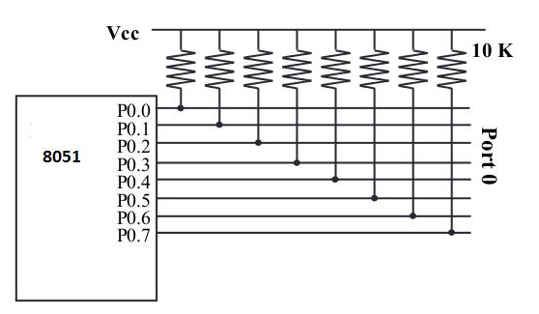

Let's see an assembly language code for making the Port 0 to be worked as an input:-

1. MOV A, #FFH; (comments: A=FFH i.e. A=1111 1111)
2. MOV P0, A; (Port 0 all pin have 1's so that it work as Input)

****Port 1 (Pin No 1-Pin No 8):****

It is also an 8-bit Port and can be worked as either input or output. It doesn't require external connected pull-up resistors because they are already present internally. Upon reset, Port 1 worked as an input port.

If port 1 is configured as an output port, then to use port 1 as input port again, we write 1 to all bits of port 1 as shown in the below code:-

1. MOV A, #FFH        ; Value of Accumulator register A=FF hex
2. MOV     P1, A      ; Port 1 worked as an input port
3. MOV     A, P1      ; get data from P1
4. MOV     R5, A      ; save it in Register R5
5. ACALL   DELAY      ; wait
6. MOV     A, P1      ; get another data from P1
7. MOV     R6, A      ; save it in R6
8. ACALL   DELAY      ; wait
9. MOV     A, P1      ; get data from P1
10. MOV     R7, A      ; save it in R7

****Port 2 (Pin No 21-Pin No 28):****

Port 2 uses a total of 8 pins and it can also be used as input and output operation. Same as Port 1, P2 also not require external pull- up resistors. Port 2 can be used along with P0 to provide 16-bit address for an external memory. Therefore it is designated as (A0-A7), as shown in pin diagram.

If Port 2 is configured as an output port, then for using it as an input port again we write 1 to all bits of port 2 as shown in the below code:-

1. MOV A, #FFH        ; Value of Accumulator register A=FF hex
2. MOV     P2, A      ; Port 2 worked as an input port
3. BACK:
4. MOV    A, P1      ; get data from P2
5. MOV     P1, A      ; save it in Port 1
6. SJMP     BACK      ; Keep doing that

****Port 3 (Pin No 10-Pin No 17):****

Port 3 is also of 8 bits and it can be used as Input/output. This port provides some important signals.

P3.1 and P3.0 are RxD (Receiver) and TxD (Transmitter) respectively and it is collectively used for serial communication.

P3.3 and P3.2 pins are used as external interrupts.

P3.5 and P3.4 are used as timers T1 and T0 respectively.

P3.6 and P3.7 are Write (WR) and Read (RD) pins.

Let's see the Port 3 table showing an individual pin function:

|  |  |  |  |
| --- | --- | --- | --- |
| **Pin** | **Function** | **P3 Bit** |  |
| 10 | Receiver (RxD) | P3.0 |  |
| 11 | Transmitter (TxD) | P3.1< |  |
| 12 | Complement of INT 0 | P3.2< |  |
| 13 | INT 1 | P3.3< |  |
| 14 | Timer 0(TO) | P3.4< |  |
| 15 | Timer 1(T1) | P3.5< |  |
| 16 | Write (WR) | P3.6< |  |
| 17 | Complement of read (RD) | P3.7< |  |

## I/O Ports and Bit Addressability:

It is a mostly used feature of 8051 while writing code for 8051. Sometimes there is a need to use only 1 or 2 bits of the port instead of using entire 8-bits. 8051 micro-controller provides the feature to use each bit of the ports.

While using a port in a single-bit manner, we provide the syntax "SETB X.Y", where X is the port number varies from 0 to 3, and Y is a bit number varies from 0 to 7.

For example: - "SETB P1.3" sets high bit 3 of port 1.

## Dual Role of Port 0 and Port 2

**Dual role of Port 0** − Port 0 is also designated as AD0–AD7, as it can be used for both data and address handling. While connecting an 8051 to external memory, Port 0 can provide both address and data. The 8051 micro-controller then multiplexes the input as address or data in order to save pins.

**Dual role of Port 2** − Besides working as I/O, Port P2 is also used to provide 16-bit address bus for external memory along with Port 0. Port P2 is also designated as (A8– A15), while Port 0 provides the lower 8-bits via A0–A7. In other words, we can say that when an 8051 is connected to an external memory (ROM) which can be maximum up to 64KB and this is possible by 16 bit address bus because we know 216 = 64KB. Port2 is used for the upper 8-bit of the 16 bits address, and it cannot be used for I/O and this is the way any Program code of external ROM is addressed.

1. **What did you understand after reading the data-sheet of INTEL 8051? List the important specifications of 8051.**

**Answer:-**Iunderstand after reading the data-sheet of INTEL 8051 that 8051 is a micro-controller. 8051 have 40 pins and 4 ports. We can perform arthematic operations,logical operation and etc.This micro-controller have 8-bit which means data bus is of 8-bits it can process 8-bits at a time.

8051 is one of the first most popular micro-controller also known as MCS-51. It was introduced by Intel in the year 1981. Initially it came out as N-type metal-oxide-semiconductor (NMOS) based micro-controller, but later versions were based on complementary metal-oxide-semiconductor(CMOS) technology. These micro-controllers were named as 80C51, where C in the name tells that it is based on CMOS technology.

It is an 8-bit micro-controller which means data bus is of 8-bits. Therefore, it can process 8-bits at a time. It is used in wide variety of embedded systems like robotics, remote controls, automotive industry, Telecom applications, power tools etc..

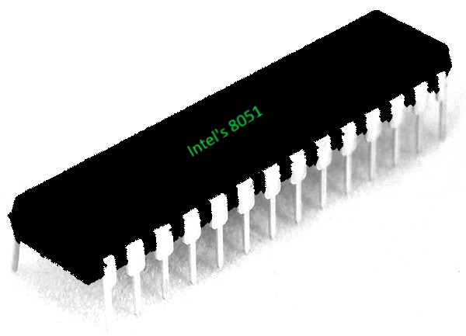

Figure – 8051 Micro-controller

System on a Chip :  
It is referred to as System on a Chip (SoC) micro-controller because it is a chip circuit/integrated circuit that holds many components of a computer together on a single chip. These components includes a CPU, memory, input output ports(I/O ports), timers and secondary storage.

Features –  
There are some key features of 8051 which works as a foundation for students to learn micro-controllers. These features include :-

4 KB on-chip ROM (Program memory).

128 bytes on-chip RAM (Data memory).

8 bit data bus (bidirectional).

16 bit address bus (unidirectional).

Two 16-bit timers.

Instruction cycle of 1 microsecond with 12 MHz crystal.

Four 8-bit ports.

128 user defined flags.

Four register banks of 8 bit each.

16-byte bit-addressable RAM.

[8051](https://www.geeksforgeeks.org/introduction-to-8051-microcontroller/) is 8-bit micro-controller with 4 KB program memory and 128 Bytes data memory. Other features include four 8-bit ports, two 16-bit timers and one on-chip serial port.

Overview of the 8051 Family :  
8051 micro-controller was initially designed by Intel Corporation in 1981. Features of 8051 made it extremely popular in market. Because of it’s popularity and high demand Intel allowed other manufacturers to fabricate and market different variants of 8051 with a condition that all these variants should be code compatible with 8051. This resulted in a lot of variants of 8051 in market, among which 8052 and 8031 are the most popular ones. Therefore, 8052 and 8031 are considered as the family members of 8051.

8052 –  
8052 is the super set of 8051 as it has all the features of 8051 with an extra timer and an extra RAM of 128 bytes. Therefore, 8052 has a total of 256 bytes of RAM and 3 timers in all. Also all the programs written for 8051 will run on 8052 as 8052 is super set of 8051, but it’s reverse is not true.

8031 –  
8031 is referred to as ROM-less micro-controller chip because it has 0 K byes of on-chip ROM. For it’s operation, 8031 requires external ROM which aids it in fetch and execute operations. Apart from this, it shares almost all the features of 8051.

Comparison of 8051 with its other family members :  
Following table highlights the main characteristics of distinction between 8051, 8052 and 8031 –

| Characteristic | 8051 | 8052 | 8031 |
| --- | --- | --- | --- |
| RAM | 128 bytes | 256 bytes | 128 bytes |
| ROM (on-chip) | 4 KB | 8 KB | 0 KB |
| Number of Timer | 2 | 3 | 2 |
| Interrupt Sources | 6 | 8 | 6 |
| Serial Port | 1 | 1 | 1 |
| Number of I/O Ports | 32 | 32 | 32 |

**PRACTICAL NO:-6**

**Aim:-** Programming of 8051 micro-controller of the C language.

**Requirement:-** Kiel_v5 Software.

**PROGRAM:-**

#include<reg51.h>

sbit sensor=P1^1;

sbit buzzer=P1^7;

void delay(unsigned int);

void main(void)

{

buzzer=0;

sensor=1;

while(1)

{

if(sensor==0)

{

buzzer=1;

delay(200);

buzzer=0;

delay(100);

}

}

}

void delay(unsigned int time)

{

unsigned int i,j;

for(i=0;i<time;i++)

for(j=0;j<1275;j++)

}

**PROCEDURE:-**

1. Click on new project under project section.

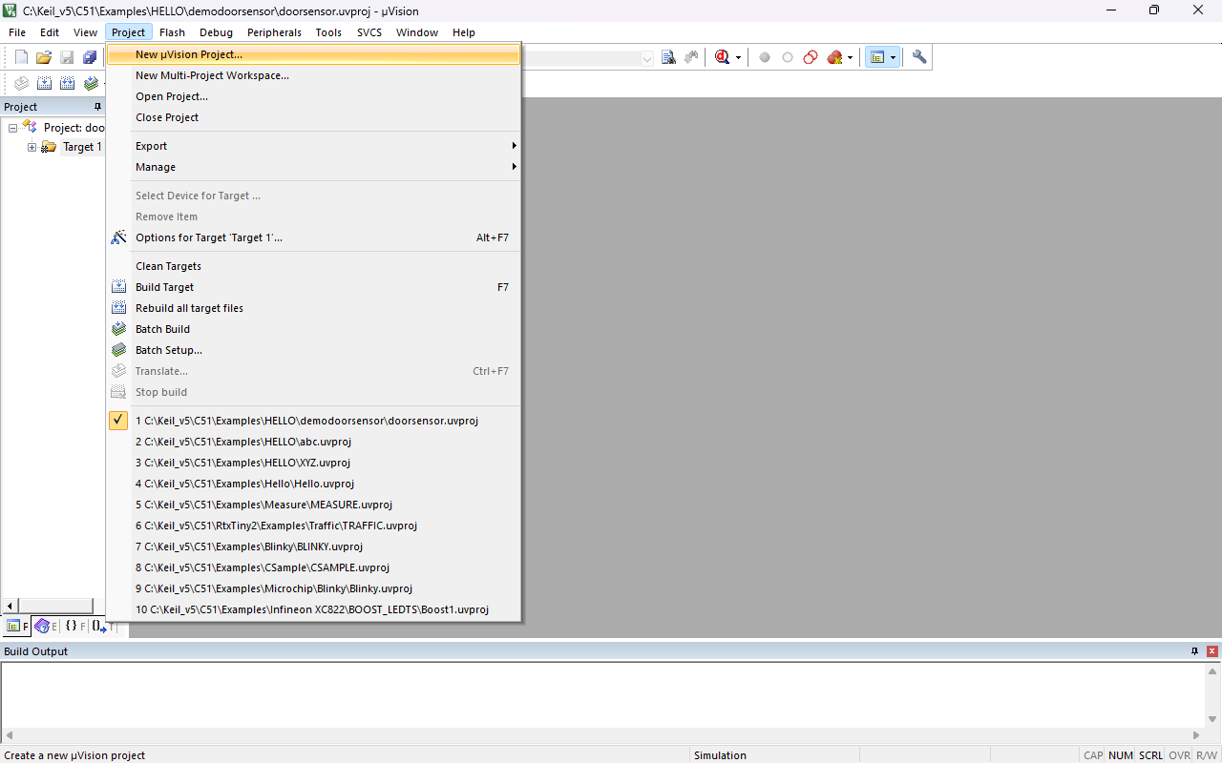

1. Give the file name and press on the save button.

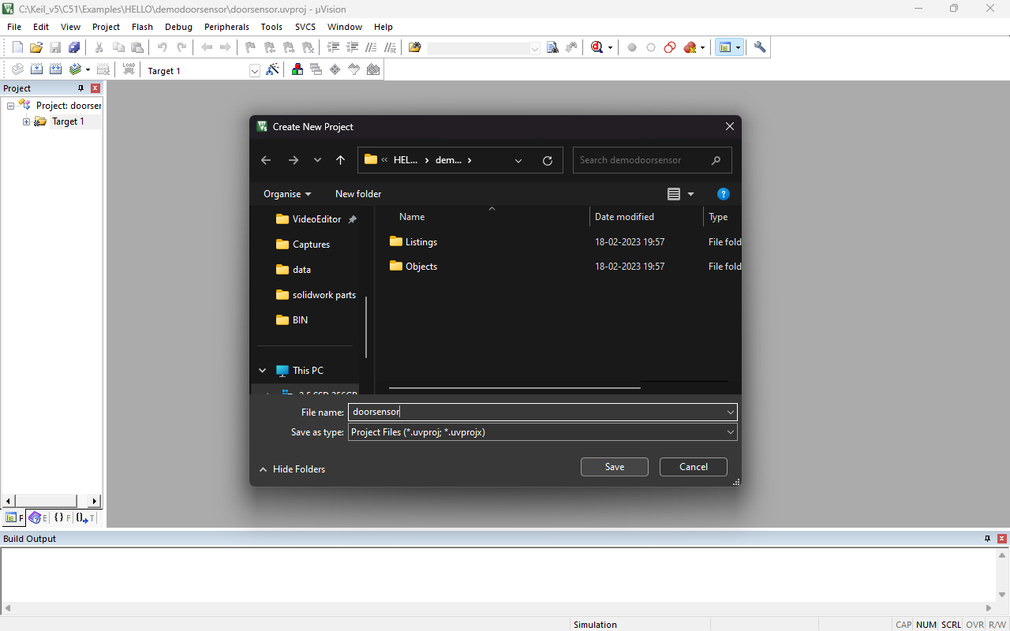

1. Under search type 8051AH this micro-controller option showing below select it and press the OK button after the Press no button.

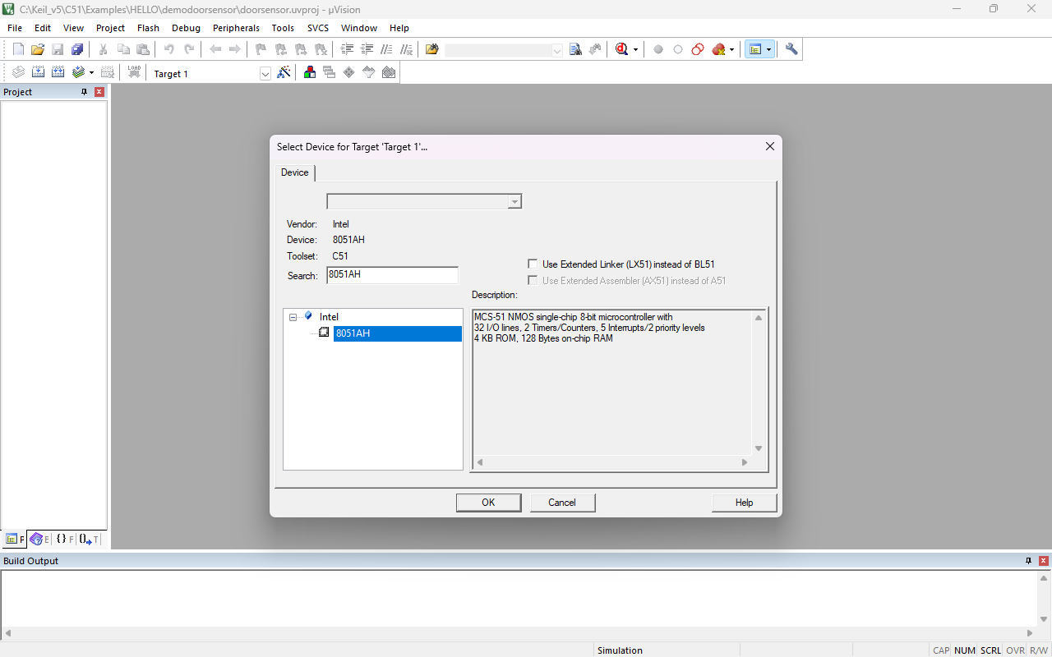

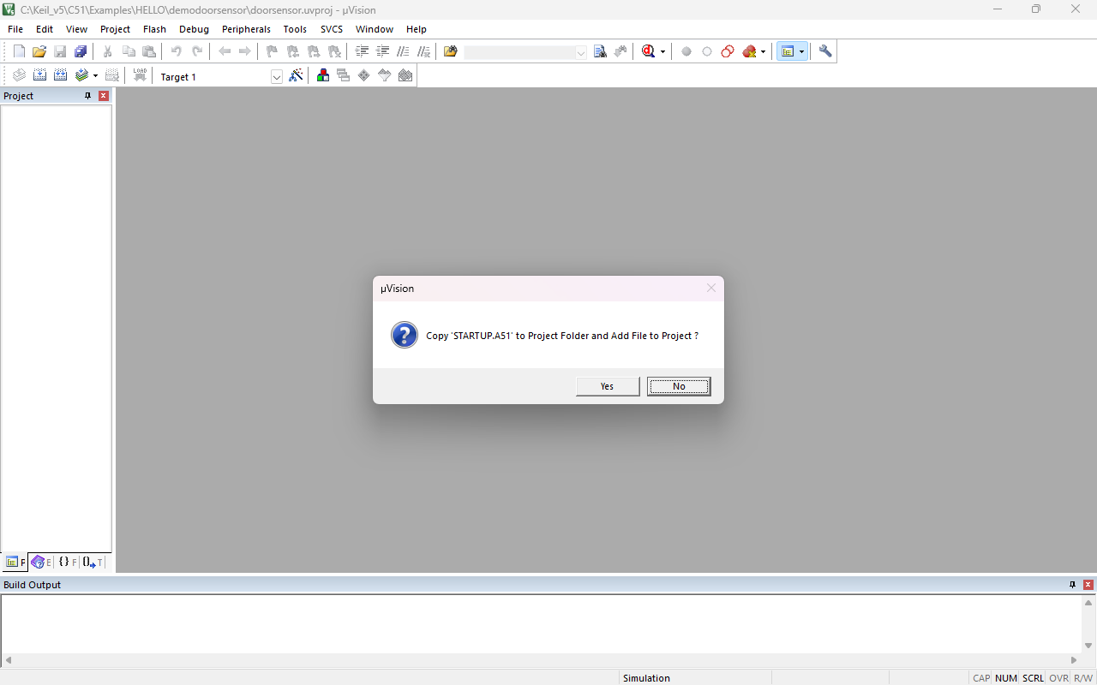

1. Press ctrl+n key for text in keil and write the c program after that press ctrl+s key and give whatever name with .c extension for saving the c language file .

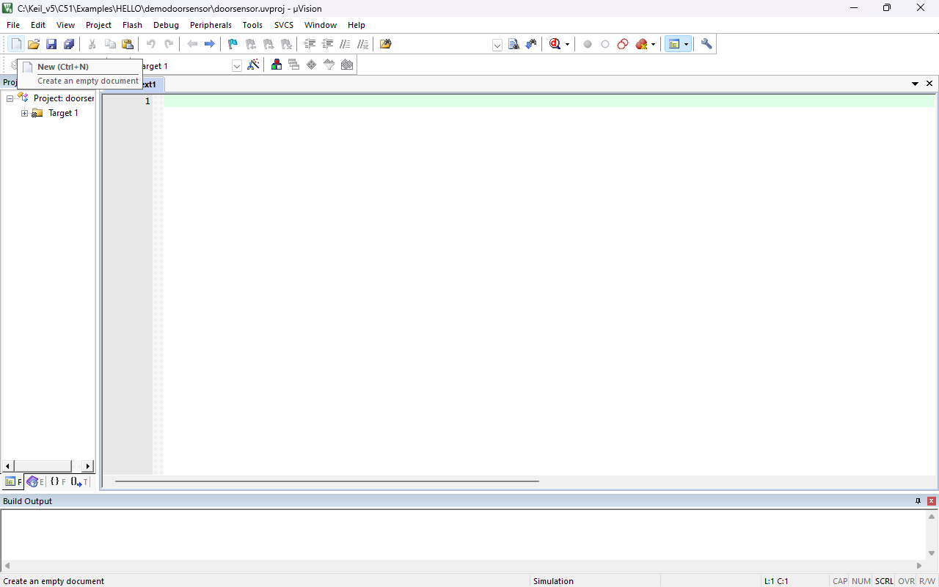

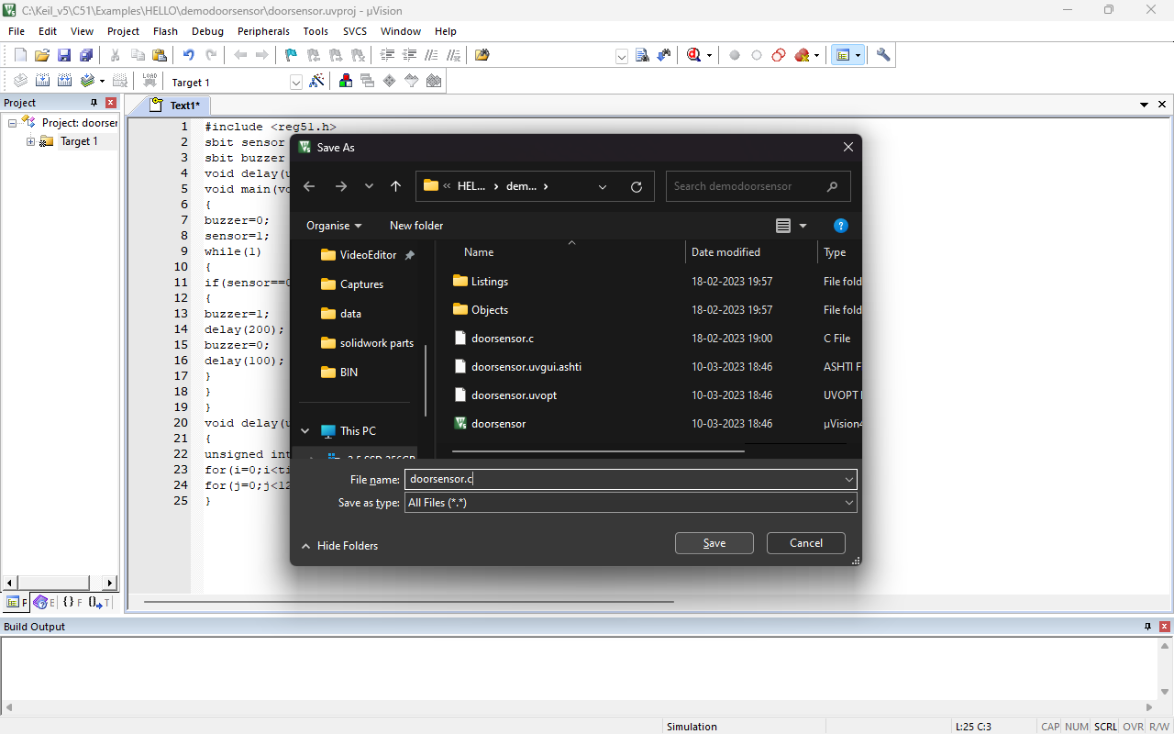

1. After saving the file double click on source under the target section and select the c language file which we are saved with .c extenstion.

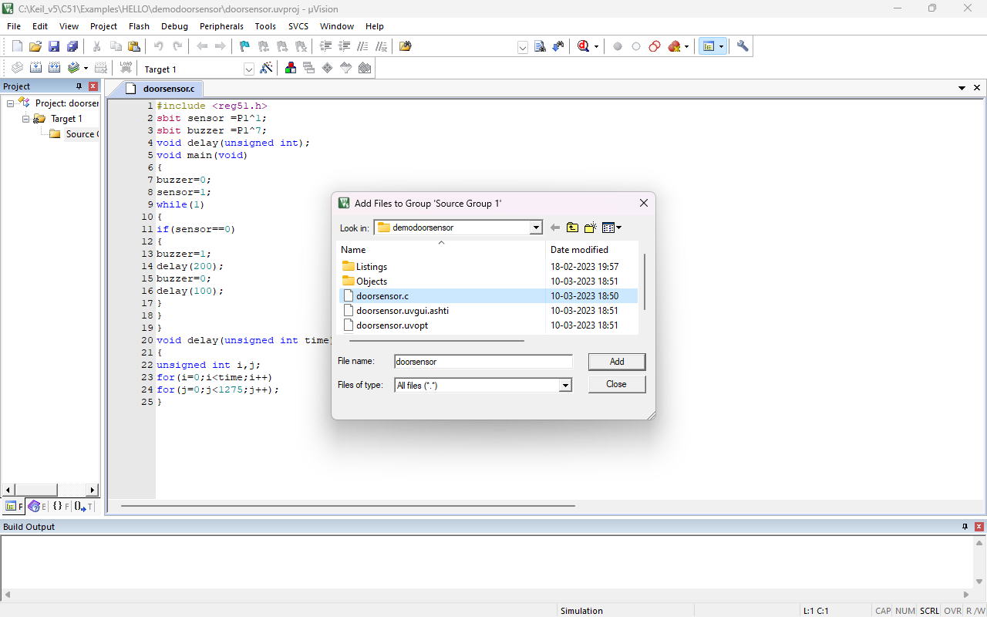

1. Now press F7 key for build the target after getting 0 error and 0 warning then right click on target there is target option click on that or you can press alt+F7 key.

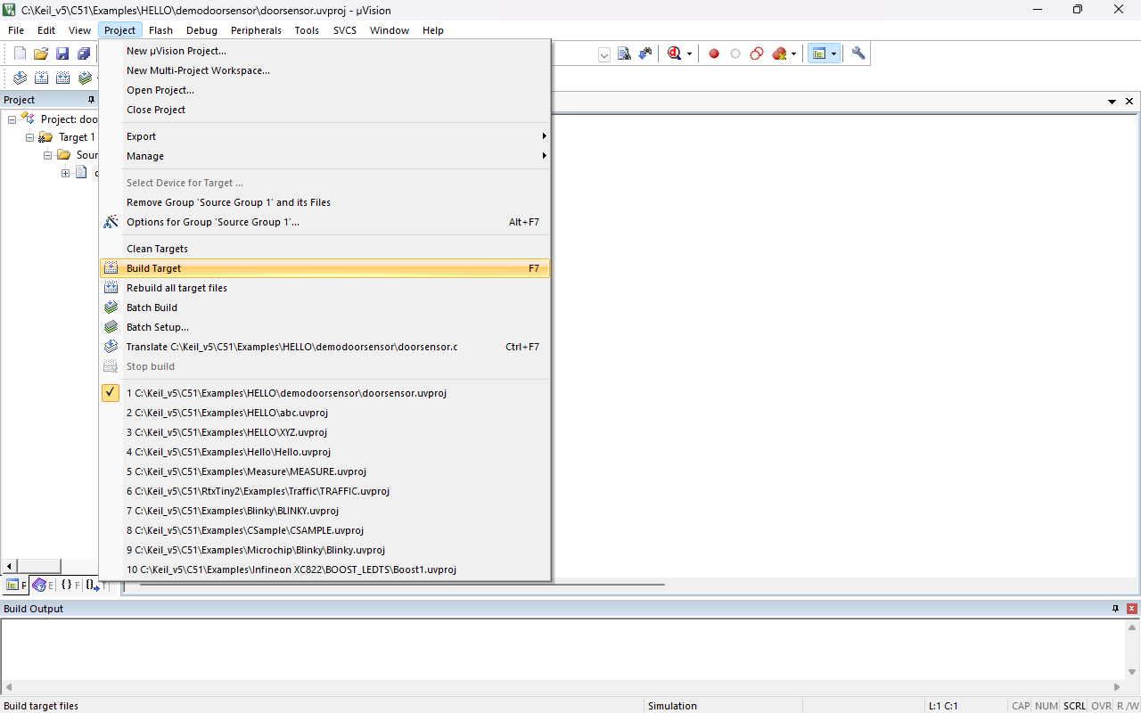

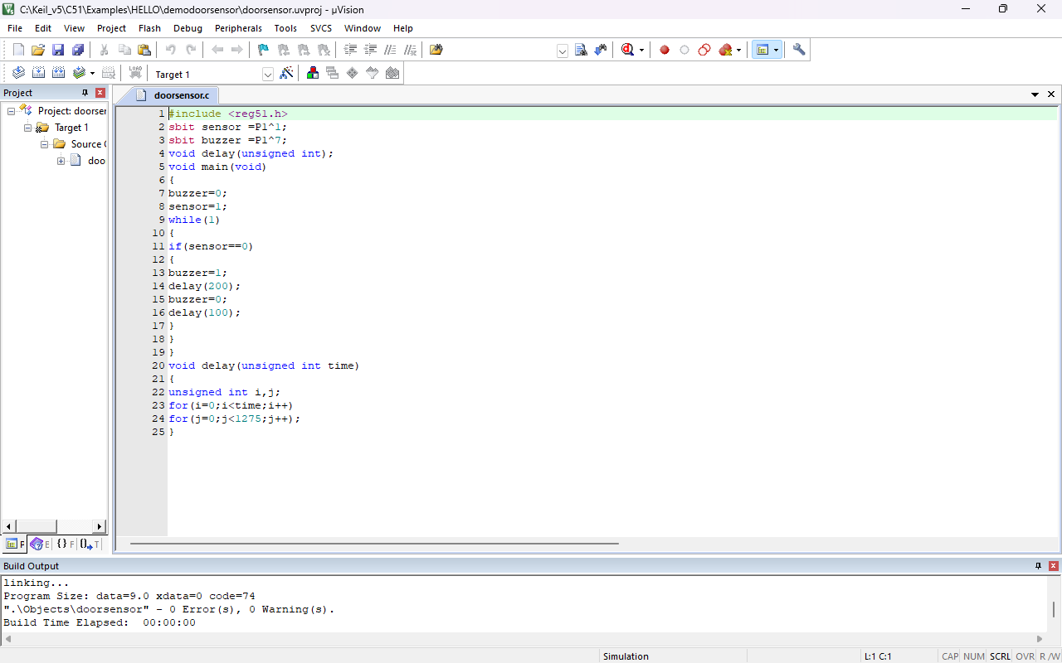

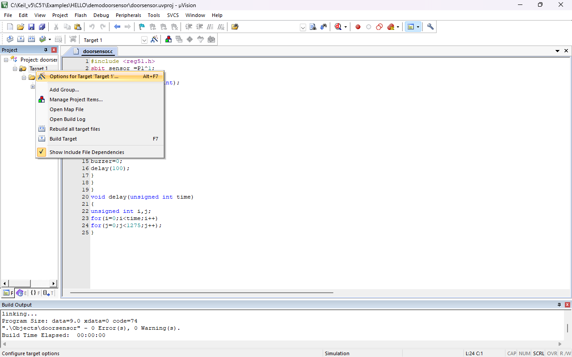

1. Click on create the hex file under the output section after that go on listing section and click on assembly code and press OK button.

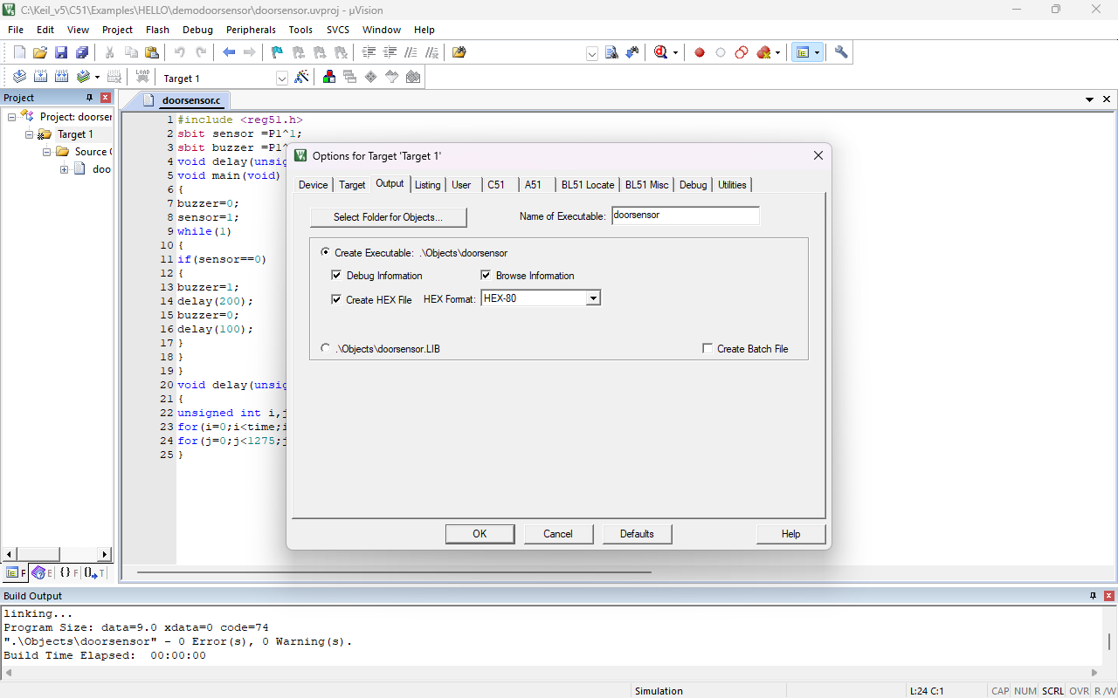

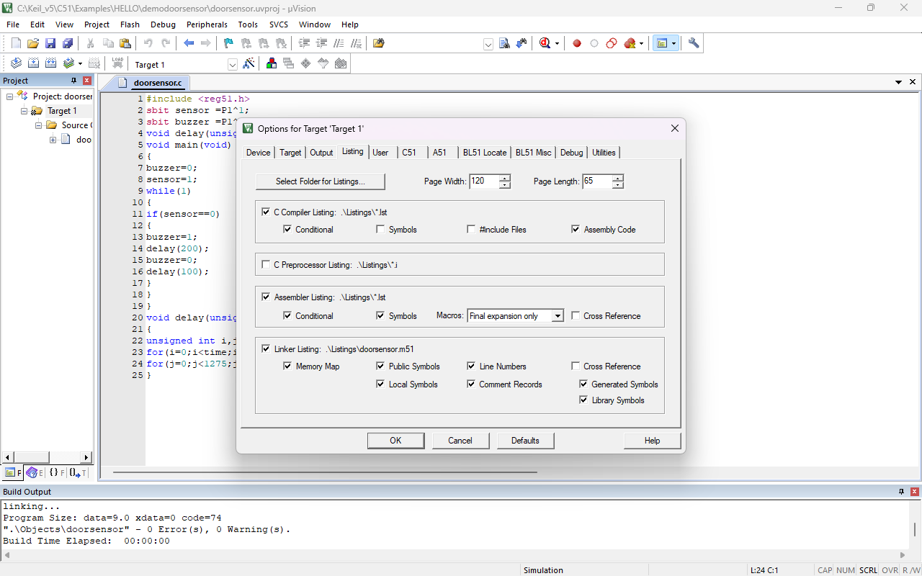

1. Now our both file is generated for checking see on top there is file location mention go on that location in file location.
2. HEX file is under object folder and m51 file is under listings folder.

**OUTPUT:-**

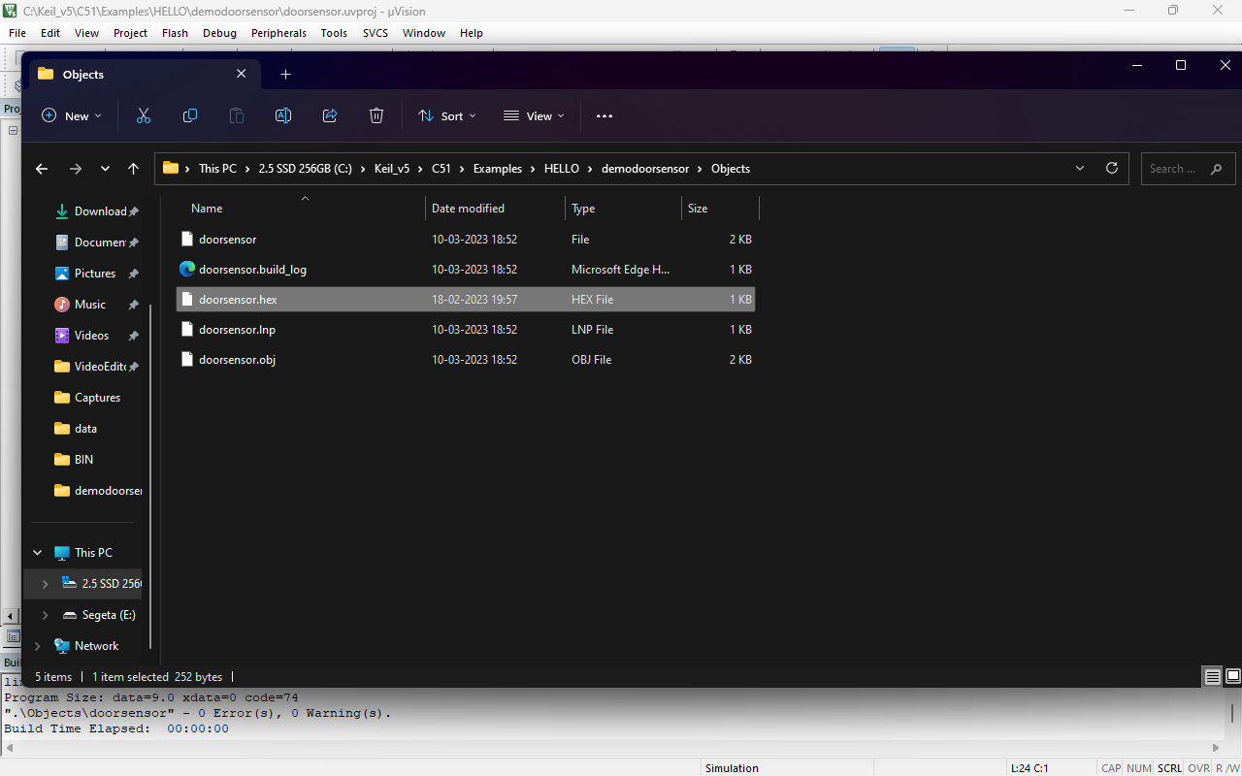

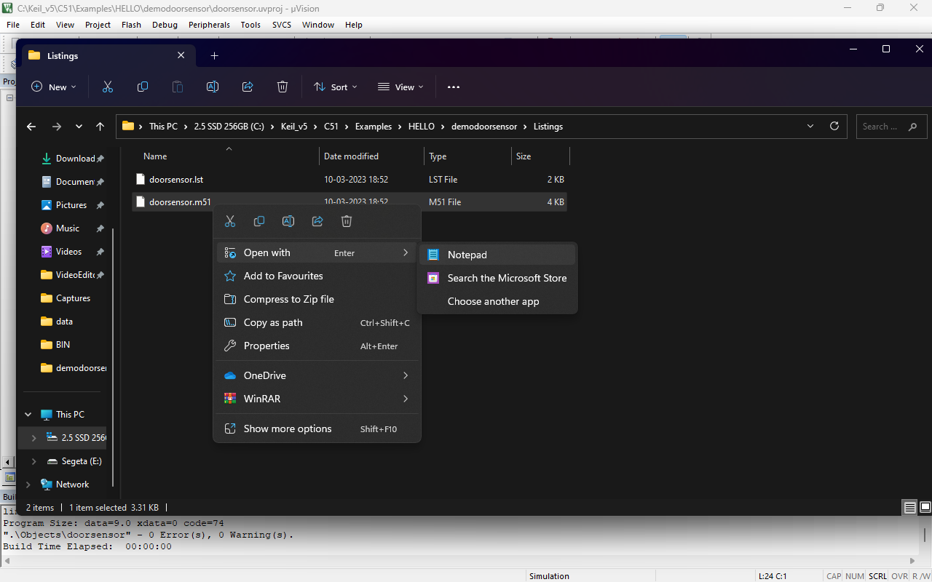

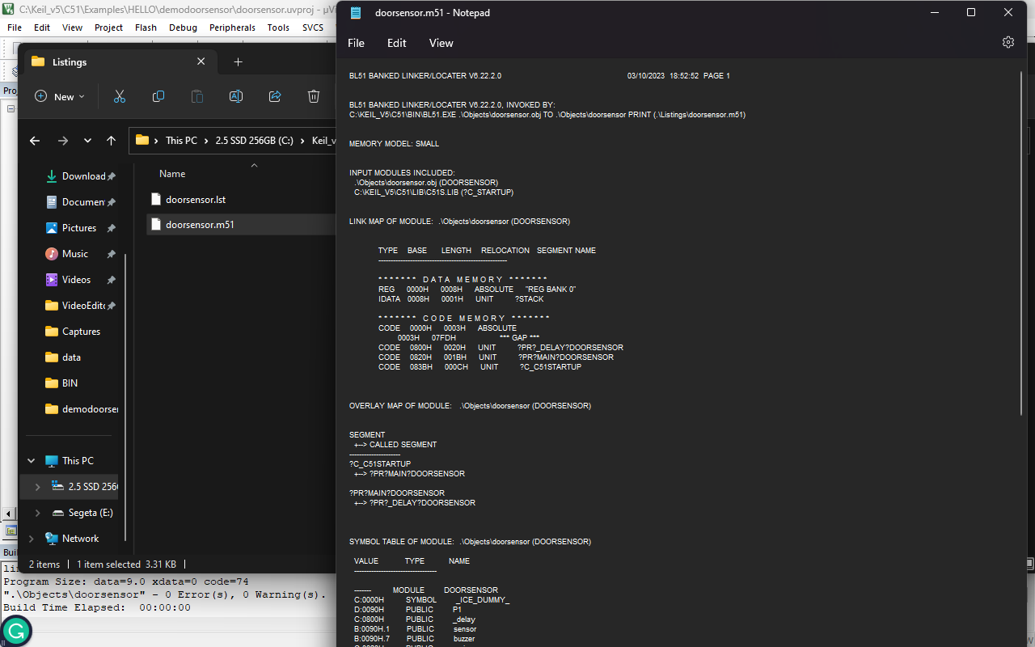

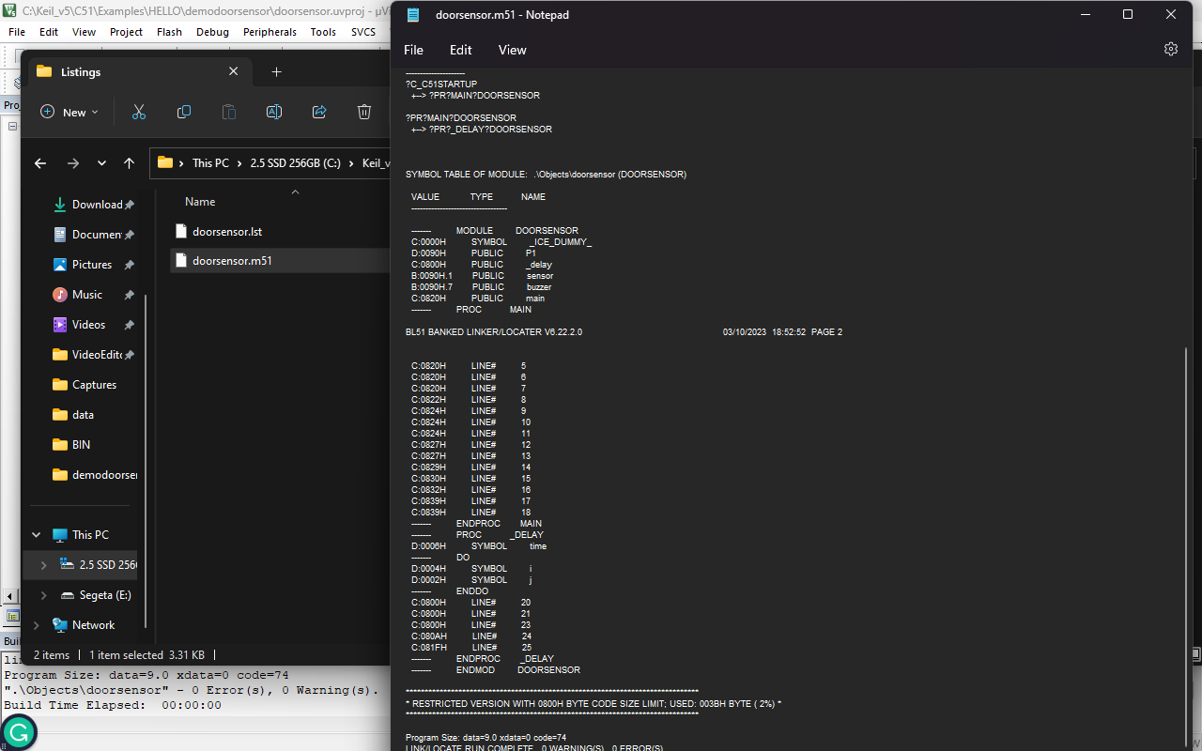

**CONCLUSION:-**

Hence Programming of 8051 micro-controller of the C language is done in keil v5 software also it’s hex file is generated .

**PRACTICAL NO:-7**

**Aim:-** To write a program in C for blinking led for 8051 micro-controller.

**Requirement:-** Kiel_v5 Software.

**PROGRAM:-**

#include<reg51.h>

sbit LED=P2^0;

void DELAY_ms(unsigned int ms_Count)

{

unsigned int i,j;

for(i=0;i<ms_Count;i++)

{

for(j=0;j<100;j++);

}

}

int main()

{

while(1)

{

LED=1;/*Turn ON the LED connected to P2.0 */

DELAY_ms(500);

LED=0;/*Turn OFF the LED connected to P2.0 */

DELAY_ms(500);

}

}

**PROCEDURE:-**

1. Click on new project under project section.
2. Give the file name and press on the save button.
3. Under search type 8051AH this micro-controller option showing below select it and press the OK button after the Press no button.
4. Press ctrl+n key for text in keil and write the c program after that press ctrl+s key and give whatever name with .c extension for saving the c language file .
5. After saving the file double click on source under the target section and select the c language file which we are saved with .c extenstion.
6. Now press F7 key for build the target after getting 0 error and 0 warning.
7. Now press key ctrl+5 for debugging, press OK button after that click on port 2 which is under io-ports and this io-ports is under peripheral section.

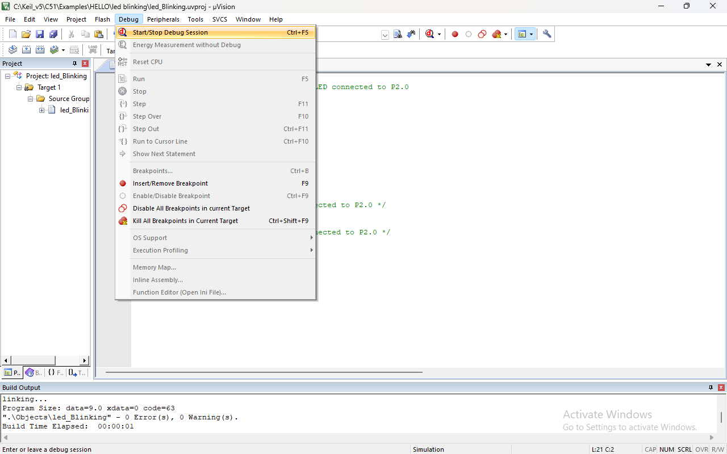

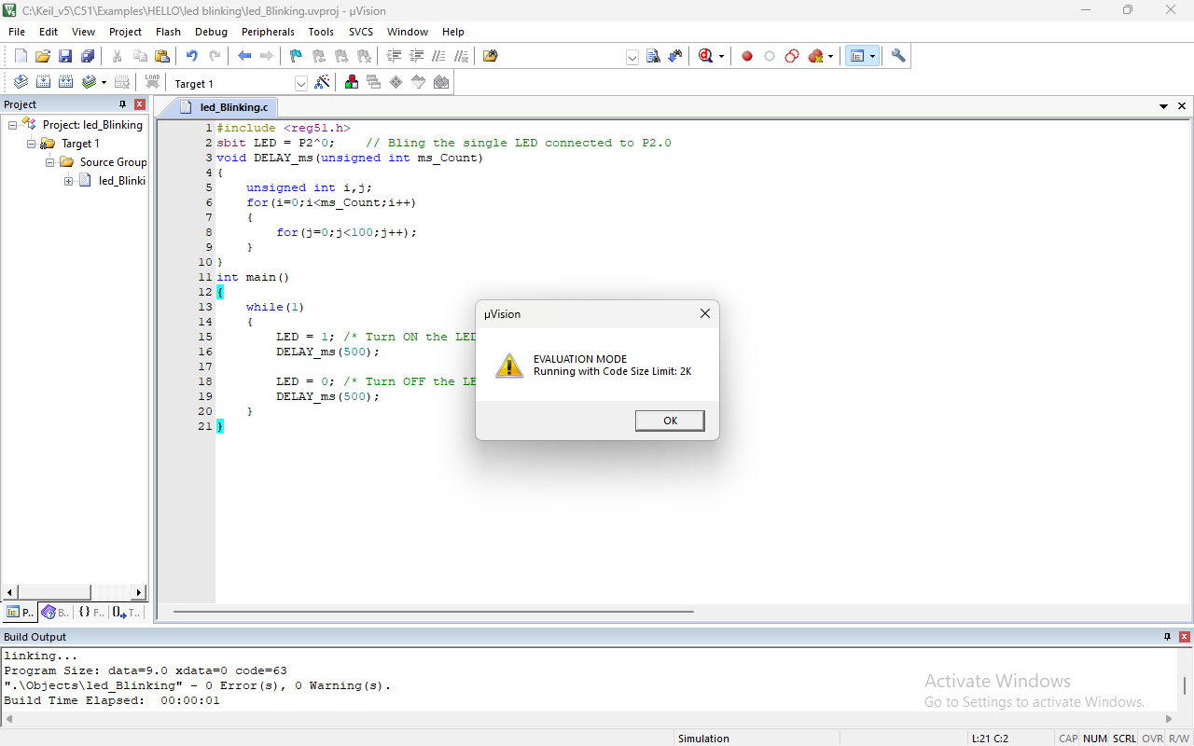

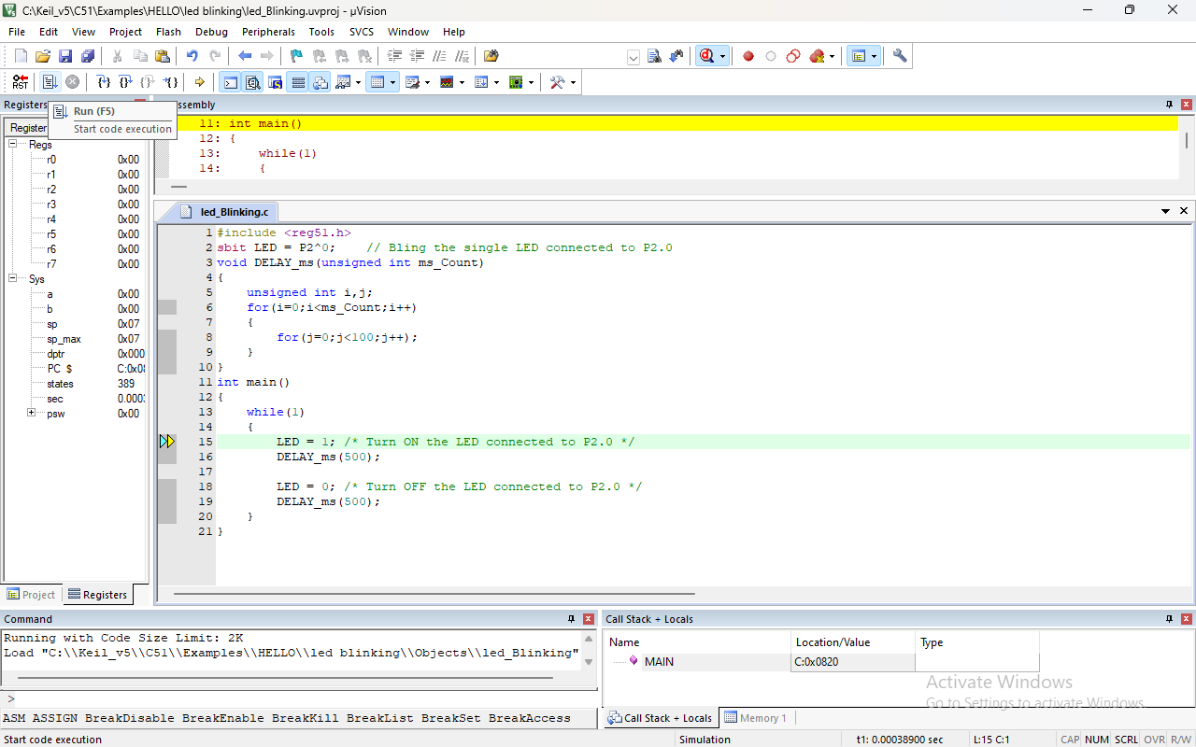

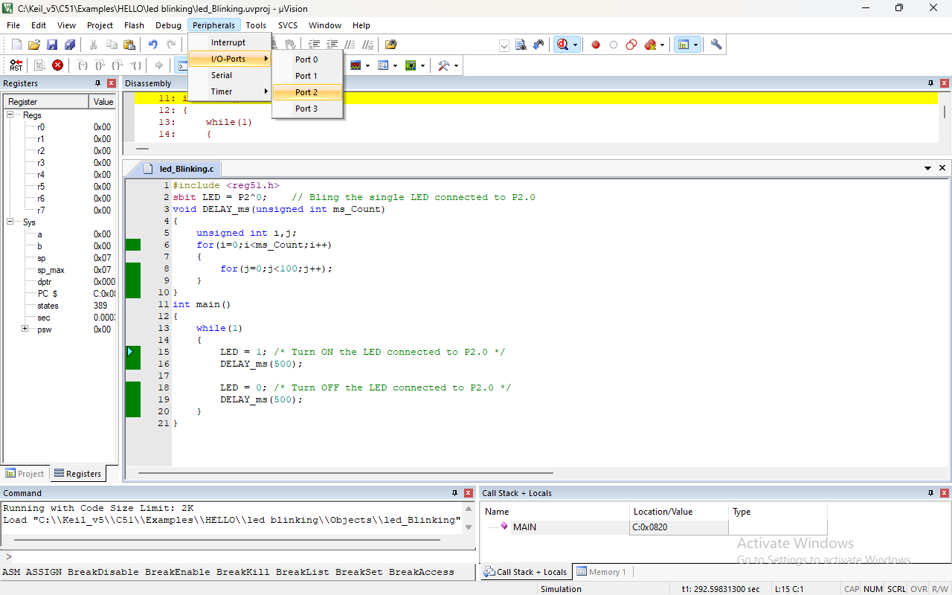

1. Check c program is working fine after that stop debugging press ctrl+5 key and then right click on target there is target option click on that or you can press alt+F7 key.

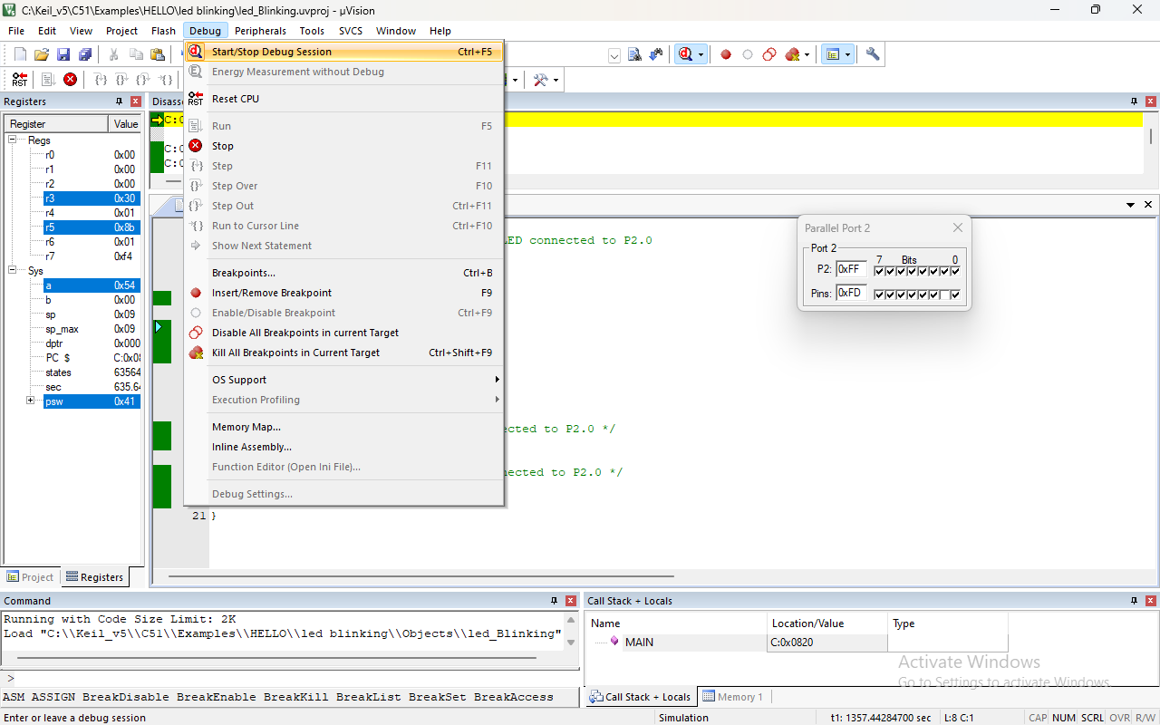

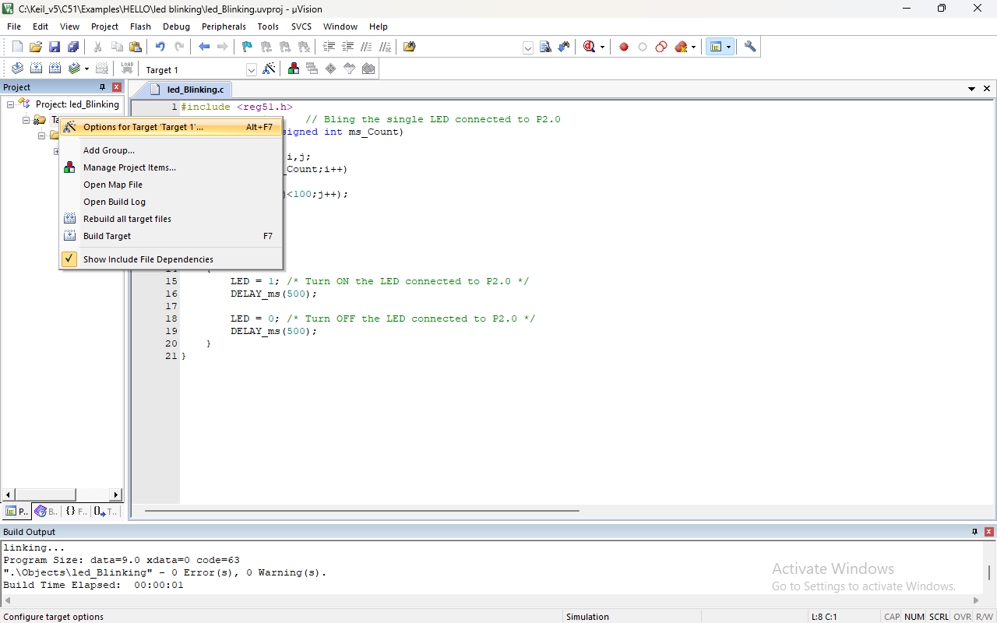

1. Click on create the hex file under the output section after that go on listing section and click on assembly code and press OK button.
2. Once again build the target for generated the HEX file.
3. Now our both file is generated for checking see on top there is file location mention go on that location in file location.
4. HEX file is under object folder and m51 file is under listings folder.

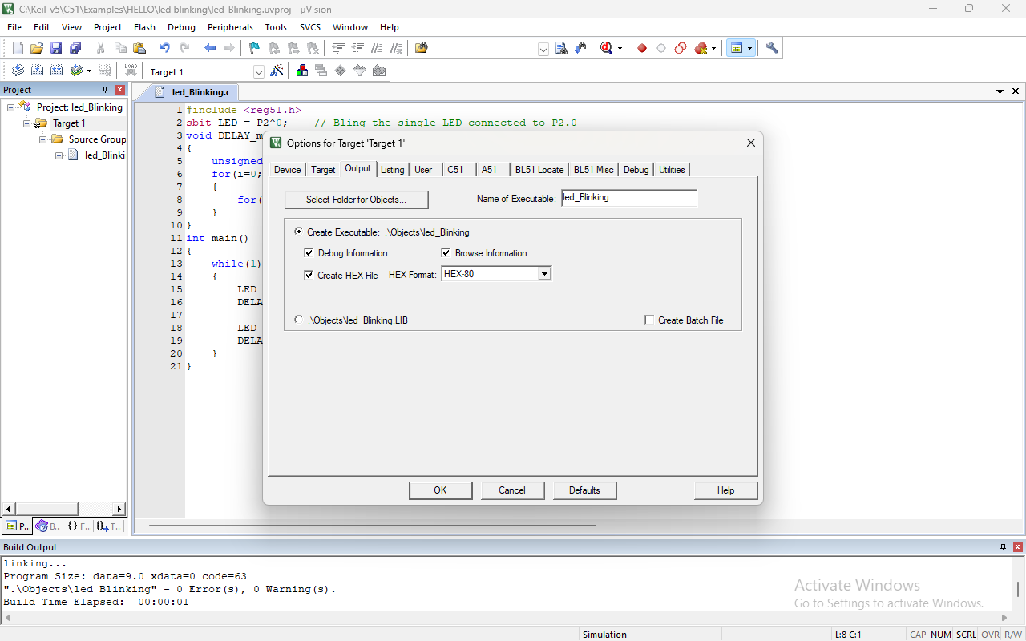

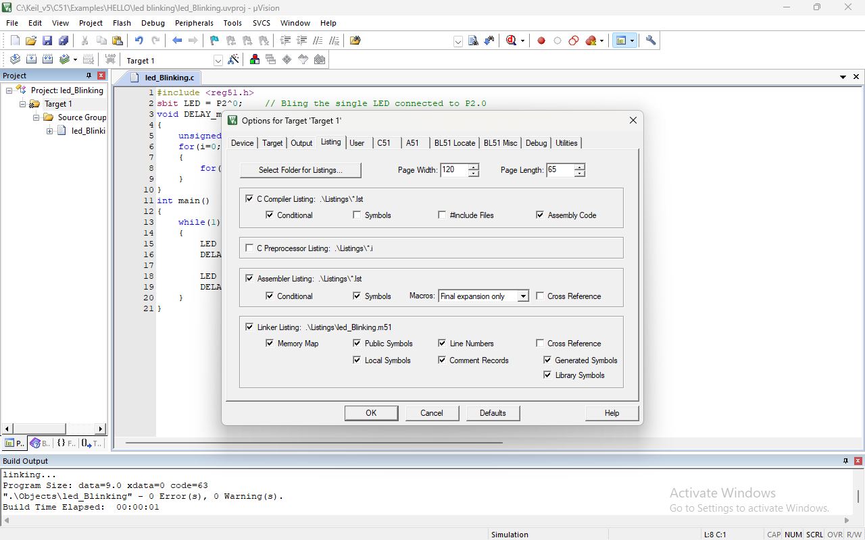

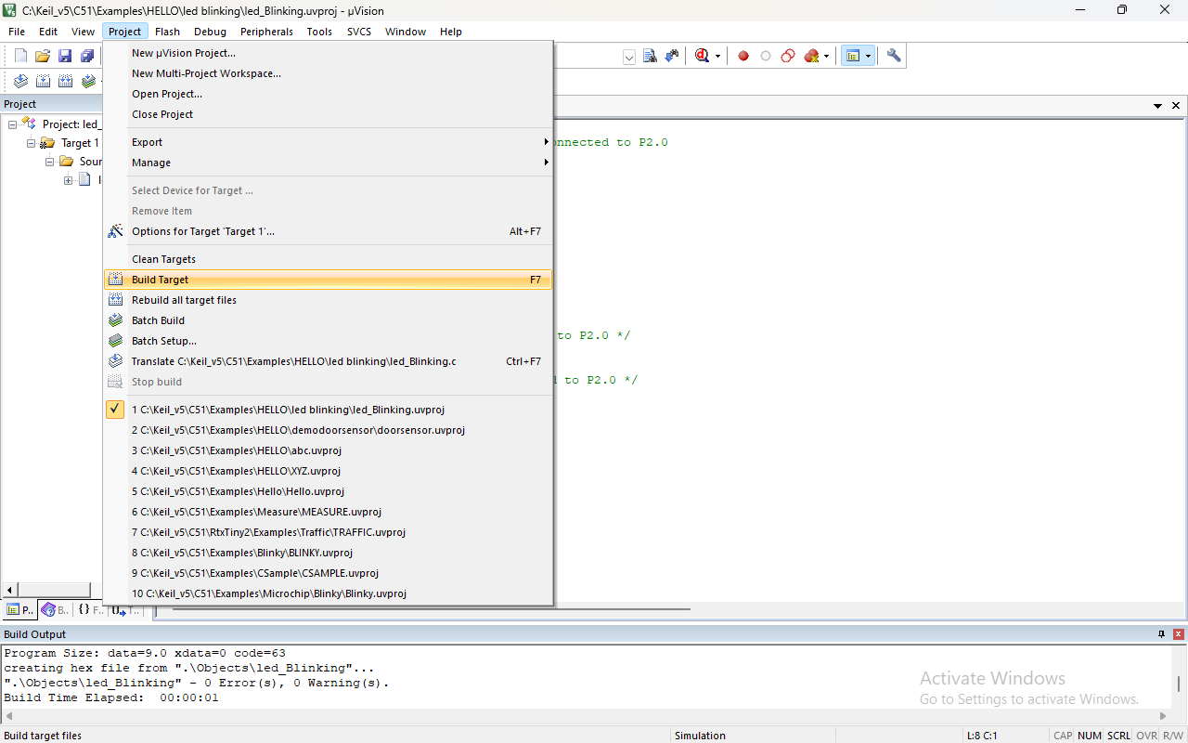

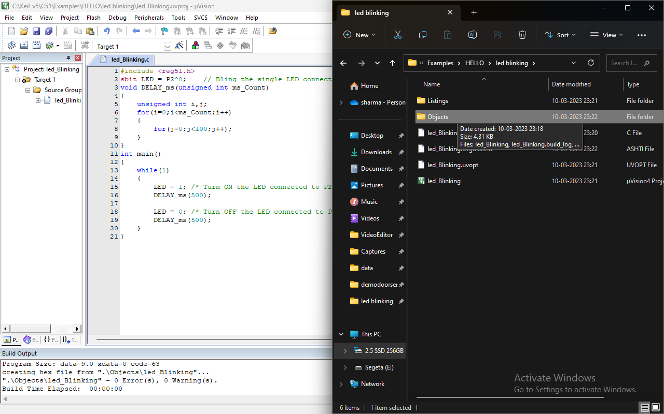

**OUTPUT:-**

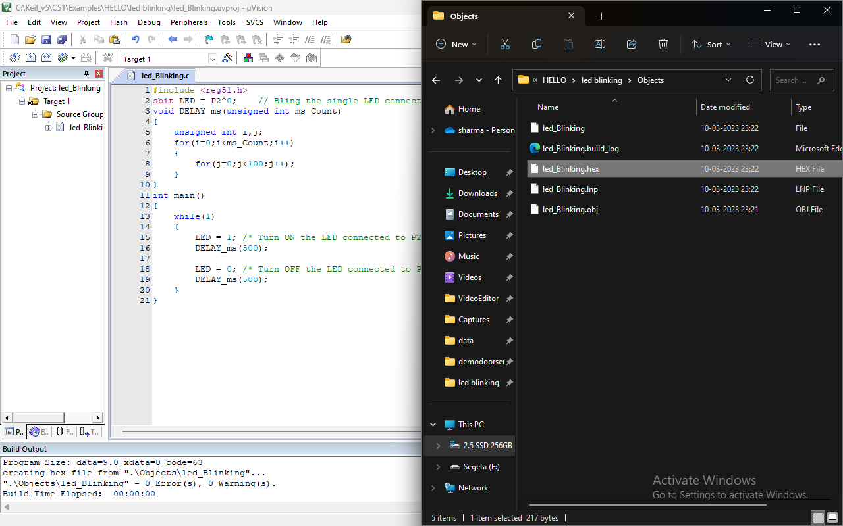

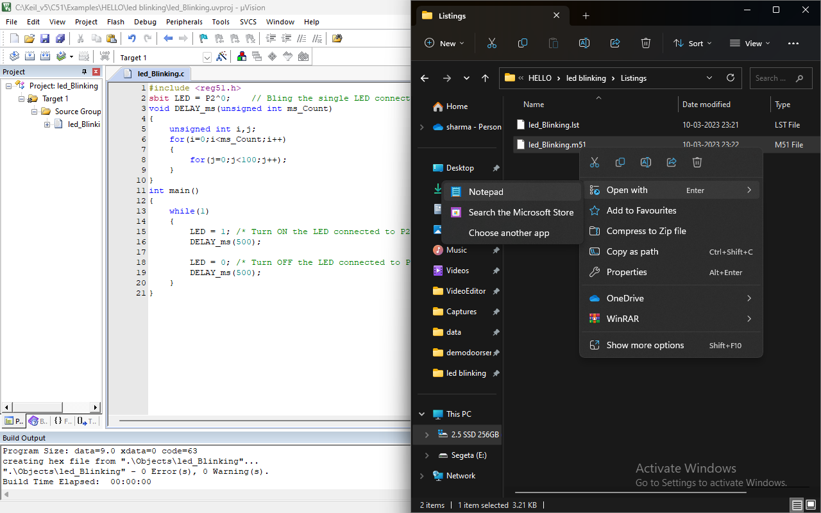

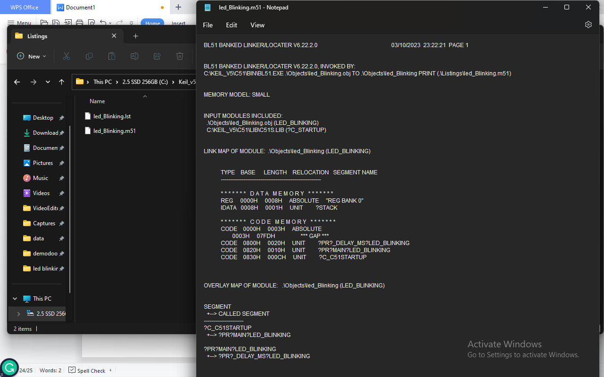

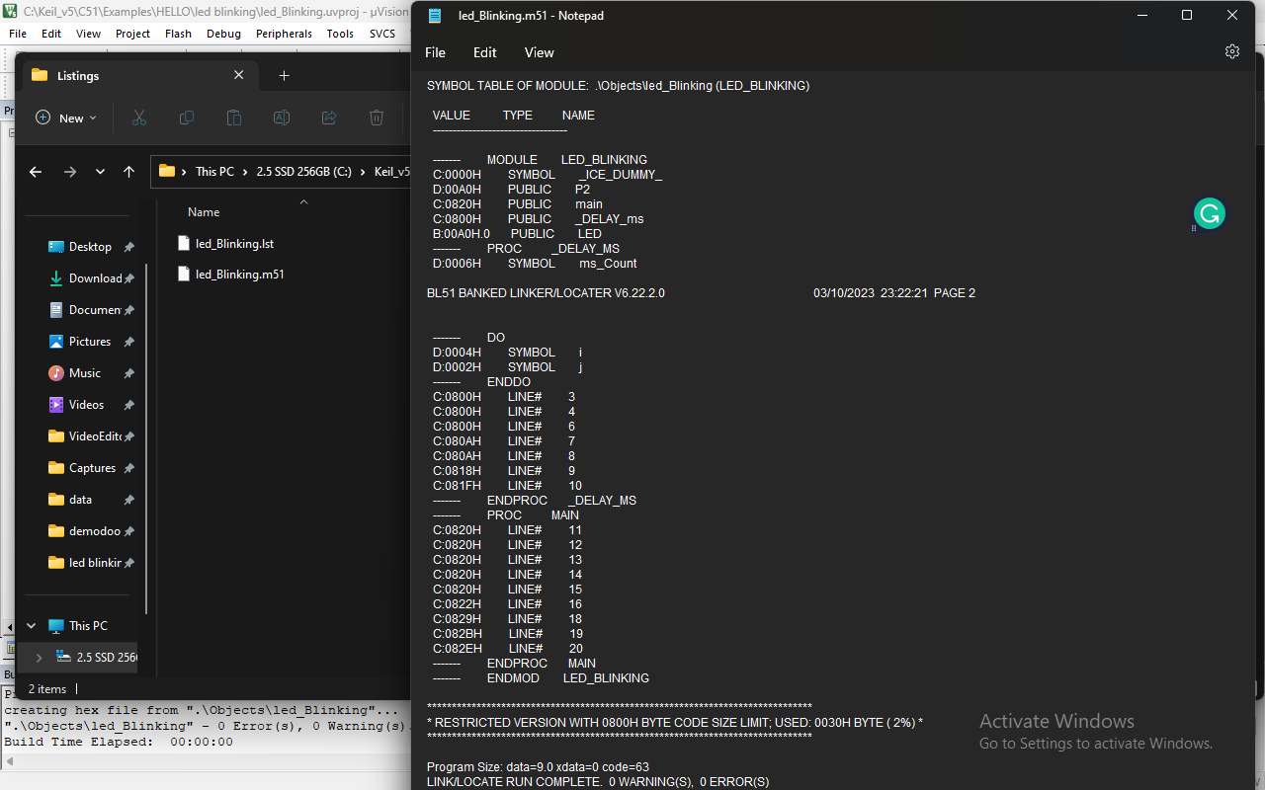

**CONCLUSION:-**

Hence c language programming and debugging is done in keil v5 software also it’s hex file is generated .

**PRACTICAL NO:-8**

**Aim:-**To design a key switch and LED circuit using 895c1 micro-controller in embedded c.

**Requirement:-** Kiel_v5 Software and Proteus 8.8 Professional Software .

**Theory:-** The Proteus Design Suite is a proprietary software tool suite used primarily for electronic design automation. The software is used mainly by electronic design engineers and technicians to create schematics and electronic prints for manufacturing printed circuit boards

**PROGRAM:-**

#include<stdio.h>

#include<reg51.h>

sbit sw1=P1^0;

sbit sw2=P1^1;

sbit led1=P2^0;

sbit led2=P2^1;

void main()

{

P1=0x00;

P2=0x00;

while(1)

{

if((sw1==1)&&(sw2==0))

{

led1=1;

led2=0;

}

if((sw1==0)&&(sw2==1))

{

led1=0;

led2=1;

}

if((sw1==1)&&(sw2==1))

{

led1=1;

led2=1;

}

if((sw1==0)&&(sw2==0))

led1=0;

led2=0;

}

}

}

**Flowchart:-**

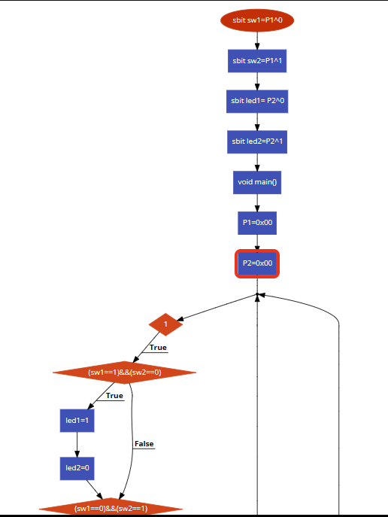

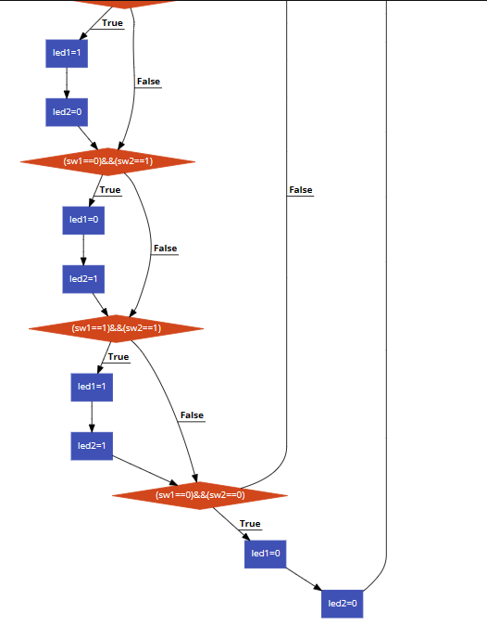

**PROCEDURE:-**

1. Click on new project under project section.

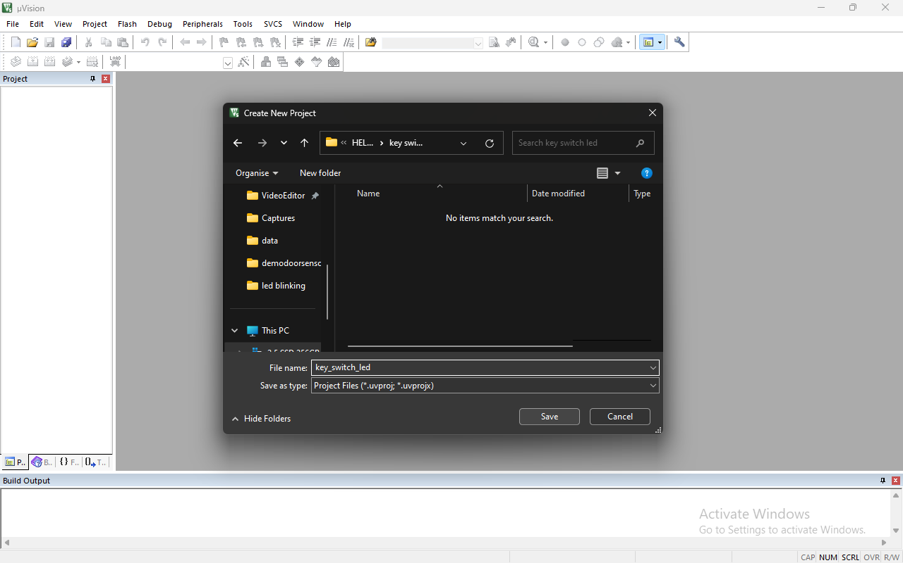

1. Give the file name and press on the save button.
2. Under search type AT89C51 this micro-controller option showing below select it and press the OK button after the Press no button.

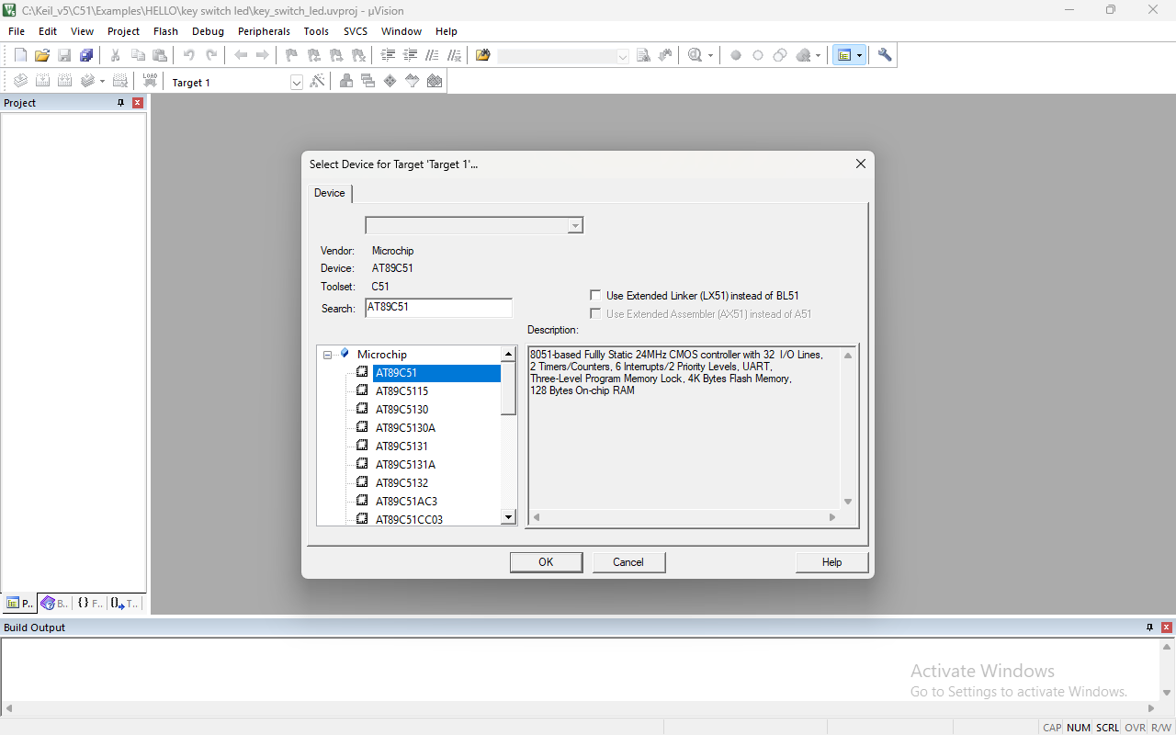

1. Press ctrl+n key for text in keil and write the c program after that press ctrl+s key and give whatever name with .c extension for saving the c language file .
2. After saving the file double click on source under the target section and select the c language file which we are saved with .c extenstion.

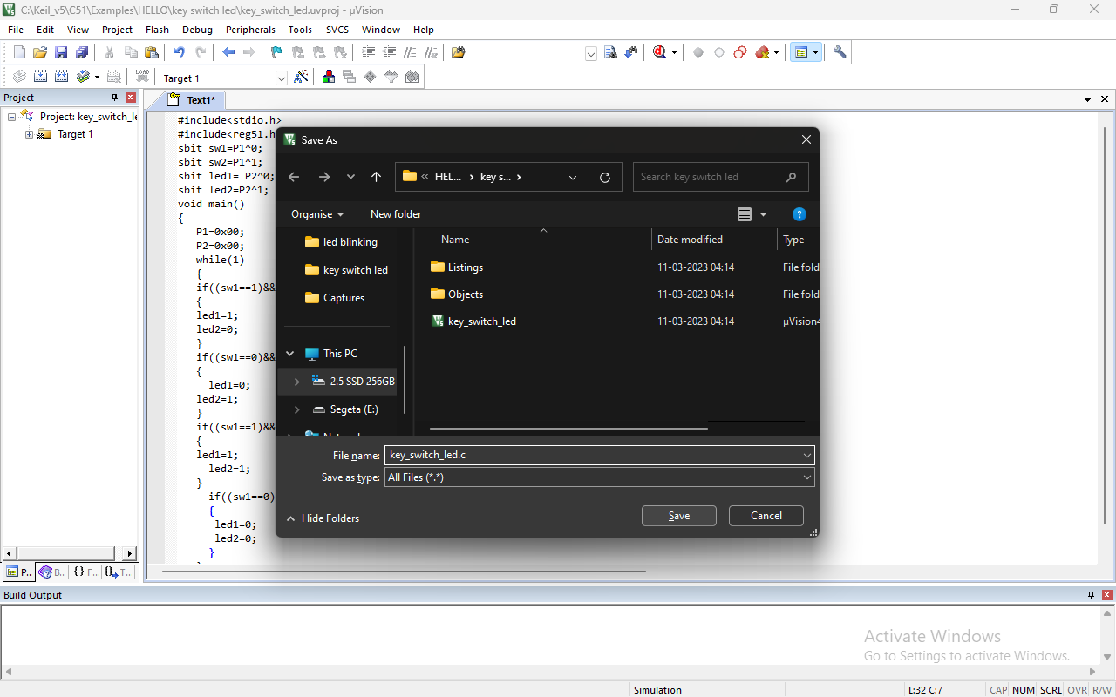

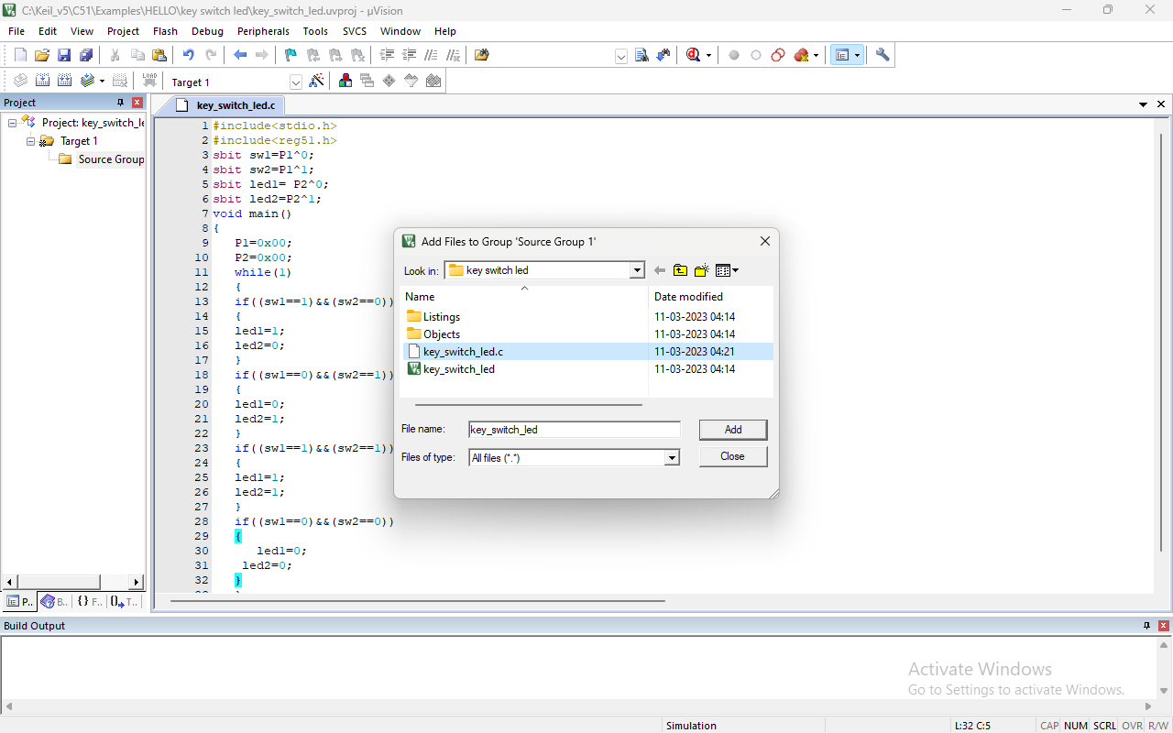

1. Now press F7 key for build the target after getting 0 error and 0 warning then right click on target there is target option click on that or you can press alt+F7key. 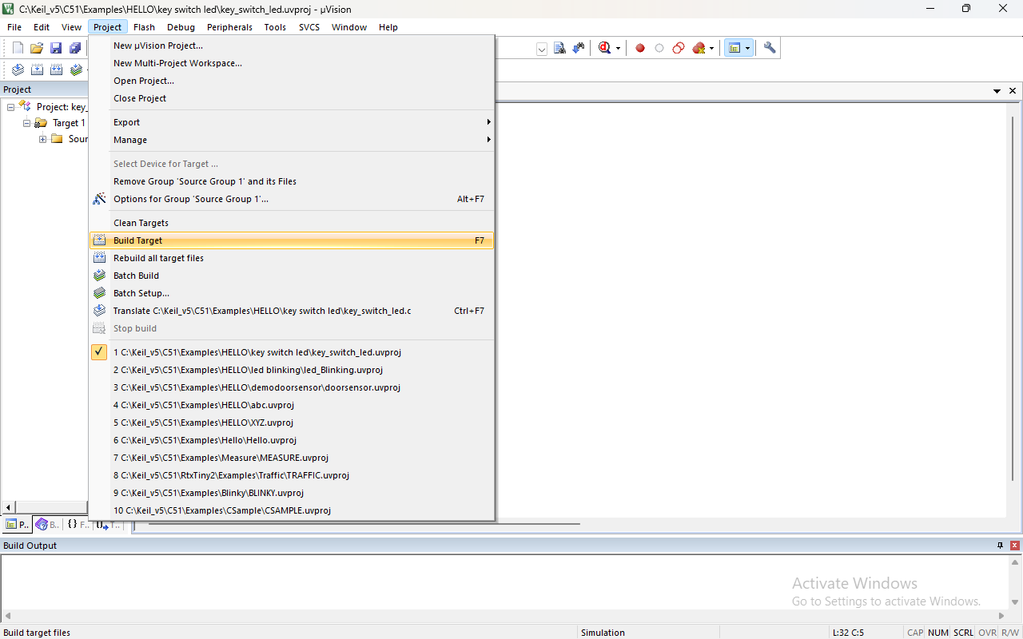

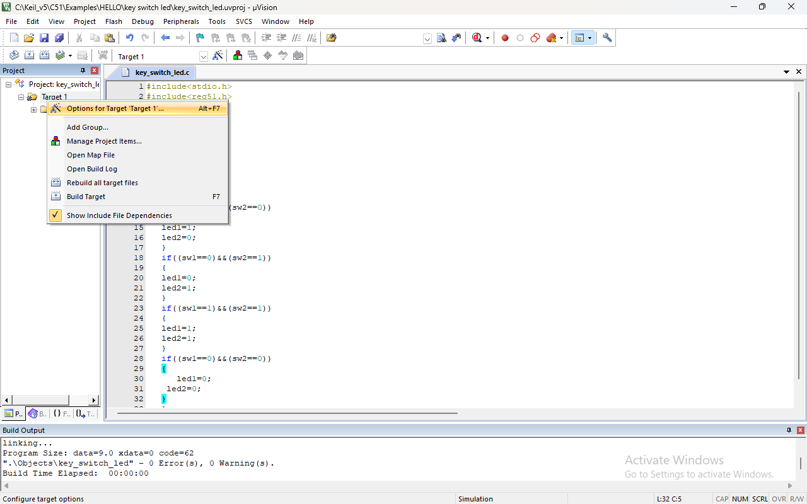

1. Click on create the hex file under the output section after that go on listing section and click on assembly code and press OK button.
2. Once again build the target for HEX file.
3. Now our both file is generated for checking see on top there is file location mention go on that location in file location.
4. HEX file is under object folder and m51 file is under listings folder.

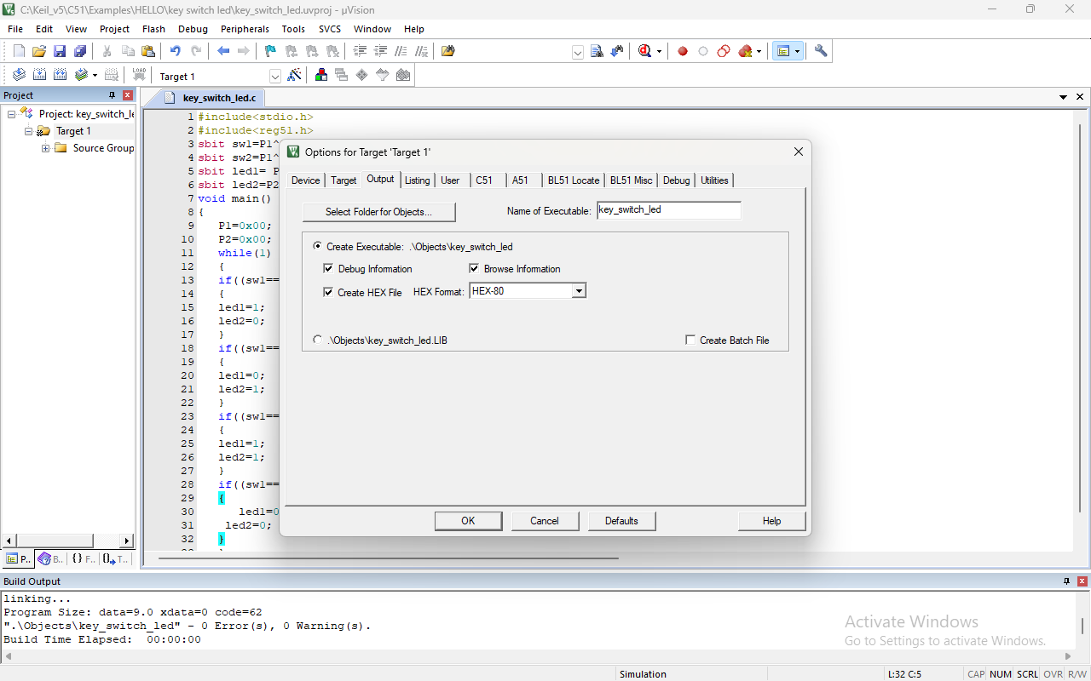

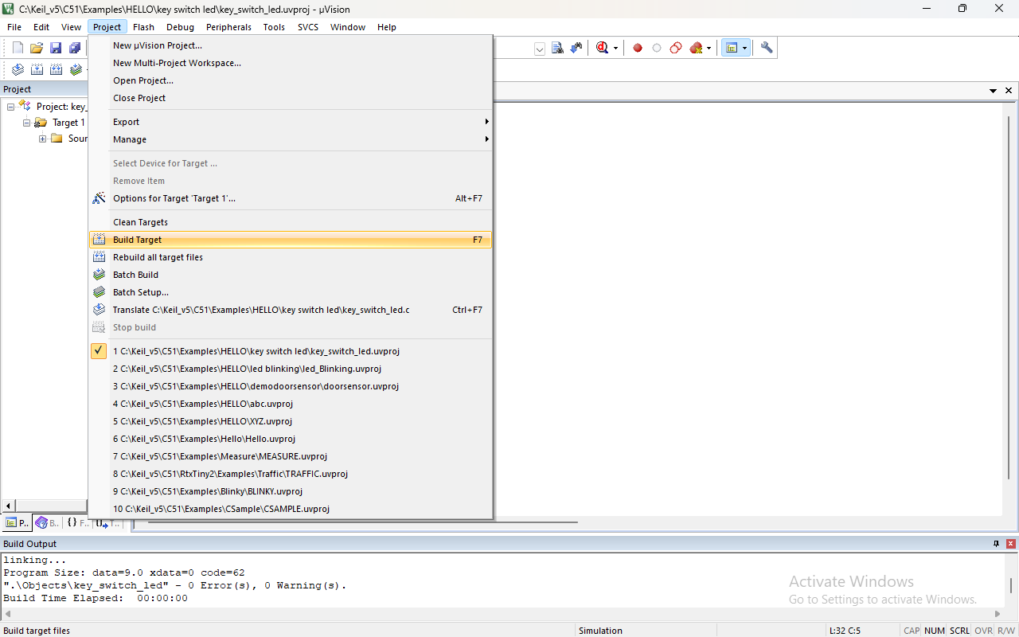

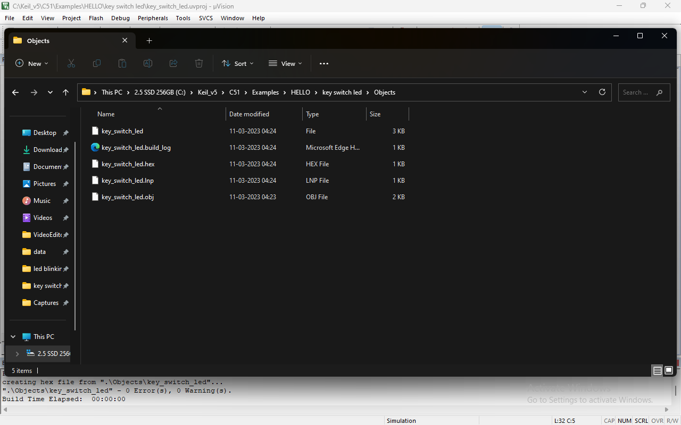

1. Open the proteus software and click on new project, after that just press on next next until you see the finish click on finish.
2. After that you see the **P** and **L** under the device section click on **P** for select the **AT89C51, BUTTON, RED LED.**

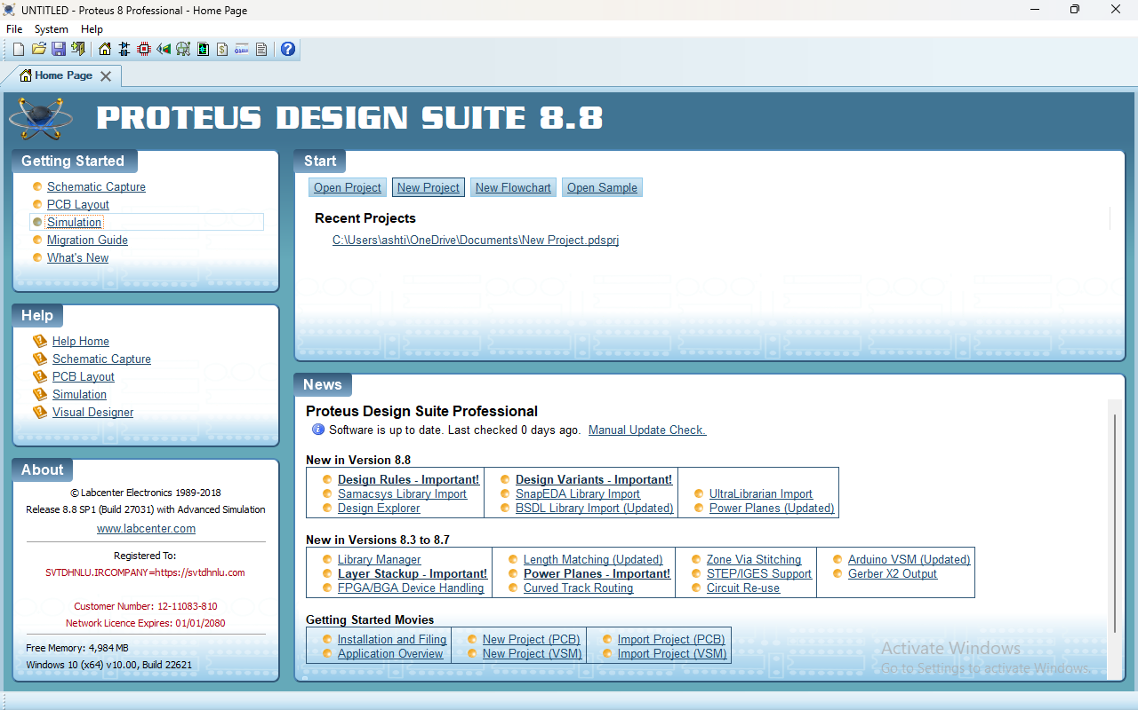

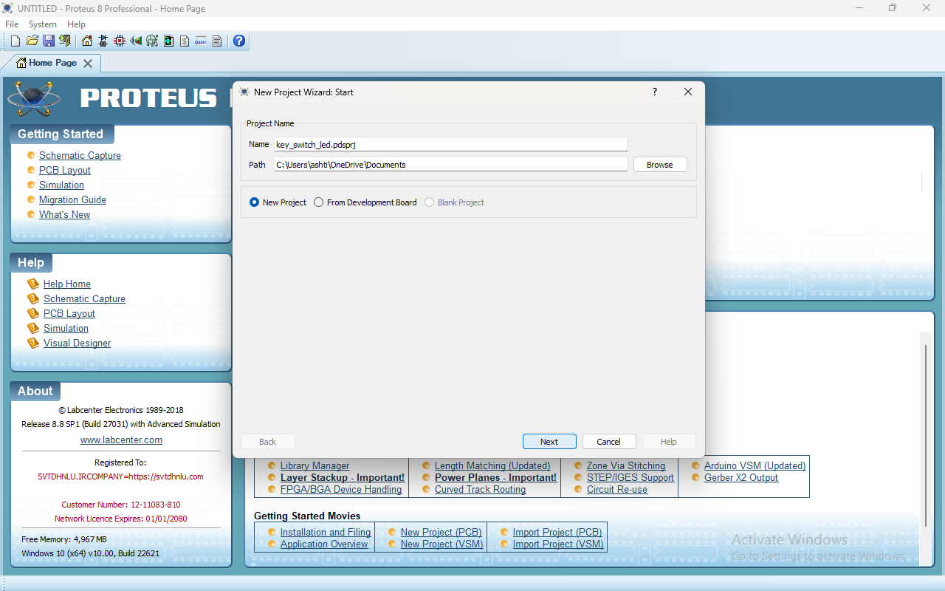

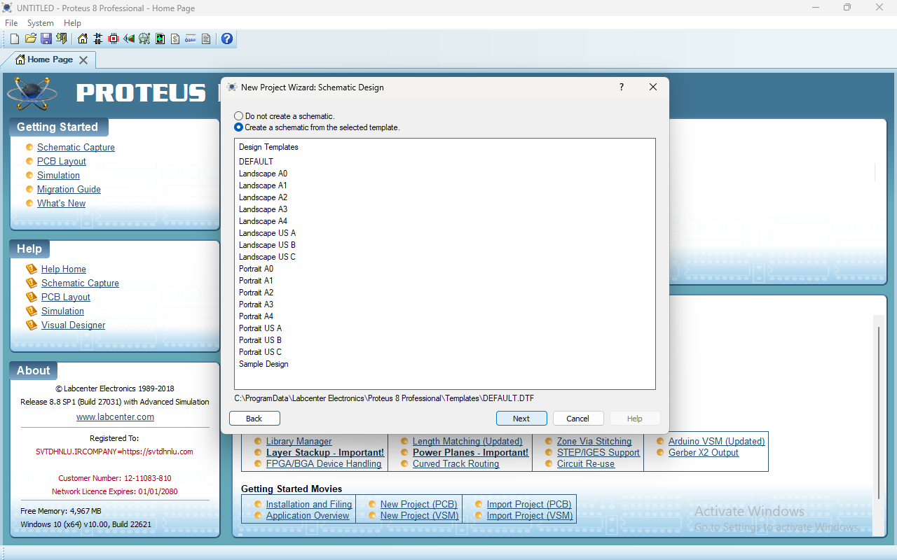

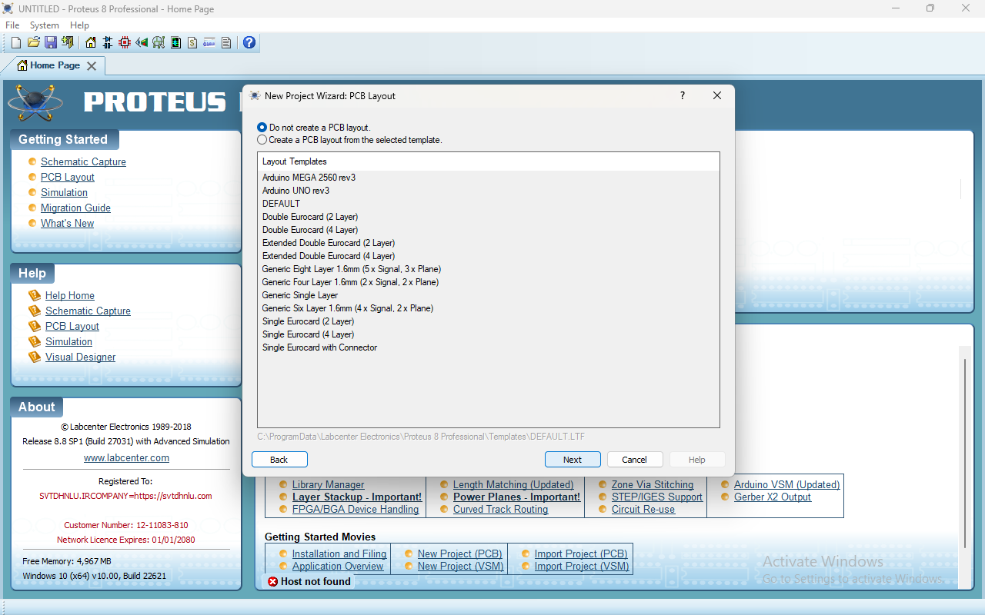

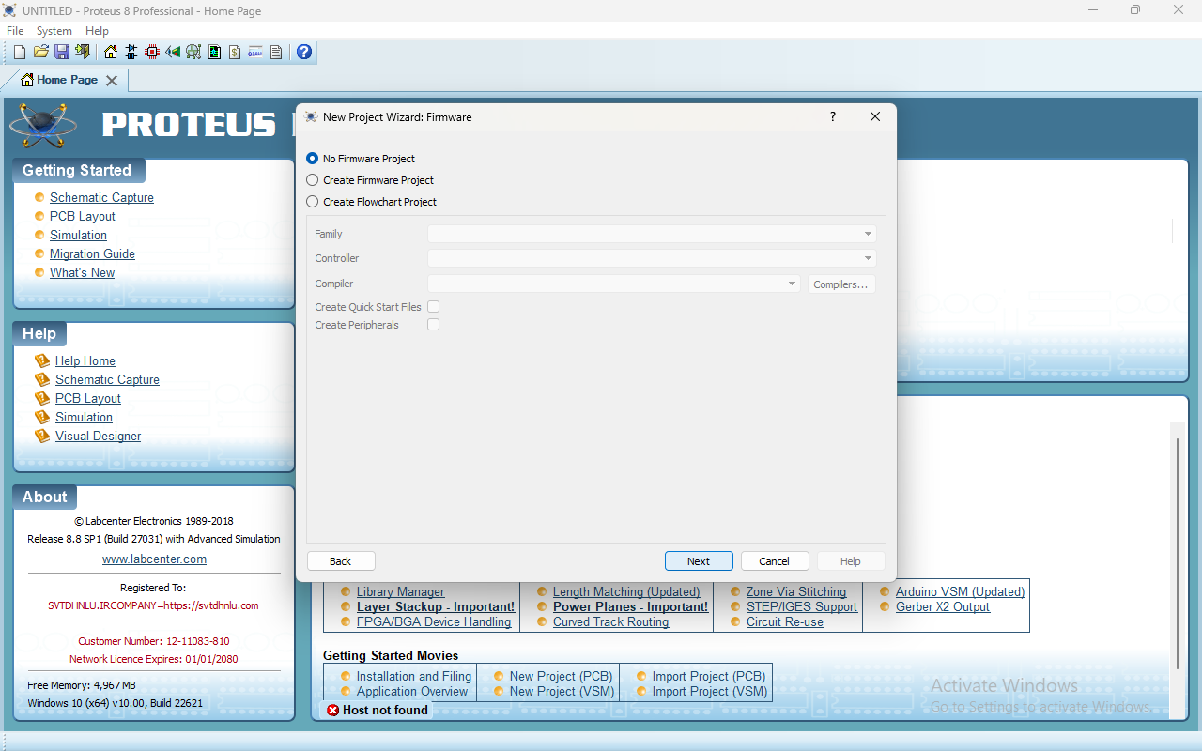

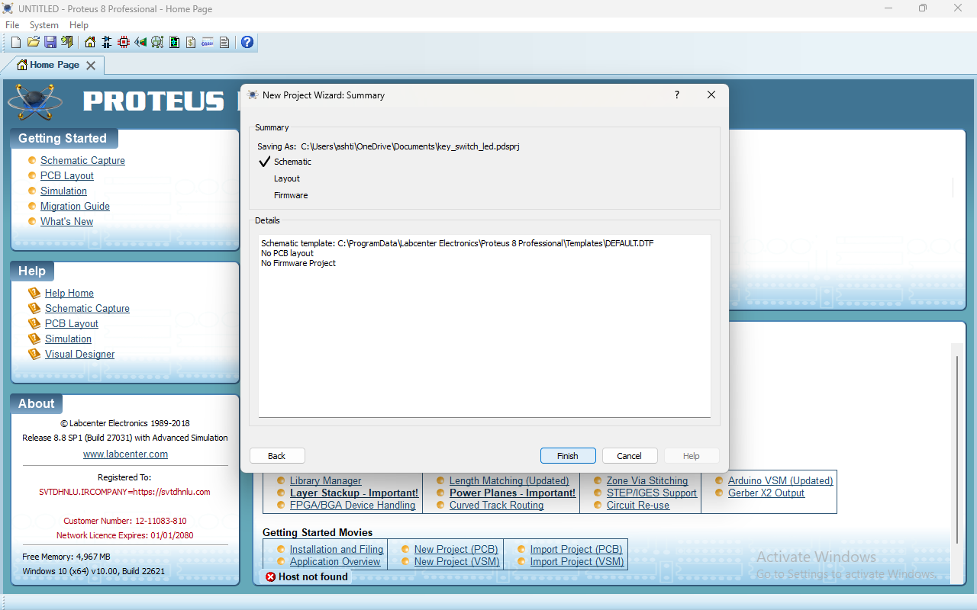

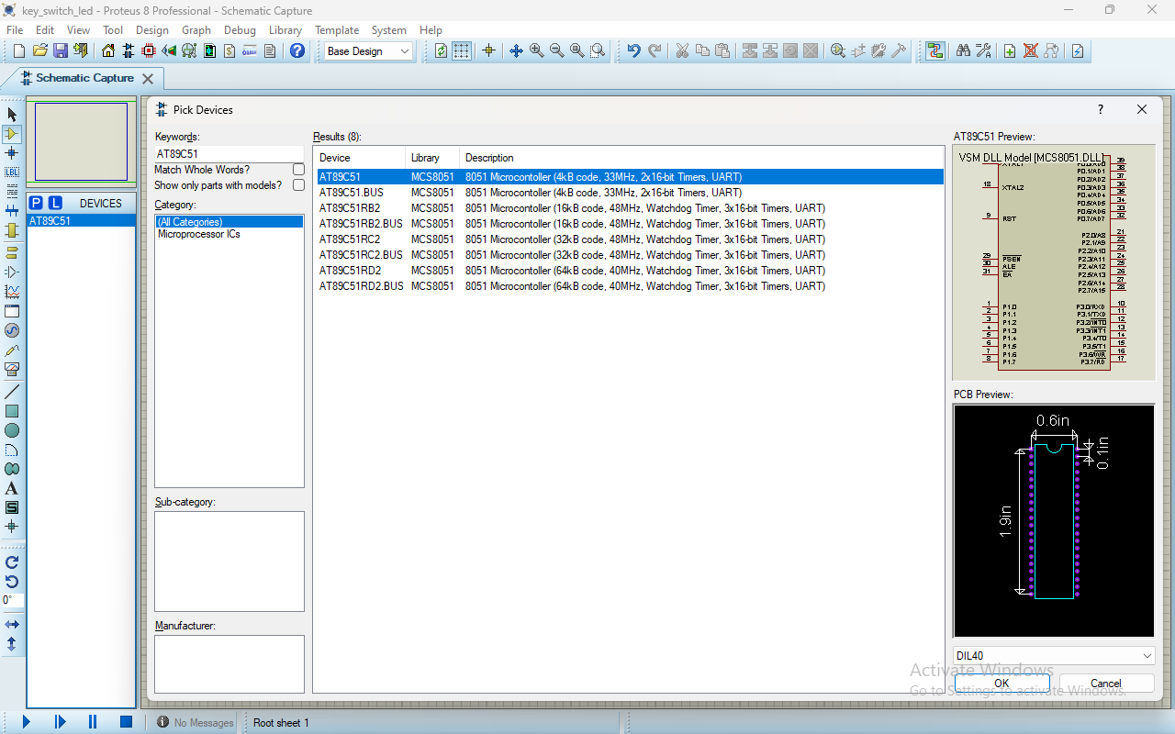

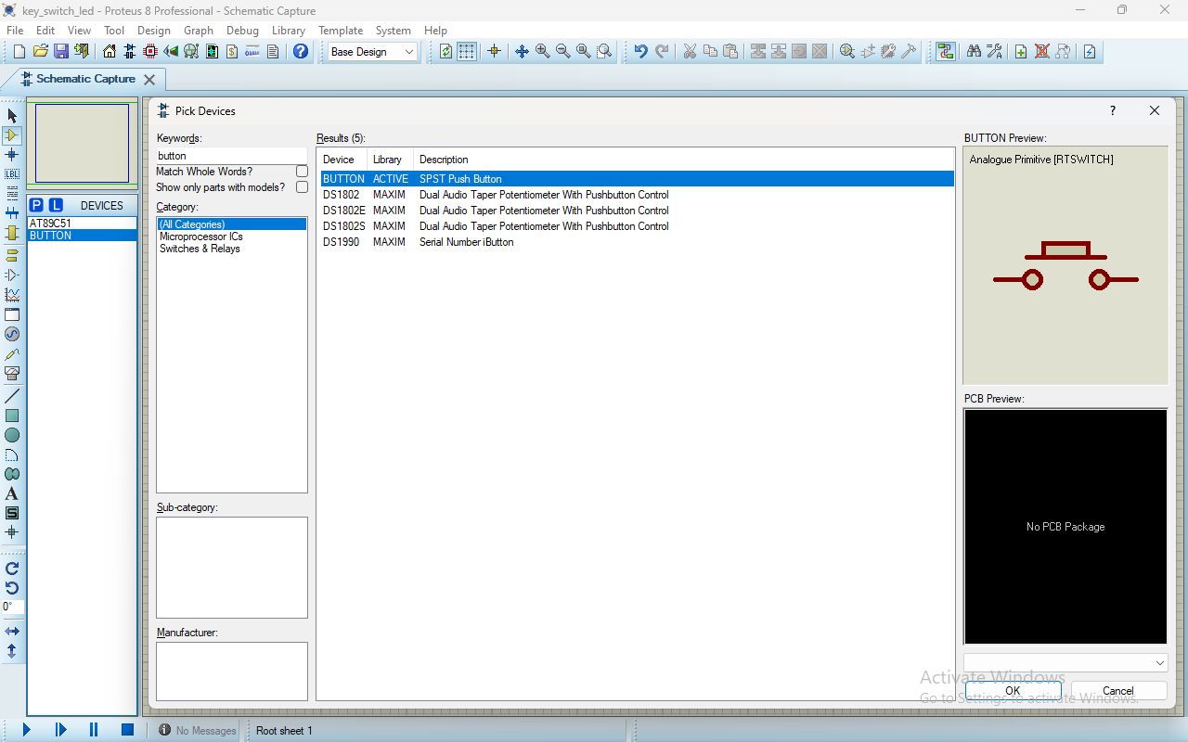

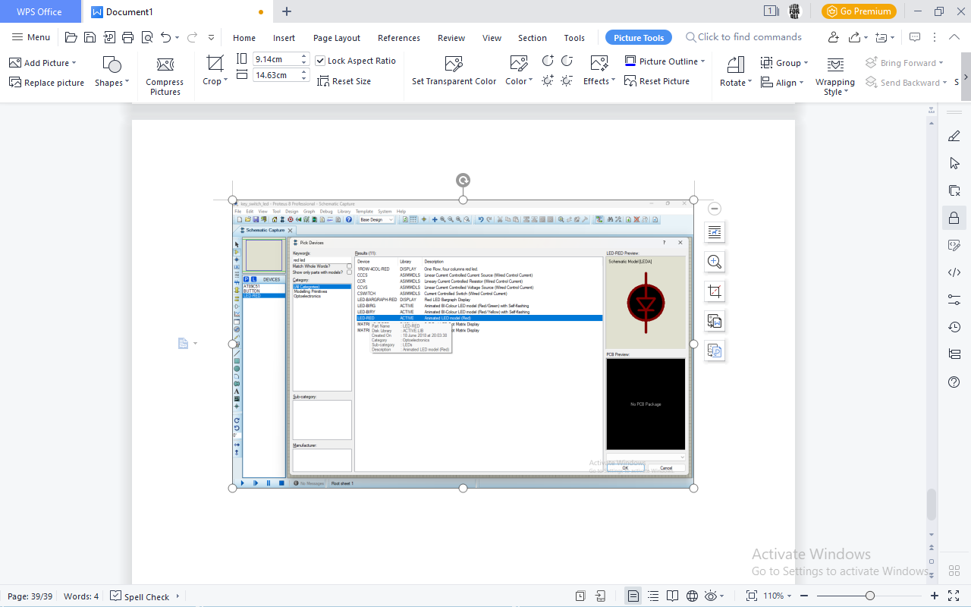

1. Now you have to click on devices section **AT89C51** then click on anywhere in sketch area Same for **BUTTON** take **2 BUTTON** and take **2 RED LED.**

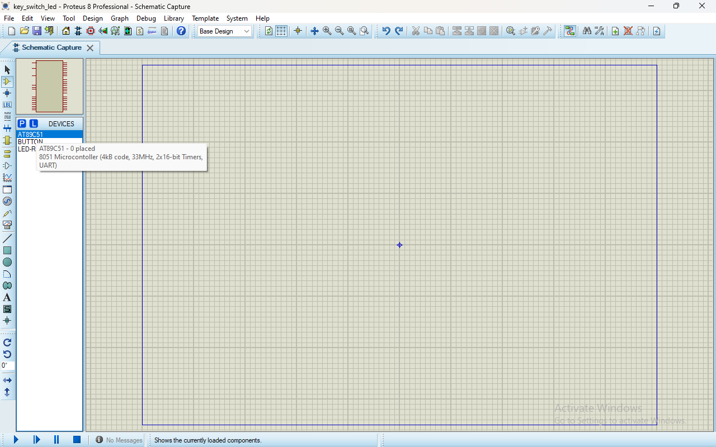

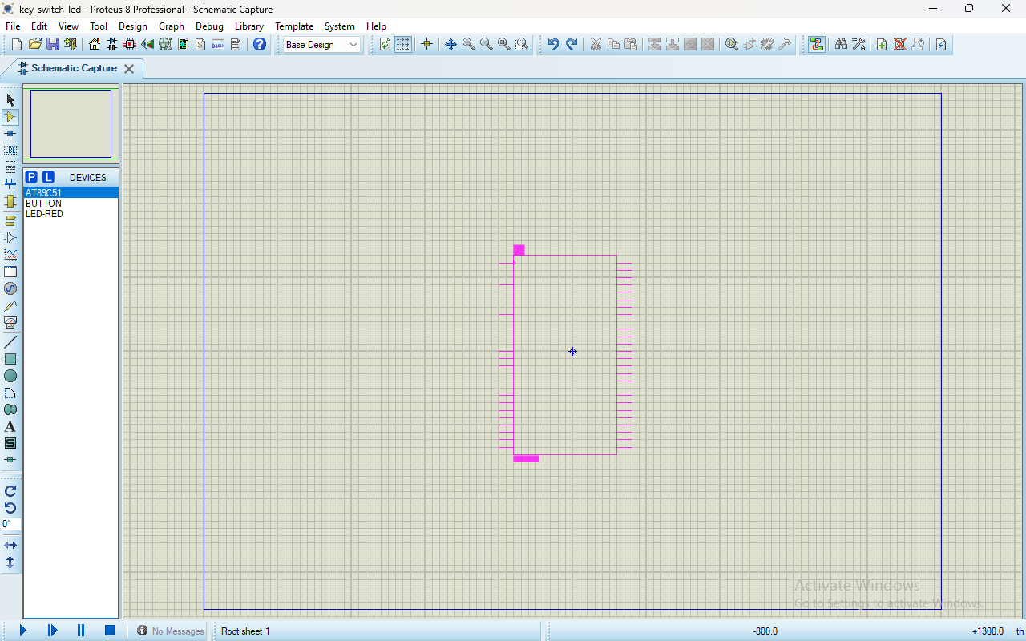

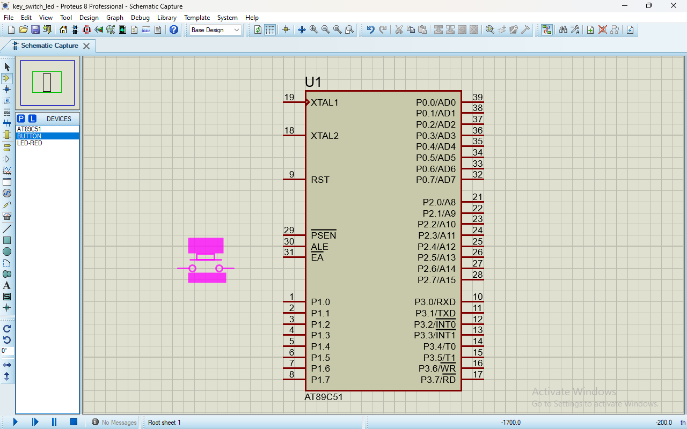

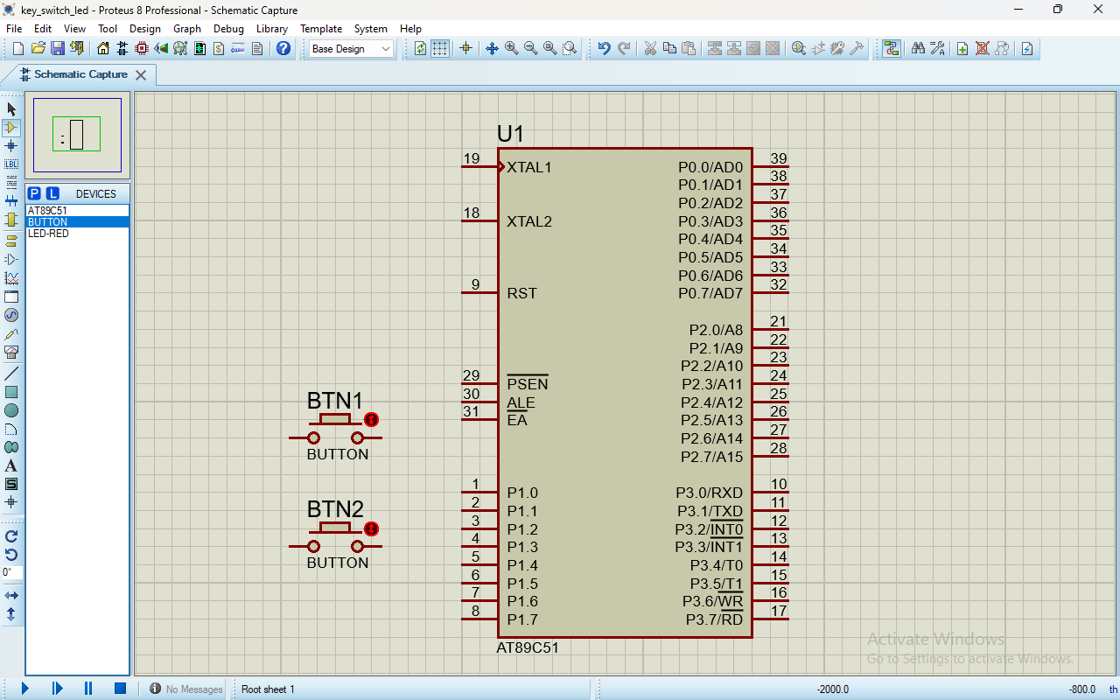

1. Connect BTN1 right pin to pin P1.0 and BTN2 right pin to P1.0 and BOTH BTN LEFT pin connect to power which you select from terminal section.
2. Connect LED D1 ANODE to pin P2.0 and LED D2 ANODE to pin P2.1. After that BOTH LED CATHODE connect to ground which you can select from terminal section.

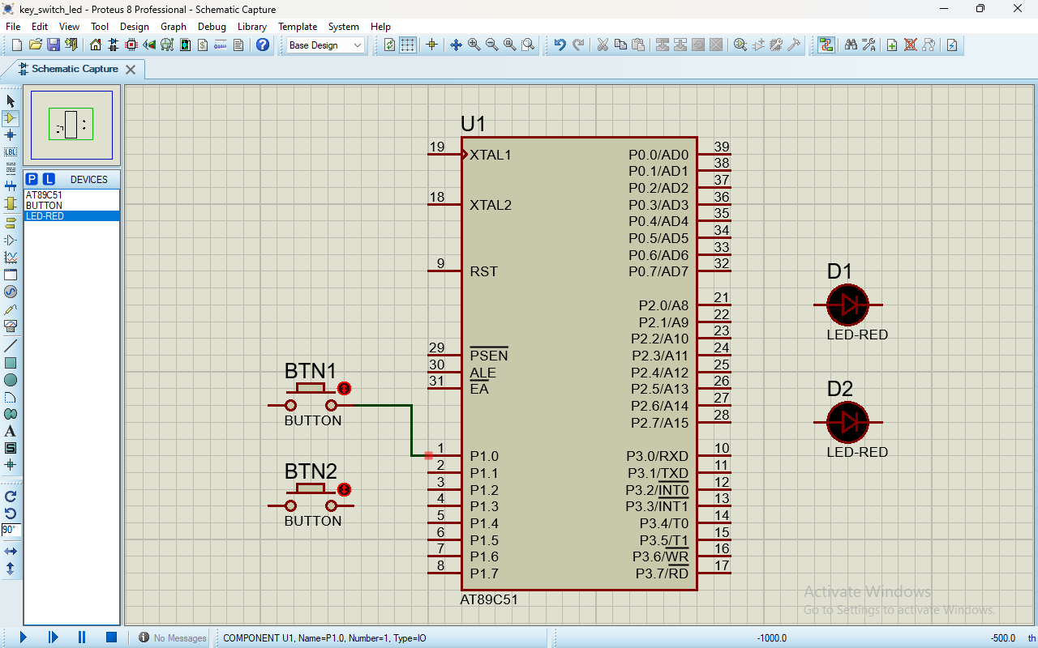

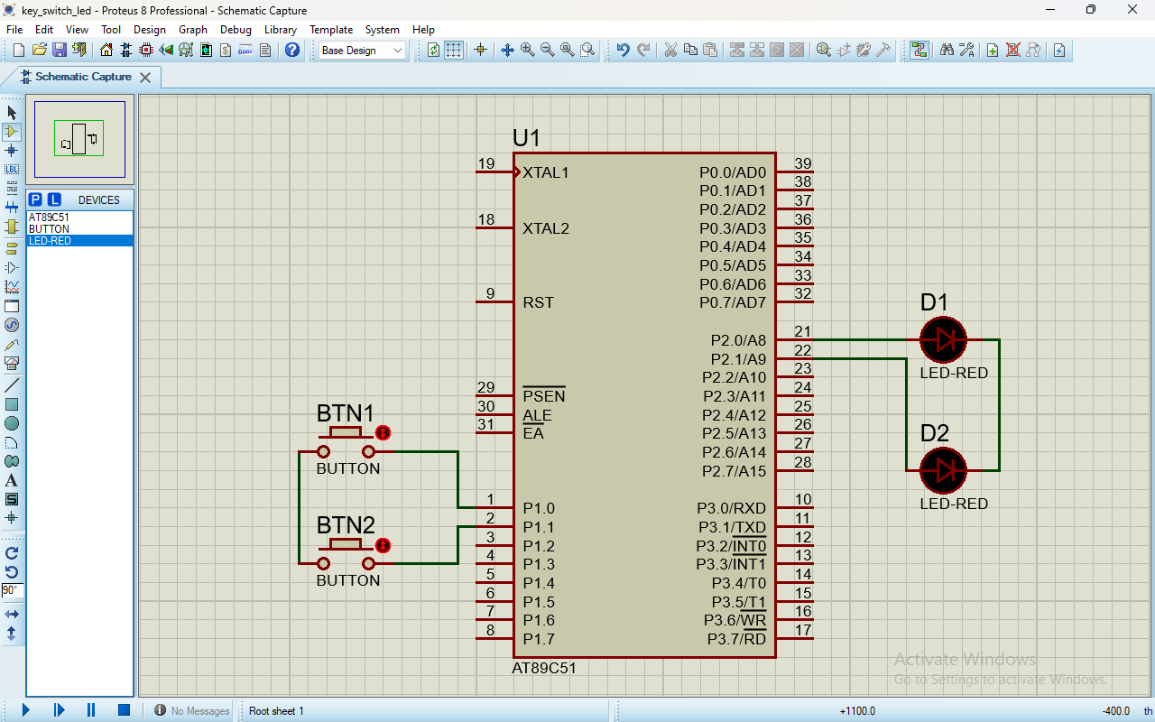

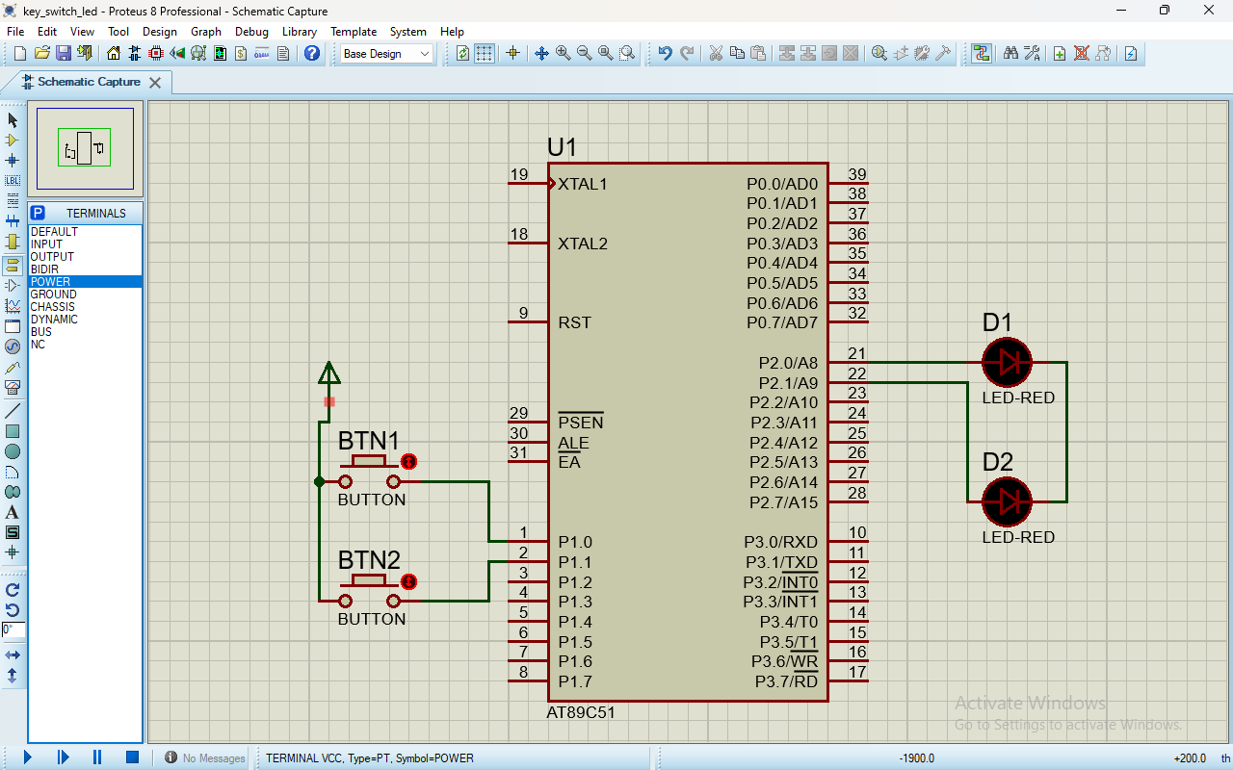

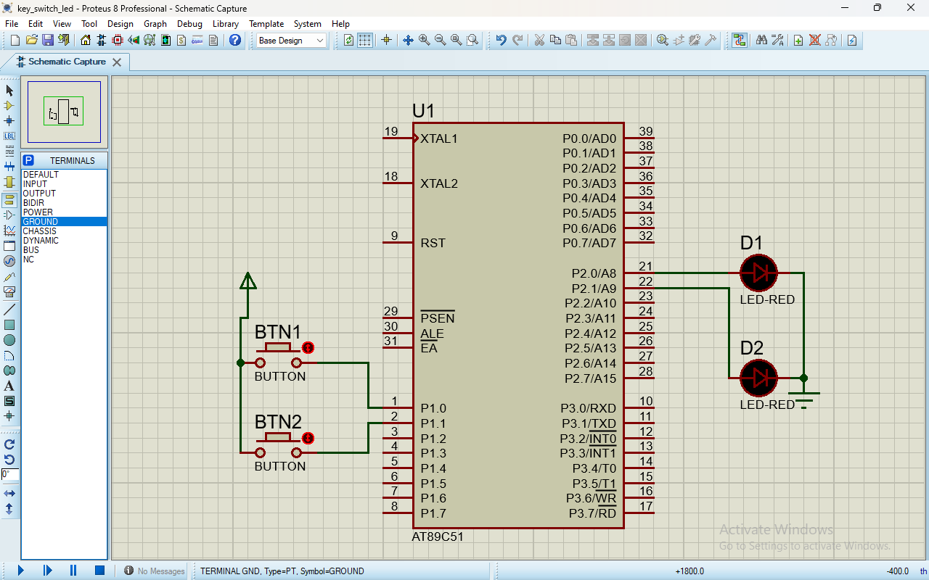

1. Now double click on your micro-controller then select HEX file which we generated from keil_v5 And type same frequency which we enter for HEX file then click on OK.

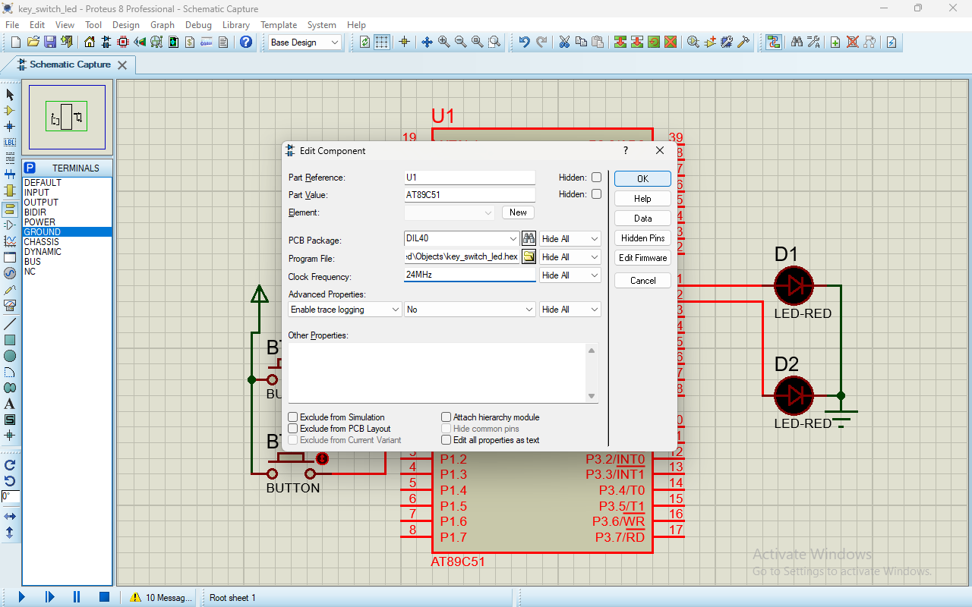

1. Now run the simulation and check both LED is on after on the switch.

**OUTPUT:-**

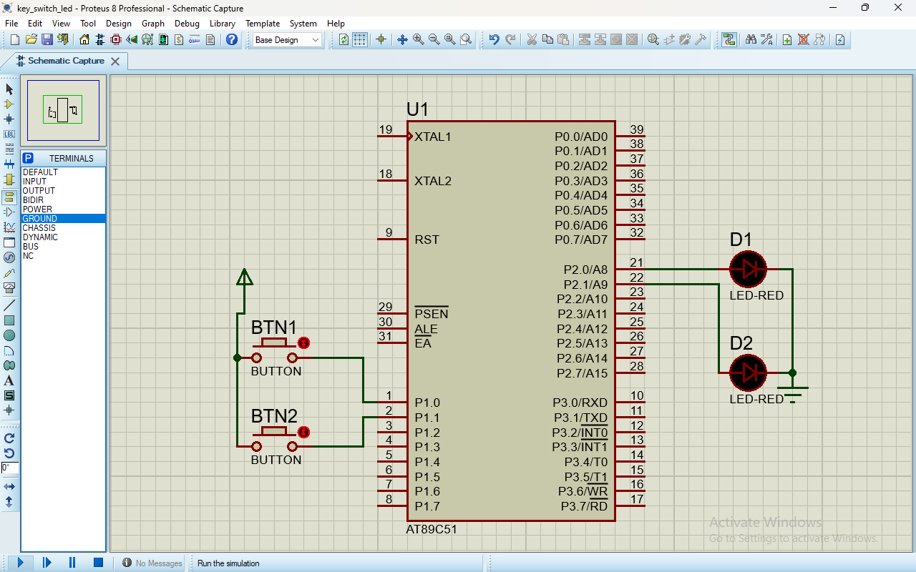

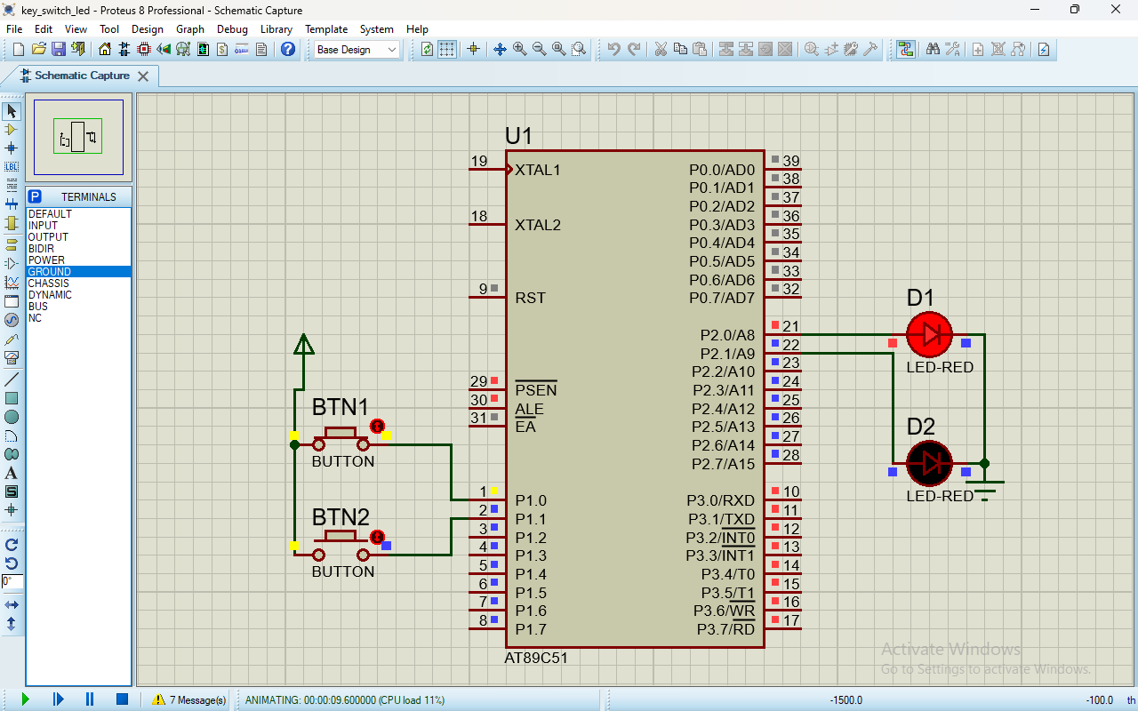

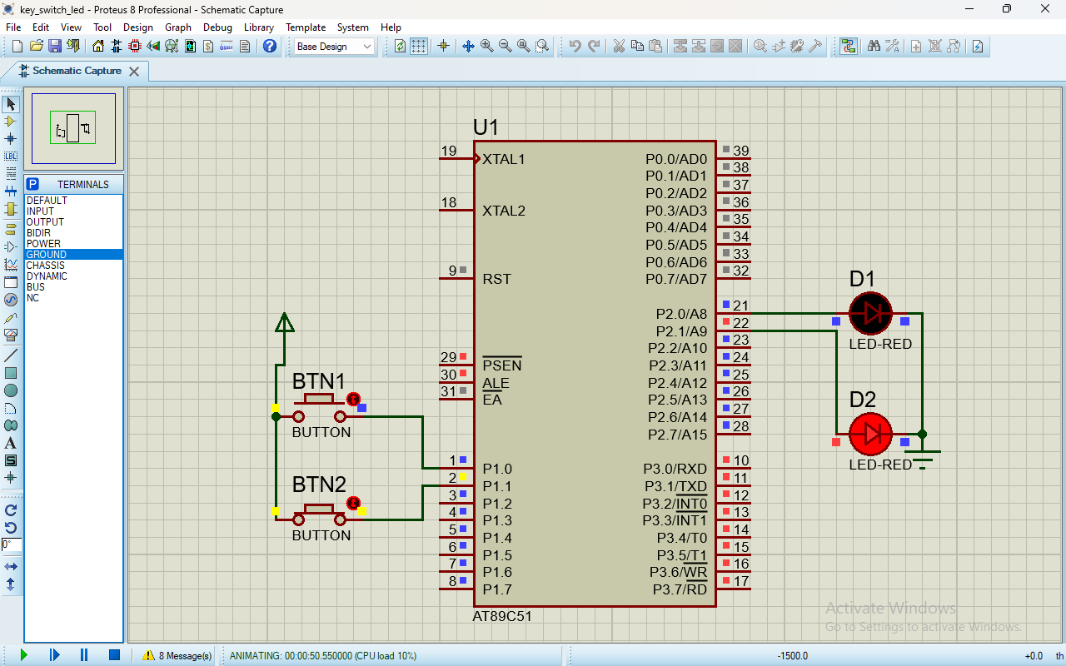

**CONCLUSION:-**

Hence pin p1 and pin p2 works fine and switch led work also fine all circuit is connected properly.